St George’s Hospital
Blackshaw Road
London
SW17 0QT

Direct Line: 020 8725 0051
Direct Fax: 020 8725 3135

ANAESTHETIC DEPARTMENT HANDBOOK

May 2015

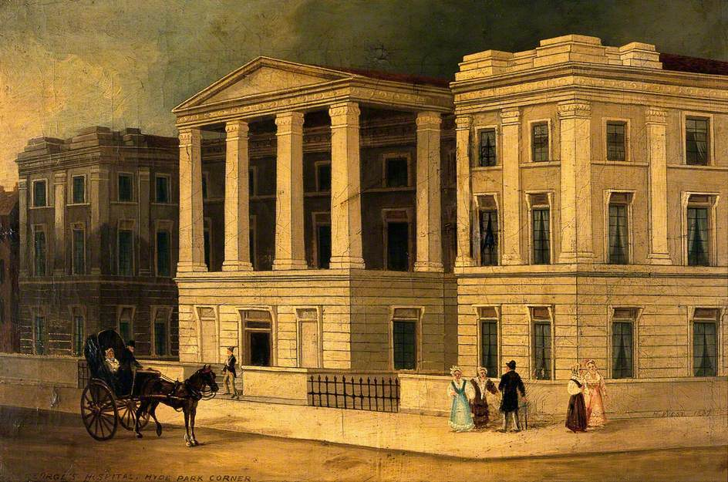
“A guide to all known knowledge and much more else besides”
Compiled by the great and the good
Edited by Oliver Seyfried



Table of contents

Department of Anaesthesia 6
Departmental Representatives 7
Trust’s “Email Acceptable Usage Policy” 9
Consultants 10
On call 10
Consultants - Private practice 11
Trainees 12
ST1-2 12
ST3-4 12
ST5-7 13
Emergency cover during the day and out of hours 14
Protocol for the management of the emergency surgery theatre 15
London NHS Commissioning Standards 19
Guidelines for 6111/7647 bleep holder 21
Emergency Handover Aide Memoire 24
Preoperative assessment of patients by non-consultant grade anaesthetists 25
Postoperative review of Patients 26
Anaesthesia Review Pathway 27
Supervision for trainees 28
Supervision in paediatric lists and cases 29
DFA consultant (bleep 8011) 30
Starred consultant 26
Levels of Supervision 26
Duty Floor Anaesthetist 27
Re-allocating evening CEPOD consultant 28
Anaesthetic cover for the rest of the hospital 32
Consultant cover for cardiac catheter lab 32
Anaesthetics and ODPs including AET cover out of hours 33
Emergency Anaesthetic Practitioner: Standard Operating Procedure 34
Staff Support 36
Leave 37
Sick leave 39
Trainee leave 42
On call rota 43
Trainees – Assessments 45
Tutorials and meetings 45
Library facilities 45
Audit 45
Induction and new trainees 46
Clinical work 47
WHO checklist 47
Moorfields WHO checklist (additional) 48
SGH Perioperative Handover Guideline 48
Patient Safety and Training 48
Anaesthetic machines 49
Clinical work (other points) 50
Acute pain team 51
Hospital Protocols 52
Guidelines for Adult Pre-operative Investigations 52
Interpreter Service 56
Jehovah’s Witnesses 58
Fasting requirements for anaesthesia for inpatient elective surgery 60
Premedication 61
Endoscopy 61
Consent 62
CEPOD Booking 63
Fibrescopes and TOE probes – traceability is IMPORTANT 65
Airway Management/Emergencies 66
SGH Guidelines on Airway Management 66
Airway and Preoperative Assessment & Planning 66
Airway Strategy in non-obstetric adult patients without aspiration risk 67
Airway Strategy in non-obstetric adult patients 68
Plan D 71
Airway Strategy during RSI 72
Difficult Airway in remote operating sites 73
Follow up after Difficult or Failed Intubation 74
Capnography and EASY-CAP 75
Capnography for monitoring and transfer 77
Airway emergencies and airway obstruction (in theatres, wards, etc) 79
Airway compromise flow chart 79
Guidelines on Difficult Airway Equipment 80
Difficult Airway Trolley Locations 81
Airway Stock Trolley (SJW3) 82
Awake fibreoptic intubation 85
Airway management during laser 88
Dental trauma 90
Safe use of oxygen 90
Oxygen cylinders 91
Blood group & save, and cross-matching 92
Blood transfusion issues 93
Consent for blood transfusion 93
Blood tracking and time expired blood 94
Management of massive haemorrhage 95
Management of massive haemorrhage for CODE RED for TRAUMA 96
Emergency open AAA repair 97
Intraoperative LidCo monitoring 98
Organ retrieval 100
Cardiac arrests 101
OHCA Management 101
Trauma 102
AET theatres Acute Emergency Theatre/ PC Theatre 102
Out of Hours – major trauma case 103
Open fractures and timing of operation 104
Optimisation of high risk surgical patients 104
Pre-op evaluation of elective major vascular patients 105
Guidelines for renal transplantation 106
Anaesthesia for AV fistula and graft surgery 108
Moorfields Wing and eye operations out of hours 110
Venous cannulation 113
Vascular access team 115
Venous Access Service referral 115
Extra-vasation policy for peripheral IVs 116
Use of cleaning solutions for neuraxial block 116
Cardiac arrest or cardiovascular collapse caused by local anaesthetic 117
Malignant hyperthermia 119
Fractured NOF protocol 120
Activation of the Primary Percutaneous Coronary Intervention (PPCI) 122
Recovery guidelines for anaesthetists 123
Surgical Division High Dependency Unit (HDU) on Holdsworth ward 125
Catastrophes in Anaesthetic Practice 127
Inter & Intrahospital Patient Transfer Guidelines 128
Eating and Drinking by Staff in the Theatre Environment 132
SGUL guidance on involving medical students in the provision of clinical care: 133
Drugs 138
Storage summary 138
Drug ampoules and boxes 139
Sugammadex 141
Pain relief 142
Diclofenac 142
Codeine 143
Midazolam 144
Ondansetron 144
VTE Prophylaxis 146
Diabetic control 147
A&E guidelines on drugs 151
Machine Check Competency 152
Adverse Incident Reporting 153
MRI Guidelines 155
Anaesthetic Assistance Guidelines 159
Intra-op Handover Guidelines 160
Clinical Product Management Policy 161
Company Representative Policy 162
Suction 162
Reporting to the Coroner 163
Police statements 163
Major incident plan 164
Admission to Cardiothoracic Intensive Care 169
Admission to Neuro Intensive care 170
Admission to Paediatric intensive Care 171
Hotel Services 174
Consultants’ Air Call Numbers 177
Appendix 178
Protocol for the management of the emergency surgery theatre 178
Adult stabilization and transfer pack 181

Department of Anaesthesia

Welcome to the Department of Anaesthesia at St George’s Hospital. It is a large but friendly department that treats an economically and racially diverse population. You might not meet some of the Consultants until later in your training/career. The care group lead or your college tutor should be your first port of call if a consultant is particularly elusive.

The department consists of offices, lecture and seminar rooms in between St. James’ and Lanesborough Theatres on the first floor of Grosvenor Wing. Pigeon holes and computers are readily available in the department. More importantly the anaesthetic department coffee fund provides snacks and refreshments and the kitchenette is usually well stocked.

Divisional administrative meetings are held monthly and STs (Specialty Trainees) representing trainees are invited to attend. Therefore any matters of administration or training should be forwarded to the representatives. They will then ask the Chairman to include those items on the agenda for the next Divisional meeting.

In addition, regular meetings are held between the College Tutors, educational supervisors, trainee representatives, the chairman and the business manager, to discuss issues of concern.

To contact consultant anaesthetists please phone switchboard or bleep them (phone extension #6321 and provide them with consultant’s air call, see last page of the handbook),

Departmental Numbers

David Mason (Spec. Manager.) 020 8725 0051

Ivy Hagan (School. Admin.) 020 8725 0018

Aisha McLeary (Admin.) 020 8725 3317

Annette Virgo (Asst. Serv. Manag.) 020 8725 3122

Luiza Peres (Th. & Anaes. Co-ord.) 020 8725 4120

David Gray (Gen. Manag.) 020 8725 1052

Monique Usher (Asst. Gen. Manag.) 020 8725 2079

Fax 020 8725 3135

Departmental Representatives

CLINICAL
Associate Medical Director Dr C Gass
Associate Medical Director Dr R Wendler
Clinical Director Dr P Quinton
Care Group Lead for Anaesthesia Dr M Edsell
Director Medical Education Dr C Gass

College Tutors: Dr A Treday (ST 5/7)
Dr M Farrar (ST3/4)

Clinical Fellow Tutor: Dr D Mathew

Module Directors:
Bariatrics Dr K Patil
Cardiac Dr A Crerar-Gilbert
GICU Dr M Hamilton
Head & Neck Dr F Mir
Neuro Dr R Devanhali
Obstetric Anaesthesia Dr A Shonfeld
Paediatrics Dr L Walker (5/7)
Dr E Monahan(3/4)
Pain Dr J Blackburn
Regional Anaesthesia Dr R Zumpe
Simulation Dr G McNulty
Trauma Dr R Kennedy
Vascular Dr G Nicholson

Clinical Leads:
Bariatrics Dr A Kayal
Cardiac Dr A Dewhurst
GICU Dr J Ball
Head & Neck Dr D Garewal
Neuro Dr A Zoumprouli
Obstetrics Dr E Evans
Paediatrics Dr D Hampson-Evans
Pain Dr A Nicolaou
PICU Dr L Murdoch
Renal Dr N Fossati
Trauma Dr P Waikar
Vascular/CEPOD Dr G Nicholson
Emergency Dept Dr G Sanders

President of the RCoA and Vice Chair of
the Academy of Medical Royal Colleges Dr JP van Besouw

AAGBI Linkman Dr B Liban
ACCS Dr S Mongia
Acute Pain Dr J Cashman
Anaphylaxis Dr A Walton
Audit Dr C Luong
Clinical Governance Drs F Peer & C Wood
Day Surgery Lead Clinician Dr S Mongia
Drugs & Therapeutic Committee Dr N Al-Subiae
ECT Dr R Ruggier
Equipment & iClip Dr L Murdoch
Induction Dr O Seyfried
President elect ACTA Dr N Fletcher
Quality Improvement Dr E Williams
Resuscitation Committee Dr D Hampson-Evans
Simulator Clinical Lead Dr G McNulty

EDUCATIONAL
School of Anaesthesia
Regional Adviser (Anaesthetics) VACANT
Program Director (Anaesthetics) Dr J Norman
Program Director (SL Teaching) Dr R Suite
Program Director (SWL Teaching) Dr D Spray
Regional Advisor (Pain) Dr R Griffiths
Regional Advisor (ICM) Dr P Newman
Training Programme Coordinator Ivy Hagan

ACADEMIC
Professor of Intensive Care Professor R M Grounds
Senior Lecturer Dr B Philips
Senior Lecturer Dr G Nicholson
Secretary/Administrator Stephanie Thomas

ADMINISTRATIVE
General Manager David Gray
Assistant General Manager Monique Usher
Administration Manager Annette Virgo
Anaesthetics Administrator Aisha McLeary
Theatres Coordinator Luiza Peries

Email
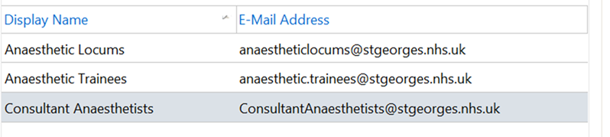

Trust’s “Email Acceptable Usage Policy”

Please read the Trust policy (hyperlink below) which expands on the use of e-mails and Internet email addresses. The consultant list contains SGH/NHS accounts but, in the past, the vast majority of trainees used Internet based accounts. Please be aware that it is a governance issue if patient data is intercepted outside a @stgeorges.nhs.uk or @nhs.net account. Disciplinary proceedings may follow the exposure of any patient sensitive data.

http://stginet/Procedural%20Documents/Corporate%20-%20IT/IT/IMnT_07emailIM.pdf

Executive Summary
Email is an essential business tool. Staff and third parties using the Trust’s email service must be aware of their responsibilities.

All staff must be aware of the restrictions that are in place and the monitoring and reporting on email use that occurs.

Trust information and, in particular, patient data, will remain secure and confidential – please see the diagram below illustrating this.

The Trust’s email system, as with all Trust computing facilities, is primarily for Trust business use and all data stored within the systems belongs to the Trust.

It is permissible for staff to send and receive email at work for incidental personal purposes, providing that this does not involve:
- Substantial expenditure of time;
- Use for profit or other non-Trust business purposes.

It is left to manager’s discretion to decide at what point personal use becomes ‘substantial’, but essentially this implies usage which impacts on the work of the Trust.

[Section] 13. Internet Email Accounts and Auto-forwarding

Users must not use Internet based email accounts (such as Hotmail and Yahoo) for Trust business or forward any emails regarding Trust business to any such account that they own. Forwarding patient identifiable data is strictly forbidden.

Access to Internet-based email accounts is enabled but use of them will be monitored as per the Internet Acceptable Usage Policy.

Users must not set up auto-forwarding of emails to any Internet based email account.

Consultants
New consultants (substantive and locum)
- Must have a Trust and local induction. The latter will include a “walk about” tour showing various parts of the hospital where anaesthetic activity is carried out.
- An appropriate mentor will be allocated

On call

“A framework for consultant job planning” (Provision of on-call) | 4.3.2 The following statements have been developed with respect to the provision of an on-call service for St George’s Healthcare NHS Trust.  All consultants on call should be contactable and able to respond in a time that will not compromise patient outcome or result in an excessive wait for the patient.
Consultant contract T&C * | Schedule 12 Other Conditions of Employment (Private Residence)  2. A consultant is required to reside within a distance of 30 minutes or ten miles by road from their principal place of work unless an employing organisation agrees that they may reside at a greater distance.
Major Incident Plan | Switchboard alert all those with action cards via the SG999 pager system and external partners via agreed methods. NB Switchboard will not call individuals mobiles.  You must carry your bleep when on call  Switchboard only have two at most, 3 staff on. It is recognised that with that for them to call services individually would not be a practical call out system for an organisation of this size.  In addition, during the 7/7/05 incident the mobile phone network went down and the pager network remained working.  Pagers and bleeps ensures that communication can take place in extra-ordinary circumstances and that we fulfil our statutory duty under the CCA 2004.

Private Practice

Please read in conjunction with the St Georges Healthcare NHS Trust Job Plan Framework and the T&C
http://bma.org.uk/practical-support-at-work/contracts/consultant-contracts/consultants-england

Department of Health “Code of Conduct for Private Practice” (2004)

http://www.nhsemployers.org/SiteCollectionDocuments/DH_085195.pdf

1.4 The Code is based on the following key principles:
- NHS consultants and NHS employing organisations should work on a partnership basis to prevent any conflict of interest between private practice and NHS work. It is also important that NHS consultants and NHS organisations minimise the risk of any perceived conflicts of interest; although no consultant should suffer any penalty (under the code) simply because of a perception;
- the provision of services for private patients should not prejudice the interest of NHS patients or disrupt NHS services;
- with the exception of the need to provide emergency care, agreed NHS commitments should take precedence over private work; and
- NHS facilities, staff and services may only be used for private practice with the prior agreement of the NHS employer.

Scheduling of Work and On-Call Duties
2.3 In circumstances where there is or could be a conflict of interest, programmed NHS commitments should take precedence over private work. Consultants should ensure that, except in emergencies, private commitments do not conflict with NHS activities included in their NHS Job Plan.

2.4 Consultants should ensure in particular that:
- private commitments, including on-call duties, are not scheduled during times at which they are scheduled to be working for the NHS (subject to paragraph 2.8 below);
- there are clear arrangements to prevent any significant risk of private commitments disrupting NHS commitments, e.g. by causing NHS activities to begin late or to be cancelled;
- private commitments are rearranged where there is regular disruption of this kind to NHS work; and
- private commitments do not prevent them from being able to attend a NHS emergency while they are on call for the NHS, including any emergency cover that they agree to provide for NHS colleagues. In particular, private commitments that prevent an immediate response should not be undertaken at these times.

2.5 Effective Job Planning should minimise the potential for conflicts of interests between different commitments. Regular private commitments should be noted in a consultant’s Job Plan, to ensure that planning is as effective as possible.

2.6 There will be circumstances in which consultants may reasonably provide emergency treatment for private patients during time when they are scheduled to be working or are on call for the NHS. Consultants should make alternative arrangements to provide cover where emergency work of this kind regularly impacts on NHS commitments.

2.7 Where there is a proposed change to the scheduling of NHS work, the employer should allow a reasonable period for consultants to rearrange any private sessions, taking into account any binding commitments entered into (e.g. leases).

Trainees
St George’s is a busy hospital and there occasionally too much going on or there are complex cases.
- So, call for help early, escalate the problem – we are here to help.
Contact the consultant on call

- Mobile numbers
  - Via Switchboard (phone extension 1000)
  - Via office, list of consultant numbers on wall
  - If voicemail – LEAVE A MESSAGE using “SBAR” and contact number e.g. number of theatre
- Pager system (extension #6321)

Trainees’ “MUST DO’S”

Trainees must document all actions including, anaesthetic assessments, reviews, interventions and emergencies attended. This is as much for your protection as anything else.

All trainees MUST contact the starred consultant in their wing and the DFA early if their list has the potential to or is going to over run (after 17.30).

Trainees should not be doing elective lists on their own outside normal working hours.

All trainees are allocated an Educational Supervisor on joining St George’s Hospital for their attachment here.

ST1-2
There are two posts in the ACCS programme. Non-anaesthetists from other training programmes (ICM or A & E) may complete short attachments within the department.

ST3-4
We provide speciality training in cardiac, neuro, obstetric and paediatric anaesthesia which last 3-6 months. In addition, training is available in chronic pain management and ICM. There are 20 ST ¾ posts at St. George’s Hospital, and a variable number of military trainees.

All blocks change over on the first Wednesday of the appropriate month. For service, training and on call purposes the department is divided into the following blocks:

1) Neuroscience Unit AMW Neurosurgery & Neuro intensive care (NICU)
Chronic pain
2) Cardiothoracic Unit, AMW Cardiothoracic surgery & Cardiac intensive care (CICU)
Vascular surgery
3) Lanesborough Wing Obstetrics service & Gynaecology
Paediatric surgery & Paediatric intensive care (PICU)
4) St James’ Wing General surgery, Plastics, Urology, Maxfax, ENT,
Acute Pain
5) Paul Calvert Wing Orthopaedics

The college tutors are responsible for the internal block organisation. The anaesthetic rota is constructed by Drs Suite, Tredray and Wood and the anaesthetics co-ordinators.
The ST ¾ educational module organisers are:

Neuro Dr R Devanhali
Cardiac Dr A Crerar-Gilbert
Paediatrics Dr E Monahan
Head & Neck Dr F Mir
Pain Dr J Blackburn
Obstetrics Dr A Shonfeld
ICM Dr M Hamilton

On Call
The on-call rotas for the above blocks are generally 1 in 8 and may include LTFT trainees who cover pro rata. ST’s are required to cover short-term sickness and unexpected absence for five weekdays and the first weekend. ST posts are resident when on-call

Locum Payments
If you cover an additional shift, (due to colleague sickness, maternity leave etc), you will be reimbursed the Trust’s standard internal locum rate.

ST5-7
There are 20 full time ST 5/6/7 posts. For administrative, educational and on-call reasons they are divided into 3 blocks (cardiac, neuro, PICU). These blocks are of six months duration and priority is given to STs undertaking their ‘specialist interest’ to maximise exposure in both the elective and emergency setting.

In addition, there are Clinical Fellows who do on-call on the ST ¾ or 5/6/7 rotas, depending on service needs. All rotas are EWTD compliant and are at least a 1 in 8.

- NEURO/CARDIAC Block (bleep 7647)
    - Usually one ST 5/6/7 will be allocated to each of these as a special interest for six months and the remaining STs will share daily duties and on-call to gain further experience, as appropriate. A minimum of one ST 5/7 must be available for daily duties in each unit. The special interest of the trainee will dictate to a large extent the priorities in emergency cover.
- PICU/GENERAL Block (bleep 6890)
    - During the day one ST 5/6/7 will be available for PICU. At night it is necessary to be immediately available for PICU and a bedroom is provided on PICU. Cover for obstetrics, general or cardiac theatres may need to be provided, to back up the ST ¾s and the on call consultants where necessary.

Emergency cover during the day and out of hours

ST3-4
ST3-4 trainees generally work within their specialty area. The ST3-4 in Cardiac and Neuro cover the intensive care units in their respective unit. The trainees completing their paediatric module cover obstetrics out of hours.
Note: Sometimes the 6111 emergency bleep is held by an ST3-4 (see below).

ST5-7
These carry bleeps 6111 for general, 7647 for cardiac/neuro and 6890 for PICU. They act as a group covering their respective areas but should be aware of work happening in all areas. The most appropriate trainee (i.e. experience and exposure, and educational requirements) should be detailed to a particular case, with appropriate consultant input.

Please ensure that emergency patients are seen, whether CEPOD, plastics or orthopaedic cases.

- They should be seen as soon as possible in order to prevent a back log developing that delay prompt CEPOD and AET list starts.

- Anaesthetic charts must be filled in thoroughly.

- Any investigations or interventions that need to be done should be communicated appropriately at hand over and to the relevant surgical team

- When patients are seen, fill in the ‘anaesthetic comment box’ in TheatreMan in St James’ Wing which will prevent you going all over the hospital only to find that your patient has already been seen.

- Data should include
    - Your name
    - Relevant clinical information

- Thorough hand over must take place at the end of each shift
    - This includes listing all patients on TheatreMan

- There is CRA (“clinically related activity”) time in consultant job plans to see patients before their CEPOD, orthopaedic and plastics list but the number of patients can sometimes be large and everyone must pitch in to pre-assess patients in a timely manner if possible.

The 6111 and 7647 are sometimes very busy and can’t see all the patients. Patients not seen should be handed over.

6111 and 7647 must communicate with each other especially during “out of hours”
- They MUST let each other know their current/pending availibility
- This will avoid delays in calling in one of the consultants on call from home

Protocol for the management of the emergency surgery theatre

- Application
  - This protocol applies to all members of the multi-disciplinary team involved in the admission and management of patients admitted to the trust for emergency surgery, excluding cardiothoracic, neurosurgical and major trauma cases.

- Anaesthetists involved in the provision of emergency surgery
  - CEPOD anaesthetist: The anaesthetist rostered for the emergency theatre between 0800–2100 on weekdays and 0800- 2000 at weekends. At all other times this role is covered by the resident anaesthetist on-call.
  - On call consultant anaesthetist: A consultant anaesthetist between 1800–0800 on weekdays and 0800–0800 on weekends, contactable through switchboard.
  - Resident anaesthetist on call: A registrar-grade anaesthetist contactable 24/7 via pager 6111.
  - Duty floor anaesthetist (DFA): A consultant anaesthetist between 0800–1730 during weekdays, contactable via pager 8011.

- Definition of the emergency surgical patient
  - Emergency surgical cases are classified according to the NCEPOD classification (see appendix).
    - IMMEDIATE – Immediate life, limb or organ-saving intervention – resuscitation simultaneous with intervention. Normally within minutes of decision to operate.
    - URGENT – Intervention for acute onset or clinical deterioration of potentially life-threatening conditions, for those conditions that may threaten the survival of limb or organ, for fixation of many fractures and for relief of pain or other distressing symptoms. Normally within hours of decision to operate.
    - EXPEDITED – Patient requiring early treatment where the condition is not an immediate threat to life, limb or organ survival. Normally within days of decision to operate.
    - ELECTIVE – Intervention planned or booked in advance of routine admission to hospital. Timing to suit patient, hospital and staff.
  - Emergency cases requiring a great deal of logistical co-ordination should be discussed with the theatre floor manager and the duty floor anaesthetist who in turn will liaise with the CEPOD anaesthetist when necessary.
  - Emergency theatre bookings are recorded on the booking system as:
Priority 1: ASAP (NCEPOD IMMEDIATE)
Priority 2: under 3 hours, (NCEPOD IMMEDIATE)
Priority 3: 3-6, (NCEPOD URGENT)
Priority 4: 6-18 hours (NCEPOD URGENT)
Any case that can be done with a delay of more than 18 hours (NCEPOD EXPEDITED) should be discussed with the consultant anaesthetist.
  - Any case booked for the next day should be booked after 6pm if possible, and have the proposed date and time of surgery clearly record on the booking form. They should be electronically ‘postponed’ on the emergency booking screen until the planned day of surgery.
  - Any request for anaesthetic assistance, such as placing central or peripheral cannuale, help with sedation, patient transfers or any other assistance should also be requested on Theatreman as well as being discussed with the 6111 anaesthetist. This will help give visibility to the emergency bleep holders workload and form a useful audit trail.

- Emergency theatre provision
  - A 24-hour emergency operating theatre is provided.
    - Between 1700–2100 on weekdays and 1000–2000 on weekends a second emergency operating theatre is provided, staffed with a nursing team and a dedicated consultant anaesthetist.
  - Cases classified as ‘IMMEDIATE’ (priority 1 & 2 on the booking form) will be operated on at anytime.
  - ‘IMMEDIATE’ cases will take precedence over all other cases.
  - The appropriateness of operating on cases classified as ‘URGENT’ (priority 3 & 4 on the booking form) between 2100–0830 will have to be determined on an individual case basis, in discussion with surgeons, theatre staff and anaesthetists.
  - Cases classified as ‘EXPEDITED’ (classified as Priority 4) will be operated on between 0830–2100.
  - Cancelled cases from elective lists must not be transferred onto the emergency list.
  - If 2 simultaneous emergencies occur, contact should be made with the floor manager who will liaise with the duty floor anaesthetist, or consultant on call after 18:00, about providing extra emergency capacity- either interrupting a suitable elective list or providing staff to open a vacant theatre.
  - If there is an obstetric emergency which cannot be accommodated in the obstetric theatres, the obstetric anaesthetist must contact the floor manager to provide suitable theatre capacity. The floor manager will then liaise closely with the duty floor anaesthetist or consultant on call after 18:00.

- Booking cases on the emergency theatre list
  - All cases are undertaken in the order that they have been booked, unless medical re-prioritisation occurs. Exempt from this rule are cases classified as ‘IMMEDIATE’.
  - A case cannot be booked onto the emergency list unless the criteria on the emergency booking screen are fulfilled:

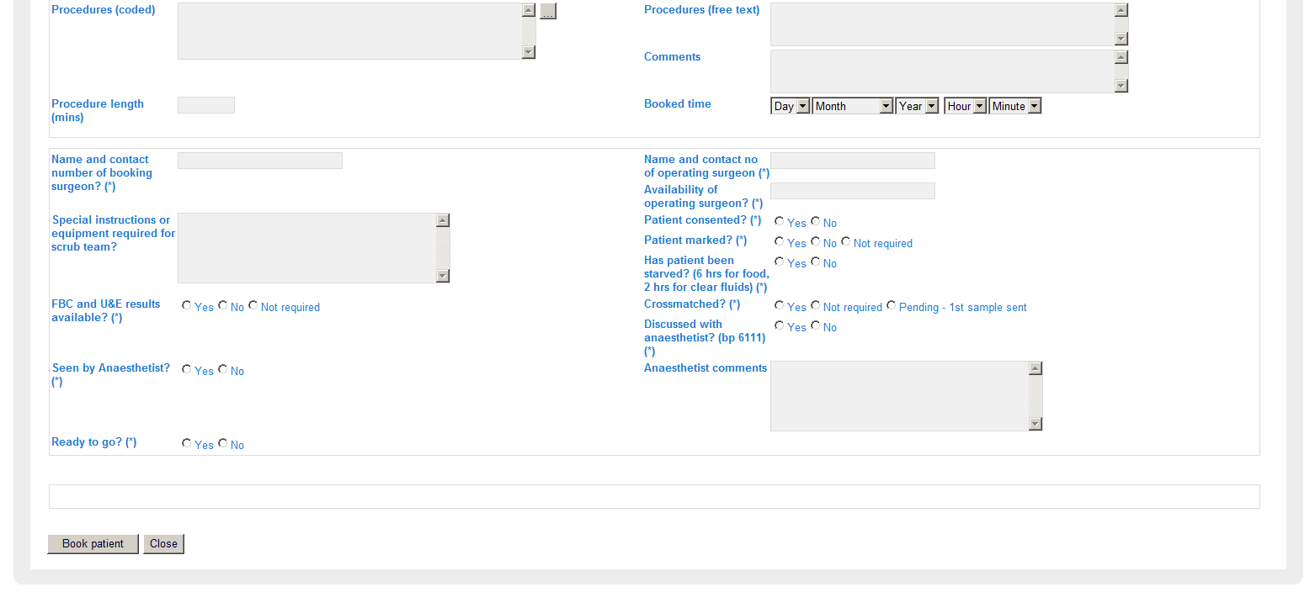

  - The patient must also be in an in-patient bed or being transferred directly from A+E.
  - A surgeon competent to perform the operation should be available at the time of sending for the patient.
  - Relevant clinical information about the patient must be clearly communicated to theatre staff and the anaesthetist when the surgical team makes the booking and entered on the electronic booking form.
  - The surgeon booking a patient on the emergency list must contact the resident anaesthetist on-call (Bp6111) about the case. The resident anaesthetist on call will then inform the duty floor anaesthetist and CEPOD anaesthetist.
  - A surgeon competent to perform the operation must be available at all times from the time the patient is ready for surgery, i.e. has been booked on the CEPOD lists and is starved, if appropriate.
  - If the operating surgeon is not available at the time of sending for the patient or the patient is not otherwise ready for surgery the case will be removed from the list.
    - It is then the responsibility of the surgical team to re-book the case.
    - At the time of re-booking the patient again joins the back of the waiting list.
  - Special requirements, e.g. for equipment or X-ray, need to be stated when the booking is made. A radiographer must be booked by the surgical team.

- Pre-operative assessment of the patient by the surgical and anaesthetic teams
  - Appropriate preoperative assessment and consent of the patient by the surgical and anaesthetic team must be undertaken in all cases.
  - A surgeon competent to perform the operation must have seen the patient prior to induction of anaesthesia.

- Cancellation of emergency cases and deferment to the following day
  - Urgent cases booked must not be postponed or cancelled without discussion with the surgeon responsible, the consultant anaesthetist, and the theatre floor manager.
  - Cases on the previous evening’s emergency list which were not completed due to time constraints are automatically rolled over to the following morning.
  - It is the responsibility of the night 6111 bleep holder to liaise with the surgical teams and the night theatre staff to identify and preoperatively assess the first patient to ensure a timely start of the CEPOD list at 8:00 am. The first patient should be sent for by latest 7:45.
  - As each surgical and anaesthetic ‘on call’ team completes their shift there must be a comprehensive hand over of relevant clinical information about each patient on the emergency list to reduce the risk of inconsistent preoperative clinical management of the patient. This should be done using the SBAR handover format in the anaesthetic handover guideline, and displayed on the wall in the St James theatre office.

- Scheduling of cases and changes to the order of the emergency list
  - As emergency cases are operated on following the order in which they have been booked request for specific scheduling times for cases should be kept to a minimum and are only possible for clinical reasons.
  - Changes to the order of emergency bookings can only be made due to medical re-prioritisation and following discussion with the surgeons and anaesthetists involved as well as the theatre floor manager.
    - Paediatric patients can be medically prioritized on the grounds of their age.
  - Once a change in the order of the emergency list has been agreed upon it is the responsibility of the surgical team taking priority to inform other surgical teams that are to be delayed.
    - Cases classified as ‘IMMEDIATE’ can be prioritized without the need for the surgical team taking priority to inform other surgical teams that are to be delayed.
8.4. The resident anaesthetist on-call will make every effort to ensure a timely list start in the morning in identifying suitable cases and liaising with the surgical specialities and the theatre staff during the night.

- Allocation of emergency cases to the second emergency theatre list and other elective lists
  - Spare capacity on elective theatre lists can and should be used to accommodate emergency cases. The duty floor anaesthetist will coordinate these efforts in agreement with the relevant surgical teams and the theatre floor manager.
  - If a case is cancelled from the emergency list consideration must be given to placing the patient on the next available elective list of that clinical specialty/ consultant firm.
  - During times when a second emergency theatre list is provided the theatre floor manager/ and duty floor anaesthetist/ on-call consultant anaesthetist in agreement with the surgical teams involved decide upon the allocation of patients to the two lists applying the principles outlined in 5 and 8.

- Audit and data recording
  - The theatre floor manager ensures that information on completed cases recorded on Theatreman is appropriate for audit purposes

- Timeframe for implementation and review of the protocol
  - This protocol will be implemented from 18/04/2015.

Appendix:

Classification of priorities for emergency CEPOD theatres

Background:

NCEPOD Classification:
“IMMEDIATE - Immediate life, limb or organ-saving intervention - resuscitation simultaneous with intervention. Normally within minutes of decision to operate.
URGENT - Intervention for acute onset or clinical deterioration of potentially life-threatening conditions, for those conditions that may threaten the survival of limb or organ, for fixation of many fractures and for relief of pain or other distressing symptoms. Normally within hours of decision to operate.
EXPEDITED - Patient requiring early treatment where the condition is not an immediate threat to life, limb or organ survival. Normally within days of decision to operate.
ELECTIVE - Intervention planned or booked in advance of routine admission to hospital. Timing to suit patient, hospital and staff.”

http://www.ncepod.org.uk/pdf/NCEPODClassification.pdf

The RCS document on Care of High Risk Surgical Patient suggested priorities:
1. Patients with septic shock who require immediate surgery are operated on within three hours of the decision to operate
2. Patients with severe sepsis (with organ dysfunction) who require surgery are operated on within a maximum of six hours
3. Patients with sepsis (but no organ dysfunction) who require surgery should have this within a maximum of 18 hours.
4. Patients with an infected source (but no SIRS) who require surgery should have this as soon as possible (7am to 10pm start).

http://www.rcseng.ac.uk/publications/docs/higher-risk-surgical-patient

Standards of Care

http://www.londonhp.nhs.uk/wp-content/uploads/2011/09/AES-Commissioning-standards.pdf
Those standards relating directly to anaesthetics:

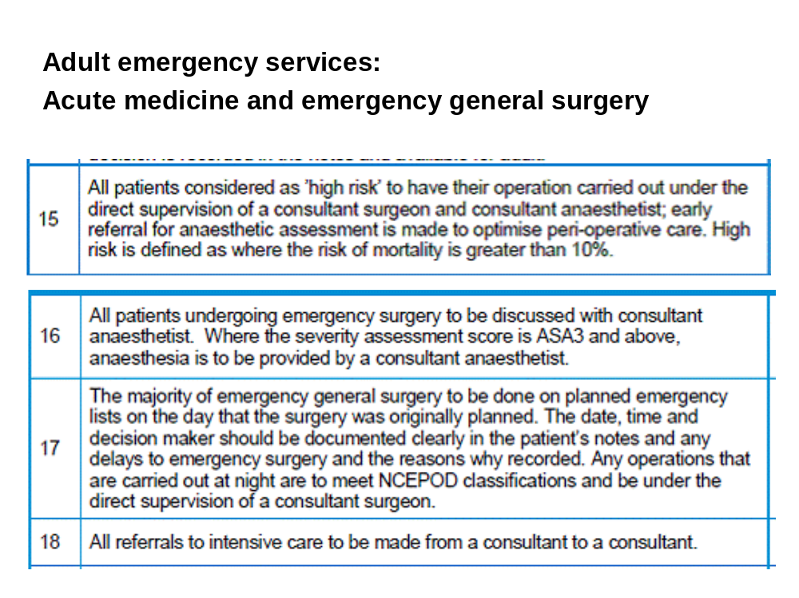

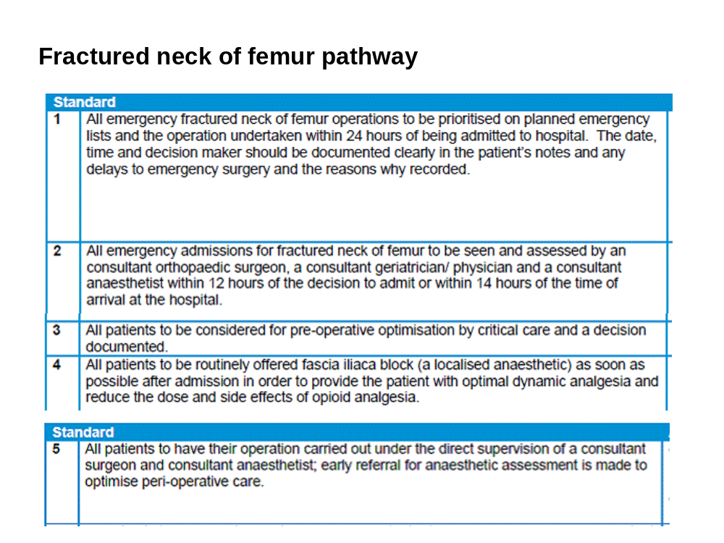

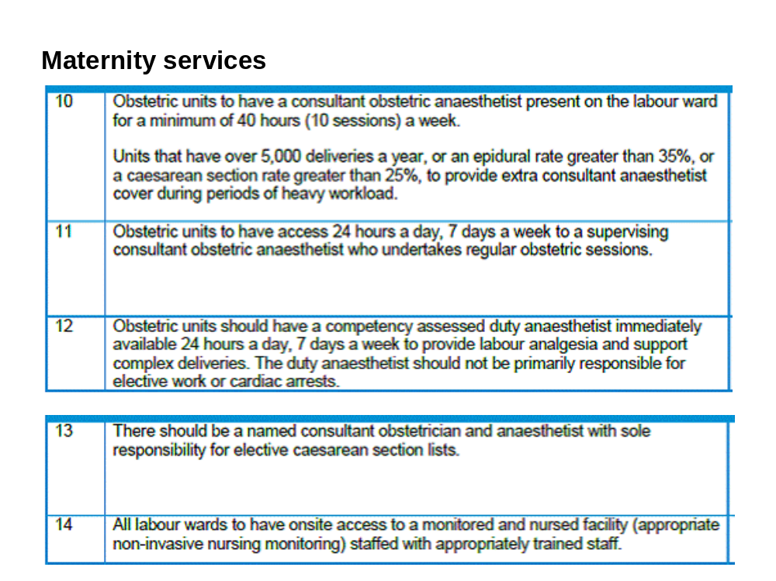

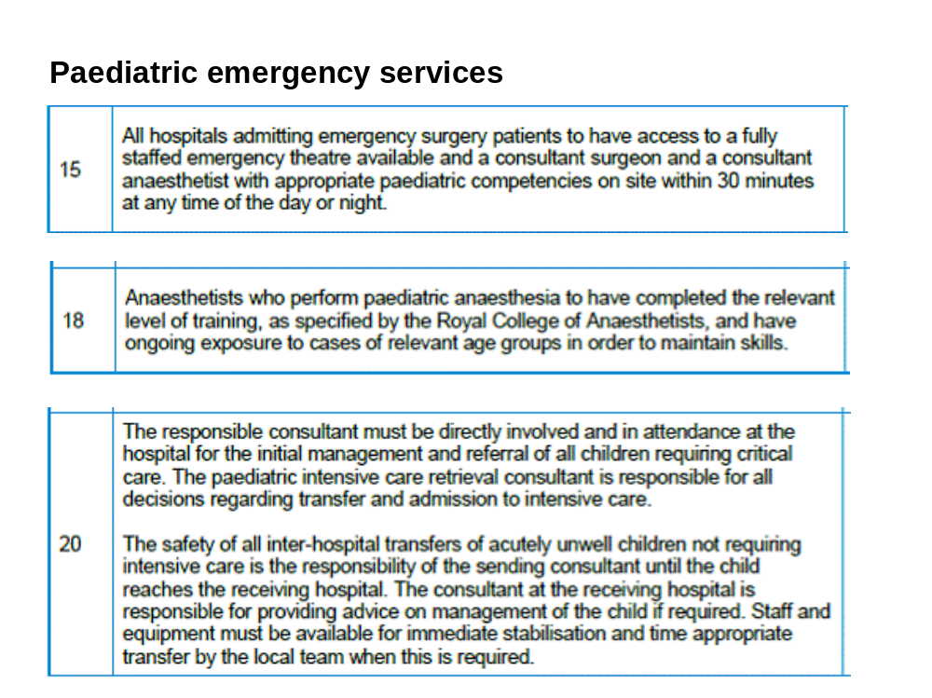

#

DUTIES
GENERAL (6111 bleep holder) duties:
- Being the on-call anaesthetist and helps co-ordinate all emergency work by liaising with
    - Duty floor anaesthetist (DFA) and CEPOD consultant (SJW theatre 3)
    - The starred consultant in each wing if needed
- Meet at 8am with the previous night-time 6111, the CEPOD anaesthetist and the DFA at St James theatre reception for hand over
- Night time 6111 must identify the first CEPOD case and liaise with surgeons and theatre staff to get that patient ready for theatres for an 8.30 am start. If appropriate, the case should be sent for at 8am or earlier – if there are any issues, then please discuss with the CEPOD anaesthetist or DFA.
- Act as “back up”
    - May be the final back up for other ST5-7 bleep holders during busy times.
    - May also have to help out in the labour ward, when it is particularly busy, or if there are challenging / difficult obstetric cases.
- When possible, please start seeing patients on the CEPOD lists from 7am as these patients often need sorting out with an aim for an 8.30 am start time for the CEPOD list
- There are CEPOD consultants in addition to 1st on call consultants from 08:00-21:00 weekdays and 10:00-20:00 weekends.
- There is an emergency CEPOD bag in SJW3 – the 6111 must check it daily (see appendix)
- There is also an adult stabilisation and transfer pack (see appendix)

CARDIAC/NEURO in AMW (7647 bleep holder)
- Covers cardiac/neuro theatre emergencies
- Must be aware of all patients on CICU and NICU (covered by the ST3-4)
- Covers emergencies throughout the hospital from 22.00 with 6111. Please see the guidelines which follow.
- Act as “back up”
    - May be the final back up for other ST5-7 bleep holders during busy times.
    - May also have to help out in the labour ward, when it is particularly busy, or if there are challenging / difficult obstetric cases.
- There is also an adult stabilisation and transfer pack (see appendix)

- Clerking/pre-med elective cardiac patients either at late times or when they are busy with emergencies [SDU meeting – May 2012]

  - Consultant cardiac anaesthetists are responsible for their patients
  - If 7647 called at inappropriate times by ward nurses, 7647 should politely explain that they are busy and the patients can be seen at more suitable times if clinically appropriate
  - If not busy, then 7647 may help clerk/pre-med cardiac patients

PICU (6890 bleep holder)
- On-call for PICU.
- May do paediatric surgical emergencies and back up both GENERAL and CARDIAC

From the terms and conditions, doctors are expected to provide cover for sick colleagues who are on the same duty rota of shift. Doctors who perform duties on occasional emergencies and unforeseen circumstances without additional remuneration may be granted time off in lieu at the discretion of the department. Trainees should have been informed in the local induction of this expectation and also should be reflected within their job descriptions.

GENERAL/ADMIN Block
The STs in this block may have varied special interests, such as Orthopaedics, Obstetrics or Pain (acute and chronic).

Guidelines for 6111/7647 bleep holder
The bleep holders will respond to cardiac arrest/trauma calls and other emergencies.

Good communication between the three ST 5/7’s on call every night is essential. The feasibility of the bleep being held by one of the three if the others are busy should be explored before calling in a consultant, unless obvious that a consultant presence would be beneficial

7647 is busy
- If there is a cardiac or neuro case that needs to go to theatre – call cardiac or neuro consultant in.
- ST ¾ to see the patient and ensure all relevant personnel called in.
6111/6890 are busy
- If there is a cardiac or neuro case that needs to go to theatre – call cardiac or neuro consultant in.
6111 is quiet
- If there is a cardiac or neuosurgical case that needs to go to theatres, then 6111 takes the calls and C/N goes to theatre.
- If 6111 then becomes busy, PICU trainee is contacted to take the bleep. If not free, general consultant is called in.
7647 in theatre or busy
- 6111 takes calls including
- If CICU or NICU needs help, then assess and communicate with on call ST3-4 and ST 5-7 and call CICU and NICU as needed
- Remember the other ITU in AMW may be quiet so use that person if necessary.
If patient needs to go for a CT scan from NICU
- ST ¾ from neuro takes the patient and unit is covered by the 6111 or 7647 depending who is free
- Any issues, contact NICU consultant
If either CICU or NICU ST3-4 calls in sick
- 7647 takes over those duties
- 6111 takes all calls for the hospital – any cases going to theatre to be done by consultant
If 7647 calls in sick
- 6111 takes all calls for the hospital – any cases going to theatre to be done by consultant
If 6111 calls in sick
- 7647 takes all calls for the hospital – any cases going to theatre to be done by consultant

Guidelines for senior general (6111), senior cardiac/neuro (7647) and PICU (68909)
[New guidelines in 2013]

If C/N case to do at night

7647 busy
7647 quiet

6111 quiet
6111 / PICU busy

7647 to do the C/N case
Call C/N consultant in to do case
- 7647 takes all calls
Call C/N consultant in to do case

If NICU/CTICU becomes busy
- Call other 6111/6890
- Call C/N consultant
Arrest/trauma calls goes to
- 6111
- Otherwise 6890, if 6111 busy
- Otherwise general consultant, if PICU busy

If neuro patient needs CT, then neuro ST3-4 goes and NICU covered by arrest bleep holder.

If a trainee is off ill and no locum cover obtained:
C/N 3-4
absent
C/N 5-7
absent
6111
absent

C/N 5-7 takes over ICU duties

6111 takes arrest/trauma calls

General consultants to do
SJW CEPOD cases overnight
C/N consultant takes over duties

6111 takes arrest calls/trauma calls

General consultants to do
SJW CEPOD cases overnight
C/N 5-7 takes 6111 duties

C/N consultant takes over C/N 5-7 duties

General consultants to do
SJW CEPOD cases overnight)

Protocol for the preoperative assessment of cardiothoracic patients by non-consultant grade anaesthetists
[Sept 2012]

Emergency Handover Aide-memoire
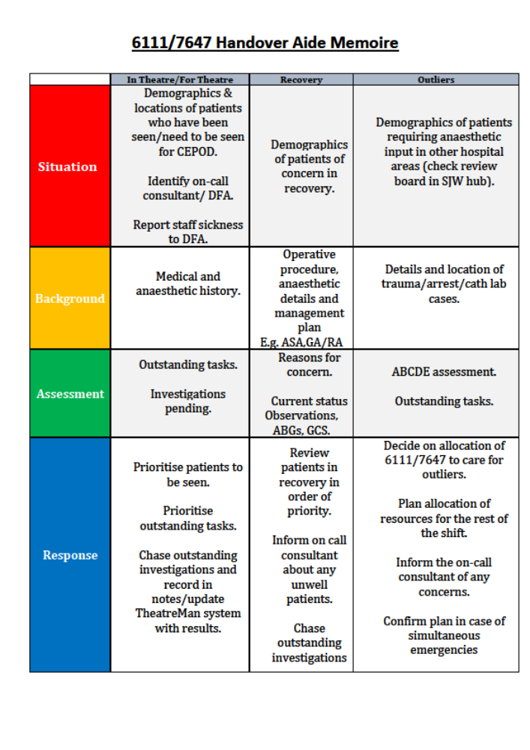

Preoperative Assessment of Patients (Cardiac Only)
Preoperative visits are part of cardiac anaesthetic training and should be done at the following times:

Weekdays between 15:00-20:00

- The preoperative assessments should be organised by the most senior trainee in cardiac theatres. The general principle is that all cardiac cases should be seen. At a minimum the first cardiac cases only if staffing levels are low. If there are complex thoracic cases, early on the list, they should be seen.
- If preoperative assessments are not completed by 20:00 the on-call senior trainee (bleep 7647) should be informed, they should attempt to see the first cardiac cases on each list before 22:00. If they cannot do this then the on call consultant cardiothoracic anaesthetist should be informed.

- If no trainees are available the consultant in cardiac T1 ensures (bleep 7647) are aware and informs consultants on for the next day that only the first cases will have been seen. All theatre consultants on that day make sure first cases have been seen.

Weekends (Sunday) between 14:00-22:00

- The senior trainee on for neuro-cardiac (bleep 7647) should organise the preoperative visits. If the junior doctor on CTICU (bleep 7647) is an anaesthetist and they are not very busy it is not unreasonable for the senior trainee to request their help in seeing some of the premeds on Ben-Weir ward. If there is an issue with this the Consultant on for CTICU should be contacted.

- If the 1st case premeds cannot be completed by 20:00 the on call senior trainee (bleep 7647) should be informed and follow the same protocol for as for weekday cases.

Premeds should not be seen after 22:00 till 06:30 unless they are an emergency.

Routine changes to the operating list made after 22:00 will be seen the next day.

Nursing and Surgical staff should inform the anaesthetic staff of unseen “premeds” but not "harass or threaten" anaesthetic staff when they maybe dealing with other urgent issues.

Consultant anaesthetists are ultimately responsible for their patients’ preoperative assessment and will review patients either in a preadmissions clinic, the afternoon before surgery or early on the morning of operation.

Post-operative review of patients (ACSA 1.1.1.10)
Author: Dr Mark Edsell
Consultant Anaesthetist
Date of last Review: 1st April 2015
Date of Next Review: 1st April 2016

Background
Anaesthetists are an integral part of the perioperative team who, in addition to operative care, provide advice and care throughout the patients’ journey. Wherever possible, the anaesthetist providing the operative care for the patient should ideally review the patient themselves within 24 hours as the prevention or early identification of post-operative complications can improve outcome. The guidance on the provision of anaesthesia services for post-operative care (2014) identifies specific patient groups who benefit from an early post-operative review by a member of the anaesthetic team. These include;
- Patients graded as ASA 3 or above not discharged to an intensive care unit
- Those receiving epidural or regional anaesthesia infusions in a general ward
- Those for whom a request is made by other medical, nursing or other clinical colleagues

Wherever possible, the anaesthetist providing the operative care for the patient should ideally review the patient themselves. If this is not possible, it is the responsibility of the consultant caring for the patient to ensure a post-operative review has been arranged. The following pathways are available to arrange a post-operative review:

Post-Anaesthesia Recovery units
- All patients should be handed over using the structured verbal and written handover provided.
- Each patient should have a named anaesthetist clearly assigned along with the contact details should advice or review be required (location/contact number/bleep)
- Patients requiring a planned review prior to discharge are seen by the responsible anaesthetist or nominated deputy
- For unplanned or urgent calls for assistance, call 6111 or 7647

Inpatient Pain service
- The acute pain service has an open referral system via bleep 6477
- Consultant anaesthesia ward rounds Monday to Friday
- Aim to see all patients within 24 hours
- Routinely review all epidural patients
- Out-of-hours acute pain referral is covered by the resident anaesthetic registrar (bleep 6111)

Inpatient Anaesthesia Review

- Those patients who require a post-operative ward review by the anaesthetic team, a referral can be made via the emergency anaesthesia team (either by bleeping the DFA on 8011 or the anaesthetic registrar on 6111). A written request of the referral must be completed by adding the patient details to the patient review board in the theatre control room (St James Wing theatre).
- The DFA will aim to review the patient within 24 hours post-op and feedback relevant information to the parent team and referring anaesthetist for on-going management.

Anaesthetic review Pathway

Planned Review
Unplanned Review
In Recovery
Consultant to review or make C2C referral to DFA
On Ward
Discuss with DFA and complete the referral information on the review board
Emergency
Bleep 6111 or 7647
Non Emergency
In Recovery
Contact Responsible Consultant or 6111
Ward referral:
Bleep DFA or 6111
Who?
- ASA 3+ going to ward post-op
- Epidural or regional anaesthesia
- Any other patient in whom you have concerns
Pain issues
In hours: direct referral to acute pain team (bleep 6477)
Out-of-hours: on-call anaesthetic team (6111)

Out-of-hours surgery

Patients undergoing emergency surgery outside of normal working hours can have a review requested by the same mechanism. The anaesthetist should complete the referral board and inform 6111. The following day, the outgoing night registrars will verbally handover the patients requiring review to the day staff during the morning briefing (held in the theatre control room).

Related Standards

- Recovery structured Handover aide memoire
- Acute pain referral service
- Emergency anaesthesia briefing

Supervision for trainees

Supervision in paediatric lists and cases
- Level of supervision will be discussed at the start of each list between the consultant and trainee.
- The level of supervision will depend on the consultant, the type of list, age and ASA grade of the children involved, and experience of the trainee
- Consultant must be informed about all paediatric cases
- Consultant to be present for all children less than three years of age

DFA consultant (bleep 8011)
Full guidelines, please see below
- Starts from 08-18:00 on weekdays and 10-20:00 at weekends
- Is in charge of anaesthetic cover in the hospital.
- The DFA must go round the theatres at the end of the shift to obtain appropriate information in order to give a full hand over to the general on call and/or evening CEPOD consultant.
- Trainees must not be left alone to finish off over runs on elective lists.
- Trainees and consultants must contact the DFA if you have an unanticipated over-run otherwise no-one will know you’re staying late in the hospital

Starred consultant
- There will be one in DSU, LW (1-3), and Neuro and Cardiac Wings
- Does not cover LW5 (that will remain with DFA)
- Is there to give advice, support and help in their respective Wings.
- Must have a double up.
- Ensures that there is appropriate consultant cover in their Wings at the end of the day i.e. trainees are not left on their own (especially after hours).

All trainees need a supervising Consultant for each case they undertake.

Only to undertake a list/case alone if feels competent and confident to do that list/case.

Levels of Supervision

Direct – Supervisor can be present within seconds

Indirect:

- Local – On same geographical site, available for advice and is able to be with the trainee within 10 minutes of being called.
- Distant – This means the supervisor is available rapidly for advice but is off the hospital site and/or separated from the trainee by over 10 minutes.
- Remote Site – The RCoA defines a remote site as any location where general or regional anaesthesia is administered away from the main theatre suite and/or anaesthetic department and in which it cannot be guaranteed that the help of another anaesthetist will be available within 10 minutes of being requested.

Daytime supervision: if allocated to list without a named Consultant is by the Consultant in the theatre suite/wing who is doubled-up or the DFA. This can be direct or indirect supervision.

Out of hours supervision: is by the on-call Consultant of the specialty. This can be direct or indirect supervision.

Contact Paediatric Consultant on call for all children under 3 years, PICU cases and intra-abdominal cases aged less than 5 years.

The Supervising Consultant can be informed or non-informed (see “informed Y/N” on yellow ICP forms)
Y – List or cases discussed with Consultant
N – Trainee does not approach Consultant but knows who to call in emergency or critical incident.

The name of the Supervising Consultant, level of supervision and whether
they are informed “Y/N” should be documented on the Yellow ICP forms

CONSULTANTS
Provide nominal emergency supervision for trainees in suite/wing. This is emergency non-informed Consultant Supervision. Consultants can only provide supervision if doubled up. Once informed, it is the decision of the Consultant whether to allow a trainee to continue with the list/case. This will depend on the level of supervision needed and that that can be provided on the day.

It is recommended that a Consultant can only provide informed supervision to 2 (rarely 3) clinical areas at a time. In preparing the rota this should be considered in Consultant allocation and experience of trainees working solo.

Duty Floor Anaesthetist

The DFA should be at St James theatre reception desk at 8.00am; they should liaise with 6111, CEPOD and AET anaesthetists, Theatre floor manager (7475) and Anaesthetic coordinator (8425) regarding emergency workload, problems or potential difficulties.

- Assess any sickness, uncovered lists & reallocate staff as necessary.
- In conjunction with Floor Manager, distribute CEPOD cases to cancelled or early finish lists.
- In the case of an emergency, which cannot wait for a space on CEPOD assess available theatre space and liaise with floor manager. If necessary an emergency case should take priority over an elective list (Section 4.1. Emergency surgery. Standards for unscheduled surgical care. Guidance for providers, commissioners and service planners. February 2011).
- Anaesthetists who become free should report to Duty Floor Anaesthetist.
- Monitor activity in the theatre blocks, be aware of lack of double ups, over-running lists etc. Liaise with Floor Manager and starred consultant in each block. At the end of the day the DFA must be able to give a full hand over to the general on call and/or evening CEPOD consultant.
- Anaesthetists must contact the DFA if you have an unanticipated over-run otherwise no-one will know you’re staying late in the hospital.

Supervision/Assistance

The DFA acts as a coordinator and facilitator and should have an overall view of the whole theatres complex. The starred consultant in each block (DSU, LW (1-3), and Neuro and Cardiac Wings)

- Is there to give advice, support, and help in their respective Wings.
- Usually has a double up.
- Each area e.g. LW, AMW cardiac and AMW should decide if they have the appropriate cover for their lists in terms of absolute numbers and skill mix. If they are not satisfied or need help they should contact the DFA.
- Individuals should try to plan their day to ensure that they get adequate breaks in the event of no double-ups.
- Ensure that there is appropriate consultant cover in their Wings at the end of the day i.e. trainees are not left on their own (especially after hours).

The DFA will co-ordinate cover in St James Wing and LW5. In addition, they will

- Organise breaks for colleagues, if possible.
- Act as point of contact & advice for trainees, 6111.
- “Second pair of hands” for difficult cases in theatre.
- Be available for problems in Recovery, A&E or Cardiac arrests if 6111 & 7647 are busy.
- Additional help for EMERGENCY situations when everyone else is busy
    - 6111, 7647 and 8011 bleep holders
    - SpRs from “protected lists”
    - Consultants doing SPAs on site
    - Consultants from CICU, NICU

General Guidance for DFA
- It is not appropriate for DFA role to be done by locum anaesthetists or newly appointed consultants who do not know the hospital.
- Do not get too involved with issues outside theatre, e.g. ward matters, assessment of patients needing assessment and optimisation.
- Do not take over lists due to sickness.
- Be familiar with the Major Incident protocol.
- Assess the state of play in all theatre areas so that information is available regarding available theatres and staff.
- Ensure that the on call and starred anaesthetists in each block are informed immediately.
- Loss of double ups: If DFA and 6111 are still available, it is not necessarily the case that a list should be cancelled, as two people could be around to help out as an interim measure. Review the types of cases i.e. complexity, length of case, general staffing levels and safety and act appropriately (use common sense). By juggling things around it might be possible to do most of a list, but just cancel a case or cases.
- List Cancellations. This is always the last option, however will need to be considered if there are fewer available anaesthetists than there are operating lists or if staffing level unsafe. As per trust policy, all cancellations of individual cases or entire lists need to be first discussed with either the General Manager for the speciality or the General Manager for theatres.

Possible strategies to avoid cancellations:

- Stop a list temporarily whilst attempting to recruit people, ask them to take their tea / lunch break etc.
- Re-arrange a list e.g. ask a theatre to do any local cases first, or their shortest straightforward cases first, or the most urgent case.
- Stagger lists so that two anaesthetists available to start complex cases. (problems are more likely to occur at start or end of list and once case is on the table situation is often more stable)
- Amalgamate lists (liaise with surgeons, theatre staff and floor manager).
- Ask Admin team to get an extra anaesthetist in.

- If in doubt, ask for advice from colleagues.

Re-allocating evening CEPOD consultant
SDU meeting – May 2012

- Decision for changes must be communicated to general OC consultant
- Other OC consultant must be made aware to decision
- Flexible workforce – to allow changes of CEPOD consultant allocations when all areas quiet
- DFA responsible to communicate changes to general OC consultant

Hospital Wide Anaesthetic Cover

Consultant cover for cardiac catheter lab
This is provided for by the Cardiac Consultant anaesthetist.
- Initial emergency care is provided by 6111 or 7647 depending on who is busy or not
- For further or more senior help, please contact the on call Cardiac Consultant Anaesthetist.

Anaesthetics and ODPs including AET cover out of hours
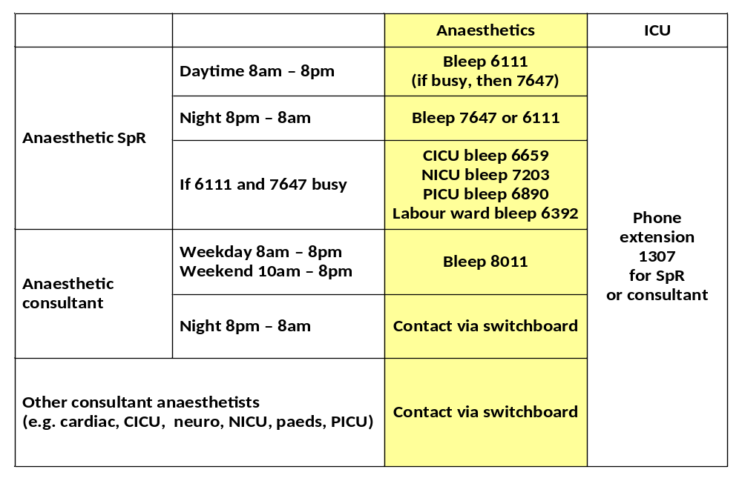

 |  | BLEEP | Extension
Jacqui Bishop | Matron | 7390 | X 2988
Robin Davies | Practice Educator | 7193 | X 1497
Steve Price | SJW | 7194 | X 2921
Donna Sayers | Cardiac & Neuro | 7195 | X 4600
Steve Price | Lanesborough / paeds | 7194 | X 2921
Allan Angold | AET / PCT | 7197 | X 1972
CEPOD/ anaesthetic co-ordinator |  | 8425 | X 2485
AET |  | 6999 | X 1972
Obs |  | 6650 | X 2529 / 6065
Neuro |  | 6400 | X 2485

AET 24hours cover is by the AET consultant. However, the AET consultant covers the orthopaedic trauma list at the weekend (10am-5pm)

Therefore, at weekends between 10-5pm, AET cover is provided by:

- 8011 bleep holder will co-ordinate cover

    - 8011 may be carried by either the CEPOD or general on call consultant.
    - A bleep on order for the AET consultant and help communication

- Response to “Damage Control Surgery” (DCS) that needs to go to surgery include

    - 6111 or 7647 as first responders to A&E
    - 8011 to co-ordinate (along with the AET bleep holder)
    - Other specialties called in as necessary and depending on work load and priorities (cardiac, general, neuro, paeds)

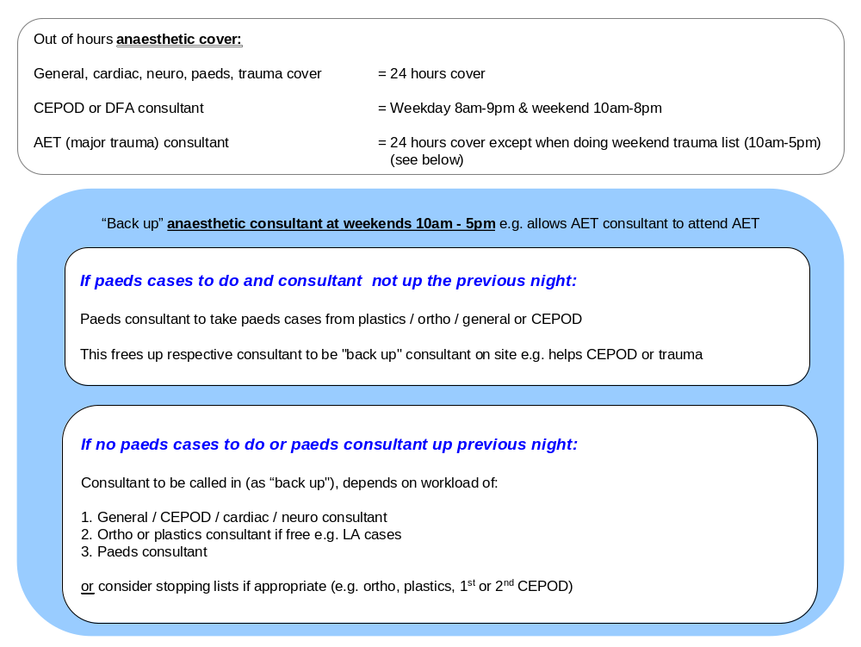

Emergency Anaesthetic Practitioner: Standard Operating Procedure
(January 2012)

Purpose
The purpose of this standard operating procedure (SOP) is to provide clear guidance on the role of the Anaesthetic Practitioner (AP) when responding to an emergency call at St Georges Hospital.
Background
The emergency AP will respond to the following emergency calls 24/7 activated by either switchboard, Anaesthetic SpR (6111 or 7647), Duty floor anaesthetist (8011), Anaesthetic Coordinator (8425), O.C Anaesthetic Consultant or O.C theatre manager (SG253);
- Adult & Paediatric trauma calls
- Adult & Paediatric cardiac arrests
- Heart attack team
- Any Fast Bleeps requesting an anaesthetist
- Acute Emergency Theatre (out of hours)
- Additional acute emergency theatres (e.g 2nd Obstetric theatre, 2nd emerg neuro case)
The role of the emergency AP attending emergency calls outside of the operating theatres is to support the anaesthetist in the initial resuscitation, stabilisation and transfer of critically ill patients. This role is not replacing any existing team members merely complimenting an already well established and effective service. The AP will be an experienced Operating Department Practitioner or Anaesthetic Nurse with appropriate resuscitation training.

Guidance
- On arrival at the emergency the AP will assist the anaesthetist with the management of the patient’s airway and assist to ventilate the patient. If the AP arrives before the anaesthetist they should commence (or assist the most appropriately skilled practitioner) with airway management and ventilation, working within their scope of professional practice at all times.
- The AP will assist in the gaining of IV, IO or central access and any additional resuscitation / stabilisation required.
- The AP will remain with the anaesthetist for as long as is required – normally until transfer to definitive care or relieved by ICU staff.
- The AP will wear their I.D badge at all times.
- Transfer bags and supplementary equipment will not normally be carried to an emergency call except in the following circumstances;
- Major Trauma Call
- Emergency call to a non-clinical location
- Specific requests for anaesthetic assistance in locations where anaesthetic equipment will not be readily available

Escalation
There will be occasions when the emergency AP is already dealing with an emergency and unable to immediately respond.
In this situation there will be a clear chain of escalation to follow, during normal working hours 08:00 – 17:00 this process is as follows:-

Lead ODP from appropriate Wing or area (see above for bleep number)
Clinical Theatre Manager Bleep 7869

In the unlikely event that both of these people will be unavailable at the same time then the on-call anaesthetist bleep 6111 and Duty Floor Anaesthetist bleep 8011 should be informed and a contingency plan made.
Out of hours 17:00 – 08:00 and weekends there should always be an Emergency AP available to respond to emergency calls, calling in further practitioners as necessary (see theatres on call SOP for further details). If the Emergency AP is unavailable then the Anaesthetic Coordinator should be informed and an available AP asked to attend. In the unlikely event of all six on call AP’s being unable to attend the on call consultant anaesthetist and theatre manager should be informed and a contingency plan made.

Post emergency actions.
- On returning to their normal place of work the AP who attended the emergency should fill in the emergency book stored in PCT1 with the following details;
  - Time of call
  - Time of arrival
  - Location of call
  - Nature of call
  - Brief details of events avoiding confidential data
  - Outcome
  - Time available to respond again

Additional Daily Duties
- Hand over: Equipment/Drug issues
- Check: Difficult Airway Trolleys A+E
  - PCT
  - St James
  - Lanesborough
  - Neuro
  - Cardiac
- Cath Lab (Heart Attack Trolley)
- Rapid Sequence Intubation drugs
- Check AET bags (adult / paed)
- Check transfer bags (adult/paed)
Document Title: Emergency Anaesthetic Practitioner (Cardiac Arrests)

Author: Allan Angold, Anaesthetic Team Leader
Vincent Bennell Advanced Practitioner
Anna Mayes Advanced Practitioner
Nigel Mahepath Advanced Practitioner

Approved by: Rob Griffiths – Clinical Theatre Manager Anaesthetics
Dr Patrick Wong – Ex Care Group Lead Anaesthetics

Staff Support

Working in a very busy Teaching Hospital can sometimes lead to a lot of pressure that is difficult to cope with. Please talk to one of us as a colleague or friend, or as a mentor, specialty lead or Care Group Lead. For trainees there are the College Tutor, Programme Director and Regional Advisor who are happy to help and advise.

For outside help please visit:

http://www.aagbi.org/sites/default/files/welfare_resource_pack_2008_0.pdf
Below are a number of schemes that may be able to help you with your problem. If these schemes do not address your problem and you would like to Ask AAGBI please call 020 7631 1650 or email wellbeing@aagbi.org and you we will do our best to put you in contact with an appropriate advisor.
At St Georges Healthcare NHS Trust
Heather Beeston – Staff Support on ext 3368
Sick Doctors Trust  (For those with dependency problems 0370 444 5163) | Web Link »
BMA – Doctors Health and Wellbeing  24 hour telephone counselling 08459 200 169 | Web Link »
BMA – Resources for doctors in difficulty | Web Link »
Doctors Support Network | Web Link »
Mednet  Consultation service covering London and KSS Deaneries 0208 938 2411) | Web Link »
Practitioner Health Programme | Web Link »
Samaritans 08457 90 90 90 | Web Link »
British Doctors and Dentists Support Group  (for those with a dependency problem 0779 2819 966) | Web Link »

Leave

The following guidelines are necessary to ensure equity in granting leave requests whilst maintaining an adequate clinical service. This is now processed on the electronic CLW system.

- Approval of annual leave will not be unreasonably withheld, although the approval of annual leave is subject to the needs of the service.
- “First come, first served basis” … So be organised!
    - Trust policy encourages booking summer annual leave before 31st January for priority consideration!
    - Advanced booking up to one year
    - Leave should be booked as far in advance as possible, especially for high demand periods
- Bookings:
Need minimum  6 weeks notice | Request generally guaranteed provided maximum numbers  of staff away are not exceeded
< 6 weeks notice | Request granted if there are no uncovered lists and enough double-ups
< 2 weeks notice | Request denied except in exceptional circumstances
If leave is refused, then please ask colleagues to swap

- To maintain service, the maximum leave (all types) allowed on any given day are:

Whole Department | 20 Consultants
Specialty group | 4 Consultants
General group | 8 Consultants
The above will be reviewed when the new e-roster CLW is in place.

- Leave will be limited to a maximum of 3 weeks during peak periods (as discussed at SDU meeting on 10/2/11)
Peak period
Summer months | 1st June – 30 September
Easter and the  Christmas/New Year period | Easter  1st December – 31st January
Half terms | Usually 3rd/4th week October  3rd week February  Last week May

- Leave of more than 3 weeks during peak periods can be managed by asking colleagues to do your DCC lists and you ‘pay back’
- No study or profession leave during peak periods (only Easter, July & August, and Christmas) – this will allow more consultants to go away on annual leave
- PL will be given for Deanery related leave (e.g. ARCP, interview days, etc.) at the discretion of the CGL
- If you do not appear on the rota in any given week, it counts as a week’s leave
- Unpaid leave
    - Please refer to Trust policy depending on the type of leave.
    - This is usually only available after annual leave entitlement is exhausted and is at the discretion of the Care Group lead

Annual Leave
- At least three weeks leave must be taken as full weeks each year
- Maximum three weeks leave may be taken consecutively
- Maximum 10 half-days in any year (pro-rata for part-time staff)
    - You can only take a half day off if you are working a whole day of DCC
- Maximum 5 days in any year may be ‘carried over’ to the next leave year
- Both SPA time and DCC time to be booked as leave i.e. half-day leave from DCC with SPA time for the rest of the day counts as 1 day’s leave. Similarly for a week’s leave

Professional/Study Leave (please see Appendix for conclusions following SDU meeting 10/2/11)
- Maximum 30 days in 3 years (10 days/year on average)
- Ratio of Study to Professional Leave is not fixed at 50:50
- Study Leave requires approval by CD as well as CG lead so allow more time for request
- Only 4 consultants from a specialty group allowed Study Leave for same conference
- Only DCC time need be booked as leave
- A review of study leave during previous year to be included in everyone’s appraisal
Sick Leave
- Inform bleep 6111/8011 and office staff initially
- Provide office staff with regular updates, especially when you expect to return otherwise you will be recorded as still absent
- Doctor’s certificate required for absence >7 days (NB not just working days)
- ‘Back-to-work’ interview with CG lead necessary after prolonged (>4 weeks)/repeated absences
- A review of sick leave during previous year may be included in appraisal
Carer’s Leave
- … “This is time off work to deal with certain unexpected or sudden emergencies involving a dependant, and to make any necessary long term care arrangements. Paid leave will normally be granted on the day the emergency arises, and any remaining leave will be annual leave or unpaid leave.”
- At the discretion of the CG lead, a maximum 6 days may authorised by the Care Group Lead
- A review of carer’s leave during previous year may be included in appraisal
Paternal Leave
- Maximum 10 days
- Give as much notice as possible
Compassionate Leave
- Maximum 6 days
- Further leave (annual or unpaid) at the discretion of the CG lead
Parental (unpaid)
- At the discretion of the CG lead
- Taken in blocks of a week at a time to a maximum of 4 weeks in any one year
- Will not normally be granted unless full annual leave quota for year has been used up
- … “A request to take parental leave will only be deferred if the manager can demonstrate that it would be disruptive to the service” [i.e. during peak periods]

Additional comments
CG Lead (and/or office staff) must be informed of private arrangement between consultants for one to cover another’s clinical duties in order for latter to take leave at short notice.

Requests for exemption from any of the above guidelines should be discussed with the CG Lead

Sick leave – it is important that you read the Trust’s policy on sick leave

Please read in conjunction with full policy:

http://stginet/Procedural%20Documents/Staff%20related/General_Employment/HR_2_12sick_abs.pdf

Length of sickness | Policy statement
All sickness | Managers should conduct return-to-work interviews every time an employee returns from any episode of sickness absence. The interview should be brief and conducted on the day the employee returns to work or as soon as practicable.  The purpose of the interview is to establish the reason for absence and check that the employee is fit to return to work. It is also an opportunity for the manager to provide an update on any developments within the team /department  At this meeting the self certificate should be completed. This will help establish whether any steps or additional support can be given to help employees maintain their fitness for work. If the employee’s attendance record has started to cause concern, the manager should counsel the employee that further action may be considered.
Up to 7 days | Complete a Self Certificate (Short Term Sickness Absence Record Form) at the return to work interview.  A self-certification form will be required from the first day of absence and days not normally worked are included in the absence period. The form will be signed by the manager and a copy given to the employee. The original will be kept by the manager and a copy put on the employee’s personal file.
More than 7 days | For longer periods of sickness (more than 7 calendar days), in addition to the Self Certificate (Short Term Sickness Absence Record Form) for the first seven calendar, absence from the eighth calendar day must be covered by a doctor's certificate.  The employee should contact the manager on the day the certificate has been issued to confirm the period the certificate covers and the certificate should be sent to the manager within 6 calendar days from the date of signing by the medical practitioner.  Medical certificates are only valid from the date they are signed by the medical practitioner. Retrospective certificates will not be accepted and any gaps between certificates will normally be regarded as unpaid unauthorised absence. The manager will retain a copy and forward the original certificate to the employee.

Persistent Short Term Sickness Absence
As a guideline, unacceptable absence includes:
- 2 absences on separate occasions during a three month period
- 3 absences on separate occasions during a six month period
- 5 absences during a period of twelve months
Stage 1  7 days notice of meeting with right to be accompanied  Copy of attendance record.  Monitoring period. | - No OH normally attend (unless occupational significance).  - If satisfactory, then no need to proceed to stage 2. If absence deteriorates again within 3 months of the end of the monitoring period, then this procedure will be reinstated at Stage 2.  - If unsatisfactory but improvements then extend monitoring period.  - If remains unsatisfactory then stage 2.
Stage 2  7 days notice of meeting with right to be accompanied  HR advisor normally in attendance  Further monitoring will be set.  The employee will be formally cautioned that continuation of unacceptable attendance may result in termination of employment due to lack of capability on the ground of ill health. | - If satisfactory improvement has been achieved and the case need not to proceed to stage 3 – if absence deteriorates again within 9 months of the end of the monitoring period, then this procedure will be reinstated at Stage 2.  - If unsatisfactory but some improvement has been made, it may be appropriate to extend the monitoring period rather than proceed to stage 3.  - If unsatisfactory, then stage 3.  If the manager decides to refer the case to stage 3 of the procedure, an OH will be requested before the stage 3 meeting takes place. Written permission may be requested of the employee to enable the OH Department to obtain a report from the GP. Occasionally, employees may be required to attend for medical examination by a Medical Practitioner nominated by the Trust.
Stage 3  A hearing will be set up by the appropriate designated officer with authority to dismiss.  7 calendar days notice of the hearing and informed in writing of the purpose of it and of the right to be accompanied (not a Trade Union Representative or work colleague), for example, a family member.  Medical report from HR  The employee will be informed that the hearing may result in termination of his/her contract on the grounds of lack of capability due to ill health. An HR Advisor will normally be present at this meeting. | The designated officer may decide:  - Further monitoring period  - Termination of contract of employment  - Redeployment to appropriate alternative employment

Long term sickness is defined as any period of sickness absence longer than four weeks.
See Policy for management
- If no occupational relevance, advice from OH re: referral
- Maintain contact – meetings after 4 weeks
- If return date unknown – refer to OH
- Review meeting at SGH(ascertain return to work date) – or at home or written statement
- 7 days notice and right to be accompanied
- Further sickness review meetings

Monitoring period - 3 months (shorter or up to 6 months)

Managers should seek early advice from Human Resources whenever an individual’s attendance gives cause for concern.

The level of absence that is regarded as unacceptable will depend on the employee’s general attendance record and the manager should consider all the circumstances before deciding whether or not to use the stages of this procedure as set out at 17.2.1 and onwards below. As a guideline two absences on separate occasions during a three month period; three absences on separate occasions during a six month period or five absences during a period of twelve months would normally be regarded as unacceptable.

However, the fact that a “trigger” has been breached does not in itself mean that the stages of the procedure will automatically be invoked. Unacceptable level of absence may also include any unusual pattern of absence such as recurrent absences on particular days such as Mondays and Fridays or just before or just after holidays. When an employee's record is considered unacceptable, management will review the situation in accordance with the following procedure.

Leave For Trainees

Annual Leave
Entitlement
Your entitlement to annual leave at ST3-4 is 27 days per annum and at ST5-7 level is 32 days per annum. Clinical fellows are entitled to a similar amount of leave, depending on which tier of rota they are working.

All annual leave should be taken during your attachment to St. George’s Hospitals. So please arrange it early.
- If you can not fit your leave in without disrupting service (2 away per block), then you may forfeit your leave.
- There is no “pay in-lieu” of annual leave that has not been taken.

Procedure
A maximum of 10 days may be taken during any three-month module. Registrars should liaise with each other to arrange internal cover for annual leave.

Adequate cover during each module/block is essential. Adequate cover requires that two registrars are available within each block, each working day. This usually means that no more than two registrars may be on annual leave at any one time.

Please note:
- Requests for annual leave should be submitted at least six weeks in advance.
- For the 2 weeks around Christmas and New Year, please re-allocate the days/extended days/nights on-call evenly between all the trainees. This will prevent one trainee doing all the bank holiday shifts.
- No annual leave is normally granted in the two weeks immediately preceding the FRCA examinations.
- Only in exceptional circumstances may these rules may be modified.

Study Leave

Entitlement
All ST’s may receive up to 30 days study leave per year, or 15 days if at St. George’s Hospital for six months.

Procedure
Study leave is granted for official meetings, approved training courses and examinations. Study leave and expenses are not automatic. Consideration is given to the type of course, amount of expenses requested and the service commitment of the department. Study leave is internally covered, so liaison with colleagues is vital.

On call rota
Revised 14/06/10
 | Mon | Tue | Wed | Thurs | Fri | Sat | Sun | Hours
1 | ED | ED | - off - | - off - | ED | ED | ED | 65
2 | - off - | - off - | NIGHT | NIGHT | - off - |  |  | 26
3 | Day | Day | ED | ED | - off - |  |  | 45
4 | Day | Day | Day | - off - | NIGHT | NIGHT | NIGHT | 67.5
5 | - off - | - off - | Day | Day | Day |  |  | 28.5
6 | NIGHT | NIGHT | - off - | - off - | Day |  |  | 35.5
7 | Day | Day | Day | Day | Day |  |  | 47.5
8 | Day | Day | - off - | Day | Day |  |  | 38
9 | Day | - off - | Day | Day | Day |  |  | 38

Day 08:00-17:30 = 9 ½ hours
ED (Extended day) 08:00-21:00 (12 hours + 1hour hand over) = 13 hours
NIGHT 20:00-09:00 (12 hours + 1 hour hand over) = 13 hours

PICU ED (Extended day) 08:30-21:00 (12 hours + ½ hour hand over) = 12 ½ hours
PICU NIGHT 20:30-09:00 (12 hours + ½ hour hand over) = 12 ½ hours

For the 2 weeks around Christmas and New Year, please re-allocate the days, extended days and nights on-call evenly between all the trainees (otherwise one or more trainees will end up doing most of the bank holidays)

8 week rota
- Basic hours = 353
  - Add 2hour/wk for PC = 369
  - Average hours/wk = 46.1 hours
- Training days (incl ED) = 23
  - Deduct 9 days A/L = 14 days for training (1.75/wk)*

9 week rota
- Basic hours = 391
  - Add 2hour/wk for PC = 409
  - Average hours/wk = 45.4 hours
- Training days (incl ED) = 27
  - Deduct 10.5 days A/L = 16.5 days for training (1.8/wk)*

      - This does not take into account any ‘training’ during weekend extended days.

Please contact HR for their calculations of EWTD compliance Emma.Barrett@stgeorges.nhs.uk)

Part time trainees – 10% equivalent calculations

1 in 8
- Days = 18 per 8 weeks = 2.25 per week
- Extended days = 7 per 8 weeks = 0.87 per week
- Nights = 7 per 8 weeks = 0.87 per week
- Week days off = 12 per 8 weeks = 1.50 per week

- Each 10% equivalent per 26 weeks (6 months)
    - Days = 10% of (2.25 x 26 weeks) = 5.85
    - Extended days = 10% of (0.87 x 26 weeks) = 2.26
    - Nights = 10% of (0.87 x 26 weeks) = 2.26
    - Week days off = 10% of (1.50 x 26 weeks) = 3.9

1 in 9 (if available)
- Days = 22 per 9 weeks = 2.44 per week
- Extended days = 7 per 9 weeks = 0.77 per week
- Nights = 7 per 9 weeks = 0.77 per week
- Week days off = 13 per 9 weeks = 1.44 per week

- Each 10% equivalent per 26 weeks (6 months)
    - Days = 10% of (2.44 x 26 weeks) = 6.34
    - Extended days = 10% of (0.77 x 26 weeks) = 2.00
    - Nights = 10% of (0.77 x 26 weeks) = 2.00
    - Week days off = 10% of (1.44 x 26 weeks) = 3.74

Annual leave 100% trainee = 32 days per year = 16 days in six months
70% trainee = 11 days in six months

Study leave 100% trainee = 30 days per year = 15 days in 6 months
70% trainee = 10.5 days in 6 months

Trainee Assessments
See below for induction of new trainees.

All trainees will be assessed at intervals by the College Tutors, who will have consulted with the Educational Supervisors, Module Directors and other consultant colleagues. These formative assessments allow trainees to discuss their progress, and educational needs. All ST’s will be given a copy of their assessment. It is essential to keep these safe. Trainees will be asked for these copies at the yearly RITA/ARCP process. Inability to do so will result in failure to progress to the next stage of training.

Tutorials and meetings
There is a weekly departmental clinical meeting at 8am. This rotates every 3 months i.e. on Tuesday (January to March), Wednesday (April to June), Thursday (July to September) and Friday (October to December). Attendance is compulsory for trainees and theatre lists start at 9 am to allow for this. Additionally, there is a programme of protected teaching for all ST3-4 and ST5-7 which comprise of all day teaching days held at various hospitals around the region. A full programme will be distributed to you throughout the year.

Library facilities
The Medical School Library contains a large number of books on anaesthesia, and has both current and past copies of all the major journals. Application for a borrowing card can be obtained from the Library Reception desk. Copies of all the ‘Recommended Reading’ for each module are available in the Library.

Audit
All trainees will be expected to become involved in an audit project during their time at St George’s. The Clinical lead for audit can give advice on projects. The Trust runs a Clinical Audit half day once a year where audit posters can be presented.
Please contact Dr Chan Luong with any queries and to ensure there is no audit crossover.

Induction and new trainees
As part of your induction in anaesthesia, you will be supervised during the first 8 lists (or on call shifts). The information we obtain from your supervised practice will help us build on your strengths and address any weaknesses. All forms must be handed in to Mark Edsell (Care Group Lead) who will scan and forward the forms to you (for your portfolio) and to your Educational Supervisor.

Trainee
Grade of trainee
Educational Supervisor
Date of last training | ILS | Date :
Date of last training | ALS | Date :
Date of last training | PILS | Date :
Date of last training | APLS | Date :
Date of last training | ATLS | Date :
Date of last training | Anaesthetic machine use | Date :

DATE:
CONSULTANT NAME:
LIST / ICU / ON CALL SHIFT:
APPRAISAL:
1= below expectations, 2 = borderline, 3 = meets expectations, 4 = above expectations, U = unable to comment

Preop assessment/
clinical judgement
Punctuality / organisation
Anaesthetic plan
Anaesthetic record
Technical ability
Hygiene
Ability to work under stress
Vigilance and
situational awareness
Postop plan
Consideration of patient
Team working
Overall ability
[Form will have a box for “Additional comments”]

Clinical Work

WHO checklist
The WHO checklist is mandatory.

Patients must not leave the wards unless their consent forms have been signed.

In summary the five steps are:

- Briefing
    - To ensure the whole team understand the plan (Surgeon, anaesthetist, ODA and theatre staff to be present)
- Sign in – before the patient goes to sleep
    - Anaesthetist and ODA to confirm patient’s identity, consent form is signed and correct side marked, prior to induction of anaesthesia. (There is of course no reason why you couldn’t ask the surgeon to be present in addition at this stage if you felt it would be beneficial.)
- Time out
    - A period where the whole team stops what they are doing (takes a time-out) just prior to starting the operation and RE-checks the patient details along with the radiology, instruments etc.
- Sign out
    - Before any team member of the team leaves the operating theatre, to ensure swabs and instruments are correct
- Debriefing
    - Try and identify problems which have occurred during the day and prevent them from reoccurring
    - Whole team present at end of list

http://www.nrls.npsa.nhs.uk/resources/clinical-specialty/surgery/?entryid45=59860

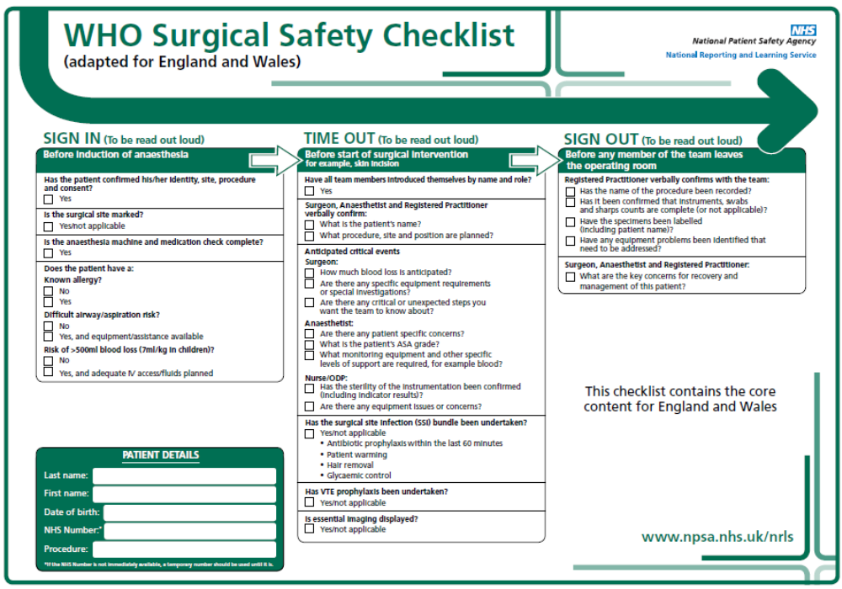

Moorfields WHO checklist (additional)
Moorfields Hospital has operating lists on LW l5 theatres. They have the following protocols:
SDU Jan 2011:

- All patients are marked, and are not permitted to enter theatres from the ward without marking with indelible ink.
- All cases should have a full “Time-Out” procedure as per the WHO forms. This has recently been extended to all intra-ocular injections.

Patient Safety and Training
London Deanery, January 2009

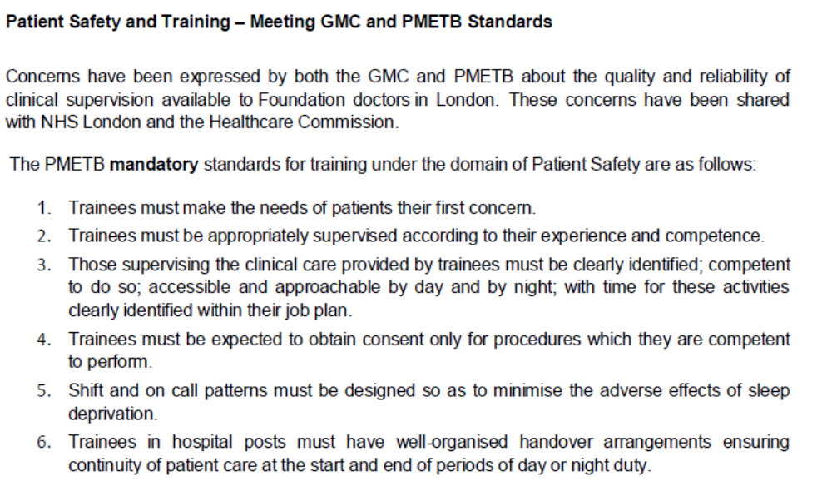

Anaesthetic Machines

All trainees MUST have anaesthetic machine training: “Checking anaesthetic equipment”, AAGBI 2011

This will be organised during induction week

If you have missed training then you must arrange for it to take place as soon as possible. Please contact Dr Suite with regards to machine training.

Types of machines
- Draeger Perseus A500 inside all theatres
- Draeger Fabius GS in anaesthetic rooms
Vapourisers are not compatible between the two!

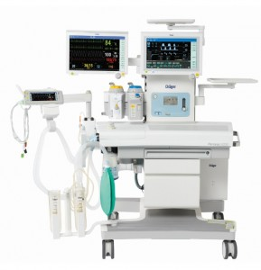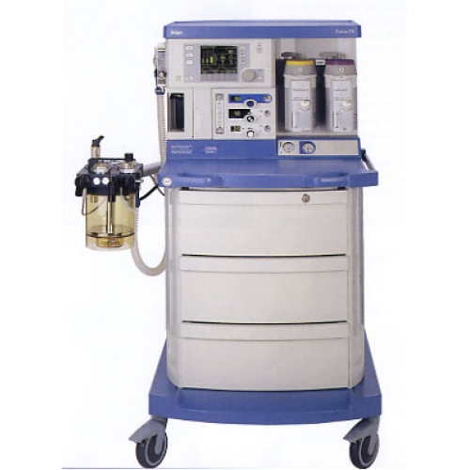

Clinical work (other points)

(1) It is preferable that the anaesthetist doing the list should see the patients pre-operatively or otherwise be fully informed about their patients. Pre-operative assessment is an important part of junior staff training and those working with a consultant will be expected to have seen the patients on the list and inform the consultant.

(2) Trainee Anaesthetists should arrive prior to the start of routine lists. They should check all equipment to be used. It is the anaesthetists’ responsibility to draw up drugs in the anaesthetic room.

(3) It is totally unjustified for an anaesthetist to leave a patient in the operating theatre except under extreme circumstances. This must not happen for tea breaks and the taking of telephone calls.

(4) Trainee anaesthetists should try to visit all their patients postoperatively. This is an invaluable teaching aid and allows anaesthetic morbidity to be assessed.

(5) Trainees who have no allocated lists or whose list finishes early must contact the DFA before leaving the hospital.

(6) Cardiac arrest bleeps must always be carried by someone and not left in the anaesthetic office or with some third party. If the night on-call person has to leave early in the morning to attend a course the person relieving them must arrive appropriately early.

(7) Please be aware that whilst in CT Scanning Room, bleeps may not work. Cardiac arrest bleeps should be left with another anaesthetist if you are going to the CT scanner. They then have responsibility to attend cardiac arrest and trauma calls.

(8) If a patient requires admission to the HDU or ITU, the anaesthetist involved should inform the duty ICM Registrar to provide continuity of care.

(9) Unexpected HDU/ICU admissions or unexpected morbidity/mortality should be reported as an “Adverse incident” (AI) on the Datix intranet system.

(10) All problems can be referred to the 8011 or on call consultant. No case should be refused anaesthesia without prior discussion with a Consultant.

(11) Consultants must be informed of seriously ill patients, difficult airways, paediatric cases, political issues (e.g. member of staff or prominent public figures), or if a consultant surgeon is operating.

(12) The ST on call for labour ward must be available to deal with obstetric emergencies at any time and must not be re-deployed to casualty or other duties.

      - The Anaesthetist carrying bleep 6111 must assist with intubation in ITU if requested to do so as an anaesthetist does not always cover the unit.

Inpatient Acute pain team

A team of consultants, clinical nurse specialists and pharmacists runs this service.

Consultants: Drs Jerry Cashman, Rick Kennedy, Sonia Mongia and Lenny Ng
Clinical Nurse Specialists: Kim Green, Rozanna King, Alison Moss and Steph Vialva
Pharmacist: Joanne Peh, Sarah Qureshi

The role of the team is to provide specialist advice on any problem concerning the management of acute pain.

P.C.A. (Patient Controlled Analgesia) service is well established in all surgical areas. The team provides supervision and training for medical and nursing staff. Protocols and observation charts are available in all surgical wards and departments.

At present an epidural analgesia service is available for obstetrics. The postoperative epidural service for selected surgical wards is currently under review. Until further notice epidurals for postoperative pain relief should be managed in Intensive Care Units only. Protocols and observation charts are available in all relevant surgical wards and departments.

Experience has shown that prescribing guidelines are essential for the implementation of effective pain relief programmes. Pain Guidelines can be found on the Trust intranet site.

The Acute Pain Team may be contacted on bleep 6477/6159 during normal working hours for advice or information.

Updated guidance for going to HDU or ICU (01/01/15)
Please connect PCA and epidurals to patients going to HDU or ICU prior to transfer from theatres. ODPs will obtain the relevant pumps from theatre recovery and these must be connected to the patient before leaving theatre.

Hospital Protocols
These can be found on the intranet
http://stginet/Units%20and%20Departments/Anaesthetics/Protocols.aspx

The St. George’s Grey Book (est 1979) is available on the intranet and is a mine of information for that that lies outside the FRCA syllabus; unbelievably we don’t know everything.
http://stginet/Publications/Clinical%20Publications/The%20Grey%20Book.aspx

Guidelines for Adult Pre-operative Investigations
The following guidelines are to be used as a supporting document to those issued by NICE (2003). Your speciality may have protocols agreed by surgeons for additional tests and these will continue to be followed.
http://stginet/Units%20and%20Departments/Anaesthetics/Documents/Reports/Guidelinnes%20PRE-OP%20JO.doc

FBC  Refer to consultant if Hb <10  Refer to GP if Hb 8-10  Critical values  Hb <7 >20  WCC <2 >30  Platelets< 100,000 | Adults | Women of childbearing age or > 60 yrs  Men > 60 yrs
 | Baseline | Adults where there is likely to be significant blood loss i.e. major vascular surgery or thoracic surgery
 | All patients with: | Significant CVS/RS disease  Sickle cell/haematological disease  Bowel disease  Liver/Renal disease  Osteo/rheumatoid arthritis  Diabetes  Connective tissue disorders e.g. SLE  All Jehovah’s Witnesses* (see below)
NB Repeat Hb if there is likely to have been a significant change since last result, i.e. bleeding.

U’s and E’s  Refer to anaesthetist if K <3.5 or > 5.5  Critical values  Na <130 >150  K <2.9 >6  Urea >28mml  Creatinine>400 | All patients with: | - 70 years of age  Significant CVS/RS including hypertension  Bowel disease/ liver disease/Renal disease  Diabetes  Connective tissue disorders e.g. SLE
 | Drugs | Diuretics / ACE inhibitors/ beta blockers  Steroids/lithium
 | Baseline | All operations likely to require large amounts of fluid/ blood replacement or those having major operations.

Clotting  Repeat all abnormal results. Refer to Haem Spr blp 6068 if results abnormal x2 | Family history | Parents or siblings with bleeding disorders
 | Liver disease | E.g. chronic liver disease, metastatic liver disease, hepatitis, high alcohol intake
 | Known bleeding disorder | Refer to Haematology  – do not request clotting at pre-op clinic.
 | Chronic Renal Disease  Neurology | EGFR < 30 or on Dialysis / - under renal team  All pts for craniotomy for r/o tumour  All Jehovah Witnesses* (see below)
Sickle Test  Electro-  phoresis | All afro-Caribbean and mixed race patients without documented test results.  All patients should be treated as sickle cell positive in the peri-operative area until the results are known .

Blood Sugar.  HBA1C  Refer to GP/Diabetic nurses  Hba1c >9%  random glucose >  15 mmols  fasting glucose >  9 mmols | All patients with:  Critical values  Blood glucose<2.2mmmols  Or > 25mmols check for ketones in urine. | Diabetes.  All pts on steroids  Large or “unusual abscesses”. 1st sign of diabetes.  Patients with known pancreatic problems (i.e. cystic fibrosis, ca pancreas, pancreatitis)  Patients who are symptomatic of diabetes.  Patients with BMI over 40

Group and Save
http://stginet/Units%20and%20Departments/Haematology/documents/REVISED%20PRE%20OP%20BLOOD%20ORDERING%20SCHEDULE.pdf

Always | All major surgery where blood loss is likely to be in excess of 1 litre.  See MBOS
Consider | All patients with clotting disorders  Obs and gynae procedures  Hx blood transfusions
Cross match early for to allow time to obtain suitable blood:
- Any patient who has had unusual antibodies in the past
- Patients who have had multiple transfusions in the past as they may have developed antibodies, which may make transfusion difficult.

Liver Function Test  Refer to consultant/anaesthetist  Bilirubin > 40  Albumin< 35 | Liver disease  CVS disease (significant)  Renal failure  Gall bladder, liver and pancreatic surgery  ↑ alcohol intake > 50 units per week  Cancer with risk of metastases

Endocrine Tests
Thyroid Function Test  Full Endocrine Screen | All patients who are clinically hypo/hyperthyroid.  In clinically euthyroid, treated hypo/hyperthyroid patients, tests need only be repeated if a recent test result is not available > 6 months.  Newly diagnosed AF  Patients taking amiodarone if last result older than 6 months  Neurology – all patients for pituitary surgery require  Thyroid function  Cortisol  Growth Hormone  Prolactin

Cardiac Tests
Disease | All patients > 60 years  CVS  Renal  Obesity  Diabetic  Thyroid disorders | Signs and symptoms  Signs and symptoms and/or biochemical evidence  BMI > 40 all age groups  All patients  Clinically hypo/hyperthyroid
Disease | Drugs | Digoxin and other anti arrhythmics  Diuretics  ACE inhibitors  Beta blockers

Echo | All patients with  Neurology | An undiagnosed heart murmur.  Known CHD and decline in cardiac function.  See echo dept guidelines  All patients for craniotomy in sitting position require bubble contrast echo

Chest X-ray | Routine: | It is not necessary to do a routine CXR on any patient whatever their age.  Patients who have stable disease do not require a CXR, if they have had one in the last 12 months and it is available.
Disease | CVS  RS  Renal  Cancer  Kyphoscoliosis  RA  Connective Tissue Disorders  Type of surgery | Signs or symptoms  Heart murmur  Signs or symptoms  Signs of symptoms or biochemical evidence  Lung metastases suspected and no CT or MRI available.  May have lung disease  Thoracotomy
BASELINE: For those undergoing major surgery, especially if it is intra-thoracic/ upper abdominal.
Need to have full report by radiologist
Spirometry/ Lung Function Test | Asthmatics with hx recurrent bronchospasm  Patients with COPD/COAD  Signs or symptoms of respiratory problem  See Respiratory Assessment Protocol

Abbreviations
AF – Atrial fibrillation
COPD – Chronic Obstructive Pulmonary Disease
CVS – Cardio-vascular system
OA – Osteo-arthritis
RA – Rheumatoid Arthritis
RS – Respiratory system
SLE – Systemic lupus erythematosus
WCC – white cell count

Acknowledgements:
Dr Jane McNeill, Consultant Anaesthetist Barts and the London NHS Trust.
Drs Gill Farnsworth, Jane Stanford, Mark Farrar, Susan Hutchinson, Judith Dinsmore Consultant Anaesthetist, St Georges Hospital, Tooting

Bibliography

Cashman J, N (2001) Pre-operative Assessment; London ;BMJ

National Institute for Clinical Excellence (2003) Pre-operative Tests London: NICE

Interpreter Service

Patient Advice and Liaison Service

Interpreting and signing guidance
“Whenever possible we should not rely solely on, or expect family members or staff to interpret or sign for patients (In an emergency this may be necessary).”
- The information below is designed to provide staff with options for different types of support, some that need to be booked in advance and some that are available 24/7.

If you have any queries, please contact PALS. Out of hours please contact the site management team.
If your require an interpreter for a patient, there are 3 options available to you
- Face-to-face
- Telephone
- Sign language interpreting
Face-to-Face Interpreting Services
Please note this service is not available out of hours and must be booked in advance. A minimum 3 days notice is required for this service, ideally 5 working days.

Face-to-Face Interpreting Services provided by Merton, Sutton & Wandworth Language Support Service

Step 1: Fill in the booking form. To download and print a copy, click here
Step 2: Email the booking form to interpretingservice@nhs.net or fax it to 020 3317 2940

If there are difficulties with the booking, or you wish to cancel it please contact the service: 020 3 317 2933

Telephone Interpreting Services
Please note this service is provided by Language Line and is available 24 hours, 7 days a week. Here are some steps to guide you through the process.

- Locate your department ID click here [or see appendix]
- Ring 0845 310 9900 and the operator will ask for
- ID code
- Organisation name (and department where appropriate)
- Initial and Surname
- Required Language (say if you need a specific interpreter. e.g. for a female interpreter)
- Client’s location (Give telephone numbers you wish connected)
- Stay on line while the operator connects you to a trained interpreter
- Note the interpreter’s ID code
- Introduce yourself and brief the interpreter.
- Say what phone you are using e.g. single/dual hand set, mobile, speaker phone. Ask the interpreter to introduce you and themselves to your client, and then give the interpreter your first question or statement
- Give the interpreter time to interpret between you and your client
- Continue the conversation
- Let your client and the interpreter know when you have finished

British Sign Language (BSL)

Please note the British Sign Language service should be booked in advance. However there is an emergency service available from RAD. There are a number of providers you can access. However the Royal Association for Deaf People (RAD) is our preferred supplier.

For the RAD booking form click here .

For further information including the RAD 24hr contact number for the emergency service, pricing and a full list of BSL providers click here .

Please note all BSL interpreting services will need to be paid for directly from your department budget.

Jehovah’s Witnesses

For AAGBI 2005 JW guidelines:
http://stginet/Units%20and%20Departments/Haematology/documents/ANAESTHESIA%20FOR%20JEHOVAS%20WITNESS%20PATIENTS.pdf

For Trust JW guidelines:
http://stginet/MeetingsandMinutes/PSC/Agenda%20Papers/2009/Nov09/150.doc

Pre-operative Care
Comprehensive pre-operative assessment of the patient and early anaesthetic involvement and review are essential for patient undergoing surgery but refusing blood transfusion. In high-risk procedures, it should also involve the Consultant Haematologist or Transfusion Practitioner and the Surgeon Assessment should include review of previous surgical procedures and any underlying medical complications.

The fact that a JW patient requires an elective operation must be ascertained and communicated to the ‘JW ad hoc team’ (see b below) at least 2 weeks (10 working days) before the operation date. Notification less than 2 weeks before planned surgery will lead to mandatory cancellation
- [see below for minor ops/day case procedures]
Responsible persons: (a) the patient (b) the surgical team.
Please note – before the assembly of the “Ad Hoc” Team the case MUST be discussed with the Consultant Haematologist or a nominated deputy to determine if the meeting is necessary. This decision will be based on the proposed surgery and risk to the patient.
b) Assembly of JW ad hoc team:
The JW ad hoc team consists of (a) Consultant Surgeon (b) Consultant Anaesthetist (c) Consultant Haematologist. The Consultant Anaesthetist is self-identified as prepared to accede to the JW patient’s beliefs and wishes. The Anaesthetic Office holds a list of appropriate anaesthetic colleagues. The ad hoc team must be instructed as soon as possible to allow diary space for all three to be cleared for the pre-operative meeting (see c below). The pre-operative meeting is then fixed with the JW patient and supporters. If such a meeting cannot be accomplished by 3 working days before surgery, or any of the key participants (a), (b) or (c) above + the JW patient cannot attend the meeting, surgery should be cancelled and the process begun again.
Updated 31/01/12

- ALL referrals for JW patients who require a pre op meeting must be sent to Abigail Brabyn – Abigail.braybyn@stgeorges.nhs.uk Ext 3545 (Secretary to Dr Uprichard Consultant Haematologist). The request will then be reviewed and the availability of the transfusion team will be forwarded to the referrer to arrange the meeting.

- With regard to minor ops / day case procedures – it is acceptable to assess these patients on the day of surgery with the surgeon and anaesthetist.

Ethical and legal issues for clinical management of JW patients including emergencies

Blood transfusion should be provided for life saving emergency surgery where there is no CLEAR advance decision applicable to the current presentation in which blood transfusion is refused.

In anaesthetics we already look for alternatives to transfusion and these alternatives should be documented along with the fact that there was no evidence that the patient would refuse blood in this particular situation.

If there is an advance decision and you feel it is applicable to the situation then this should be followed and documented.

I would include documentation of the views of the family and state these were considered in the decision which was made (even if the family views were not followed.)

Ultimately the decision should NOT be made by the anaesthetist alone but with the medical team so that it is a shared decision and I personally would also seek the opinion of a consultant colleague and the Trust Legal Team. All of above would demonstrate that you had tried to determine the best interests and not taken the decision lightly.

05/09/12
Dr Rehana Iqbal
Consultant Anaesthetist, Programme Director Foundation Year 2 and Lecturer in Medical Ethics & Law

Out of hours…
- Involve Consultant on call

- For further assistance (including out of hours) ask switchboard to contact:

- Firstly, Shanti Kelly (Legal Services Manager)

- Secondly, Bevan Brittan (Legal Advisor)

Fasting requirements for anaesthesia for inpatient elective surgery

WE NOW RECOMMEND THE MINIMUM FASTING PERIODS OF:

6 hours for solid food, infant formula or other milk
4 hours for breast milk
2 hours for clear non-particulate and non-carbonated fluids

ACCEPTABLE water, fruit squash, Ribena, black tea or coffee
UNACCEPTABLE Fruit juice, fizzy drinks, milk whether in hot drink or not

There is now evidence that patients benefit from continuation of their fluid intake up until 2 hours prior to ELECTIVE surgery and we should encourage them to drink up until that time.

EMERGENCY patients should still be starved from the time that surgery is booked with theatres. This may mean that they require intravenous fluids prior to surgery to prevent dehydration.

Individual anaesthetists may choose to alter the above regimen for a variety of reasons and it will be their responsibility to tell the relevant staff of their decision.

Delay in Surgery
If surgery is delayed for whatever reason no infant should be without fluid for 4 hours, or child for 6 hours. Ward nursing staff must ask the medical team responsible for the care of the child when surgery will be occurring and plan a feed or offer fluids to the child in accordance with the above guidelines. If the timing of surgery is unknown and the medical team wishes the child to remain NBM, consideration must be given to starting an intravenous infusion.

Please discuss with Dr C Johnstone if any concerns.

Guide to premedication
Primarily based on clinical assessment and indications, the following may be used:

Adults
Day Cases Not normally pre-medicated
Inpatients Not normally pre-medicated
If indicated: Temazepam 10 mg 2 hrs pre-op orally
Emergencies As for inpatients
Consult senior anaesthetist responsible

Children
Day cases AMETOP cream
Inpatients AMETOP cream
Consult senior anaesthetist responsible if oral pre-medication required:
Midazolam 0.5mg/kg (max. 20mg) 30 minutes before the start of anaesthesia or
temazepam 10mg (above 30kg)

Emergencies Consult senior anaesthetist responsible otherwise no pre-medication

• Pre-medication should be suitably modified to accommodate special circumstances, e.g. debilitated patients, compromised airway.
• Avoid administration by any route where absorption is likely to be delayed.
• If in doubt, cases should be discussed with the appropriate senior member of staff

N.B: Sedative pre-medication may be particularly desirable in the very anxious, those with limited understanding or learning difficulties. The anaesthetist is responsible for timing its administration and any alterations in the order of the list and must take account the necessary time interval for effective pre-operative sedation.

Endoscopy
There is a Drager ETCO2 pod, which is kept in the drugs cupboard in the main endoscopy procedure room. This attaches on to the Siemens portable monitor (kept in Lanesborough or James recovery), and there are nasal oxygen/capnography cannulae available in endoscopy so that you can monitor EtCO2 during ERCP procedures.

We are also due to get the adapted pennine mouthpiece attachment (invented by Dr P Keeling) which can be used as an alternative to the nasal cannula.

Please also be aware that we are also asked to provide anaesthetic services for OGD procedures, where conscious sedation has been unsuccessful. Some of these patients may have gastric outflow problems due to tumour/strictures so please consult with the gastroenterologists before the procedure so that you can make the appropriate choice of anaesthetic.

Patient Consent
SDU January 2012
http://www.rcoa.ac.uk/docs/GPAS.pdf
Information
- 7.5 Patients should be fully informed about the planned procedure.
- 7.6 All patients undergoing elective procedures should be provided with easily understood information materials covering anaesthesia and post-operative pain relief before admission to hospital.12,13
- 7.7 The anaesthetist should explain what the patient will experience before and after anaesthesia,8 and include any choices of anaesthetic technique and details of post-operative management.
- 7.8 The anaesthetist should invite and answer questions from the patient, or the patient’s relatives if appropriate.
- 7.9 The anaesthetist should document in the patient’s case notes that the above has been properly performed.
Trust Policy available here:-
http://stginet/Procedural%20Documents/Patient%20related/Patient_Management/Consent%20for%20Treatment.pdf

http://www.aagbi.org/sites/default/files/consent06.pdf
5.3.8 Information should be provided about:
- generally what may be expected as part of the proposed anaesthetic technique. For example, fasting, the administration and effects of premedication, transfer from the ward to the anaesthetic room, cannula insertion, noninvasive monitoring, induction of general and/or local anaesthetic, monitoring throughout surgery by the anaesthetist, transfer to a recovery area, and return to the ward. Intra-operative and postoperative analgesia, fluids and
- antiemetic therapy should also be described;
- postoperative recovery in a critical care environment (and what this might entail), where appropriate;
- alternative anaesthetic techniques, where appropriate. Patients do not have to agree to the anaesthetist's preferred anaesthetic technique;
- commonly occurring, 'expected' side-effects, such as nausea and vomiting, numbness after local anaesthetic techniques, suxamethonium pains and post dural puncture headache;
- rare but serious complications such as awareness (with and without pain), nerve injury (for all forms of anaesthesia), disability (stroke, deafness and blindness) should be provided in written information, as should the very small risk of death. It is good practice to include an estimate of the incidence of
- the risk [22]. Anaesthetists must be prepared to discuss these risks at the pre-operative visit if the patient asks about them;
- specific risks or complications that may be of increased significance to the patient, for example, the risk of vocal cord damage if the patient is a professional singer;
- the increased risk from anaesthesia and surgery in relation to the patient’s medical history, nature of the surgery and urgency of the procedure. If possible, an estimate of the additional risk should be provided;
- the risks and benefits of local and regional anaesthesia in comparison to other analgesic techniques;
- the risk of intra-operative pain, and the need to convert to general anaesthesia, should a proposed local or regional technique be inadequate or ineffective. The risks and benefits of adjunctive sedation or general anaesthesia should be discussed;
- the benefits and risks of associated procedures such as central venous catheterisation, where appropriate;
- techniques of a sensitive nature, such as the insertion of an analgesic suppository

Cepod booking
Feb 2013 (You will need to enlarge this document to 200% to read the booking protocol) (Only the very bravest should expose themselves to such expanded protocols)

Surgeon
Anaesthetist
Theatre Staff
Surgeon books case in Theatreman system.

NB - Bookings will not be accepted until all information has been provided.

Surgeon discusses case with Anaesthetist (6111) and Floor Manager
CEPOD case
Anaesthetist (6111) discusses case with CEPOD anaesthetist & DFA
Floor Manager reviews Theatreman booking and prioritises with DFA/Surgeons
Floor Manager informs DFA/ CEPOD anaesthetist, removes patient from list, and sends for next patient
Surgeon is informed of cancellation due to patient not being ready for surgery
If…
✗ Patient is not ready
✗ Patient is not consented
✗ Patient is not starved
✗ Operator is not available

If…
✗ Patient is not consented
✗ Patient has no blood results
✗ Patient is awaiting further diagnostic tests
Anaesthetist (6111) informs DFA/ CEPOD anaesthetist who removes patient from list
Surgeon needs to re-book the case
Surgeon
Anaesthetist
Theatre Floor Manager
Revised Booking Procedure for SJW Emergency Theatre
Anaesthetist (6111) reviews patient
Floor Manager and DFA allocate patient to 2nd CEPOD theatre or other theatre list where possible
Patient joins waiting list
Floor Manager sends for patient when at the front of the queue
Floor Manager to complete outcome on Theatreman

Surgeon
Anaesthetist
Theatre Staff
Referring clinician books case on Theatreman system

NB - Bookings will not be accepted until all information has been provided
Clinician discusses case with Anaesthetist (6111) and Floor Manager
Floor manager informs anaesthetic coordinator of case and requirements.
Urgent Anaesthetic Case requiring GA outside of theatre (ie MRI, CT or Endoscopy)
Anaesthetist (6111) discusses case with DFA
Anaesthetic Coordinator assesses staff availability and confirmes the time and date the case will be done.
Clinician is informed of cancellation due to patient not being ready for case
If…
✗ Patient is not consented
✗ Patient has no blood results
✗ Patient is awaiting further diagnostic tests
Anaesthetist (6111) informs DFA anaesthetist who removes patient from list
Clinician needs to re-book the case
Referring Clinician
Anaesthetist
Anaesthetic Coordinator
Booking Procedure for Urgent Anaesthetic Cases
(MRI, CT, Endoscopy)
Anaesthetist (6111) reviews patient
Anaesthetic Coordinator and DFA allocate anaesthetist and ODP to case where possible.
Anaesthetic Coordinator documents time of cancellation or completion of case in Theatreman

Fibrescopes and TOE probes – traceability is IMPORTANT



Scopes must scanned – make sure you and the ODP

Two intubating fibrescopes were used in 2011 that had no patient details and therefore no traceability regarding risk of disease transmission. They were disposed of at a cost of £12,000 each.

- Endoscopy decontamination training will be mandatory for those using scopes - please contact Care Group Lead for Anaesthetics or Vicki Hedley, Lead Nurse Endoscopy Service, for times and dates)
- The scopes in SJW will be locked (keys easily available – SJW recovery, Team Manager)

Staff members are given a practical demonstration on how to use the electronic tracking system, ‘TrackerScope’ and are issued a personal ID label. This process is very similar to ‘ScanTrak’, already used in theatres and therefore very easy to operate. This will greatly reduce the risk of errors and scopes not being associated to patients.

TOE probes have been sent to the Endoscopy unit for reprocessing out of hours lately. Can you all please inform your teams that these should be sent to cardiac investigations or cardiac theatres to be reprocessed in between patients.

Airway Emergencies
We encourage the teaching of advanced airway techniques during working hours. However
- Out of hours there is no on call sterilization so fibrescopes MUST not be used unless for predicted or actual difficult airway (i.e. not for teaching out of hours),
- Otherwise there may not be any left for true emergencies.

No anticipated difficult airways to be done in remote areas e.g. DSU, LW5.
(SDU Dec 2010 and March 2011)

Guidelines for difficult airway management from Difficult Airway Society:
http://www.das.uk.com/guidelines/guidelineshome.html

SGH Guidelines on Airway Management
The departmental guidelines for common or serious airway problems include:
- Preoperative assessment and planning
- Airway Strategy in non-obstetric adult patients without aspiration risk
- Failed Rapid Sequence Induction
- Failed Intubation, Failed Ventilation (CICV)
- Difficult Airway in remote operating areas
- Patient follow-up after difficult or failed intubation
- Capnography
- Difficult Intubation Trolley
- Airway alert from (see under Head & Neck Anaesthesia Guidelines)
- Awake Fibreoptic Intubation (see under Head & Neck Anaesthesia Guidelines)
- Difficult or Failed intubation in Obstetrics (see under Obstetric Guidelines)

Airway and Preoperative Assessment & Planning
For all adult patients receiving sedation or general anaesthesia prior to a surgical procedure or a diagnostic investigation:

- Perform an airway assessment
  - record the bedside tests you have performed
  - in patients with H&N pathology review any airway investigations (CT, MRI, nasendoscopy) jointly with the surgeon
- Assess the risk of aspiration
- Plan an airway strategy which:
  - is a co-ordinated combination of plans
  - is consistent with the identified risk of aspiration and the anticipated airway difficulty
  - covers the entire period of anaesthetic care, especially the start and end of anaesthesia
- Airway evaluation is not perfect and unexpected difficult intubation may occur. We endorse the Difficult Airway Society Guidelines for unexpected difficult intubation during routine induction of anaesthesia and during rapid sequence induction.

Airway Strategy in non-obstetric adult patients without aspiration risk
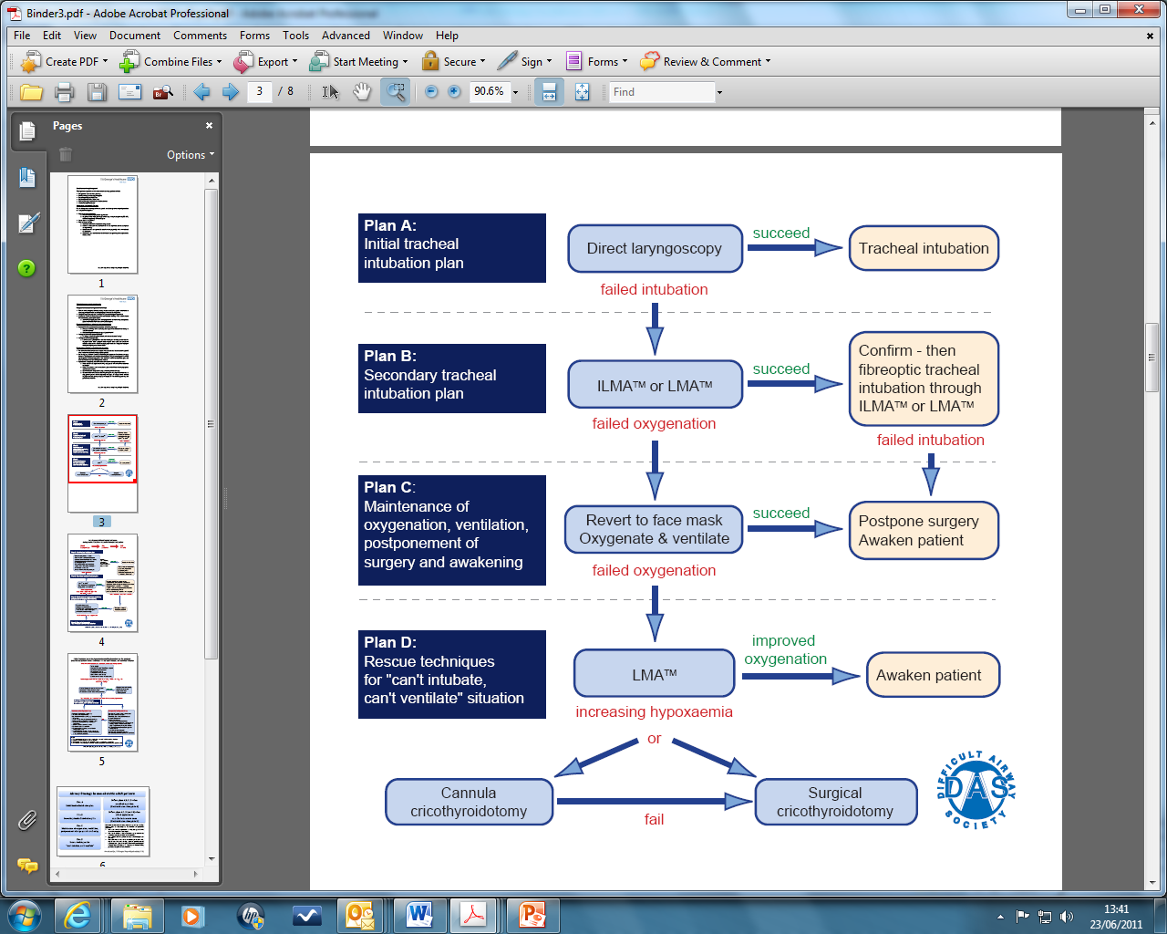

Start:
- with right equipment (check as per AAGBI guidelines, includingself inflating bag)
- with right assistance in a familiar environment
- and plan in advance for failure (plan B, C,D)

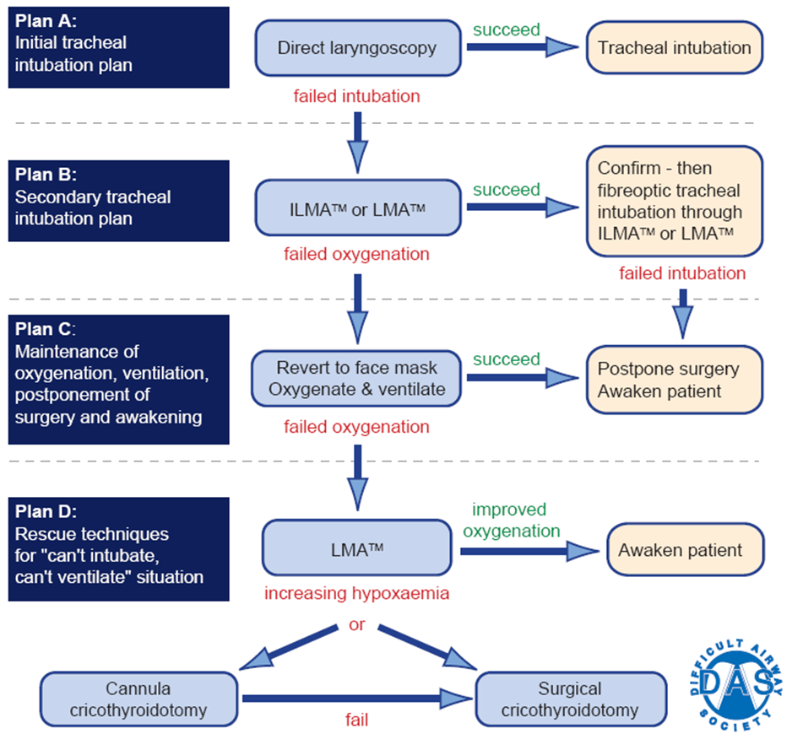

For plan A: ensure optimal conditions

Execute plan A with great attention to detail:
- Optimal patient positioning (ramp-up or “sniffing morning air”)
- Ensure adequate muscle paralysis
- Use obvious adjuncts: bougie, different size of Mac blade, McCoy
- Optimal BURP or external laryngeal manipulation
- Limit number and duration of intubation attempts
- If still poor view, call for HELP and move to plan B
- It is difficult to justify use of the same direct laryngoscope more than twice and the maximum number of laryngoscope insertions should be limited to four.
- There is not enough evidence to support use of plan B, instead of plan A i.e. it is generally not recommended to omit plan A

Plan B available in all areas except Day Surgery Unit & Lanesborough 5
- LM, Proseal, ILMA
- Airtraq
- Glidescope with stylet
- Flexible scope
- Rigid scope (Bonfils)
- Aintree Catheter

Plan B available in Day Surgery Unit& Lanesborough 5
- LM, Proseal, ILMA
- Airtraq
- Glidescope with stylet
- Disposable Flexible scope (ambuscope)

For plan B: use a different approach
- The priority is oxygenation and stabilisation of the patient, not intubation.
- Use the most appropriate plan B (for the patient, your skills, the location)
- During normal working hours DFA is your immediate double-up (bleep 8011)
- Out of hours, put out “airway emergency” call to all anaesthetic bleeps via 2222
- If two attempts at plan B fail, consider waking the patient and moving to plan C

For plan C: wake up patient, postpone surgery
- Wake up patient when plan A and plan B have failed
- Wake up patient after plan A (and omit plan B) when other factors are present, i.e. difficult face mask ventilation, blood in airway

For plan D: rescue techniques
- A “can’t intubate, can’t ventilate” (CICV) situation is rare however every anaesthetist should acquire and maintain the skills to manageit and to perform an emergency cricothyrotomy.
- The decision to proceed to an emergency cricothyrotomy is often inappropriately delayed.
- Various techniques have been described and there is no consensus yet, on the best technique or device.
- Therefore, a surgical technique should be taught alongside a cannula technique.

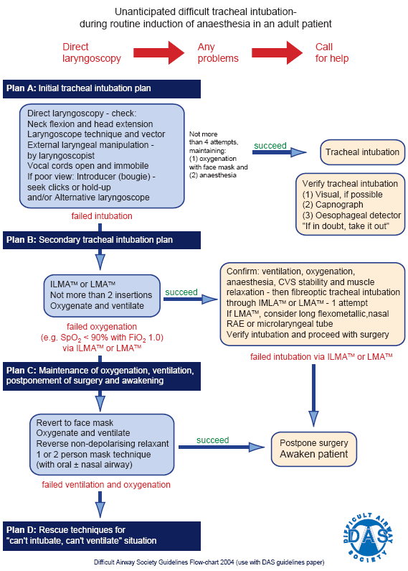

Plan D

Airway Strategy in non-obstetric adult patients
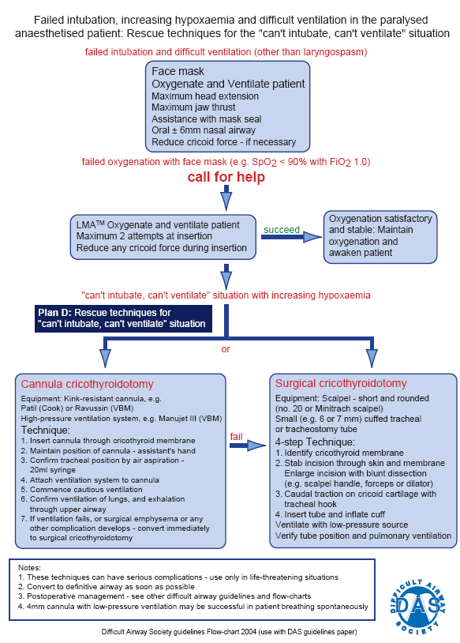

Airway Strategy during RSI
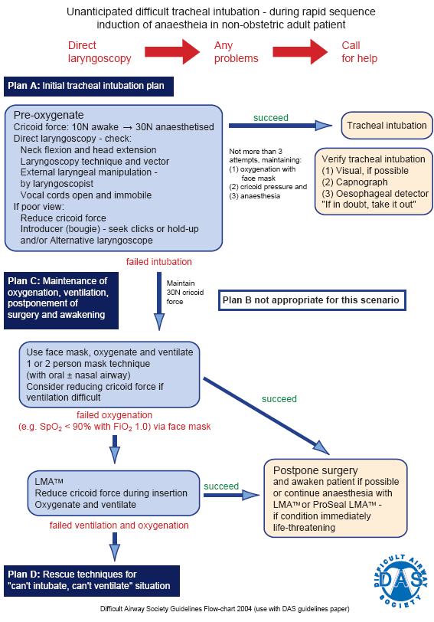

Notes
- There is no plan B and no further doses of succinylcholine should be given
- Whenever possible aim to postpone surgery and awaken patient
- It is essential to proceed with surgery, consider using a second generation supraglottic device (i.e.Proseal). Cricoid force may be reduced to help insertion.

Difficult Airway in remote operating sites

Preoperative assessment: anticipated difficult airway

- Patients with anticipated difficult airway are not suitable for general anaesthesia in remote operating sites such as the Day Surgery Unit or Lanesborough five.
- The planned surgery should be re-scheduled for the main operating theatres.
- Inform the Anaesthetic Co-ordinator (ext 0051), the weekly rota team (AT, TW, RS) and document in the office diary, so that the necessary planning takes place:
  - availability of appropriate staff and equipment for difficult airway management (Consultant cover, availability of H&N Anaesthetist, double up etc).

Patients not suitable for anaesthesia inremote operating sites
- Known difficult face mask ventilation and/or difficult laryngoscopy
  - History of difficulty with “breathing tube” in previous anaesthetics or history of “failed intubation”
  - Documented grade of laryngoscopy as “grade III or IV”
- Anticipated difficult face mask ventilation
  - i.e. history of radiotherapy to the neck as the tissues become “woody”
- Anticipated difficult laryngoscopy
  - Limited mouth opening to less than 3cm would pose difficulty in insertion of a laryngeal mask. Most laryngeal masks require more than 2cm interdental distance and some like the intubating laryngeal mask and the proseal laryngeal mask generally require more than 2.5cm

Unexpected difficult intubation in patients inremote operating sites
- You may start an anaesthetic in a remote area when you are happy that you have the right equipment on location (for plan A direct laryngoscopy, for plan B alternative intubation method), the right assistance and you are familiar with the environment.
- Follow the DAS guidelines
  - With great attention to detail when executing plan A (direct laryngoscopy) as your first attempt should be the best one (optimal conditions)
- Call for help when you experience difficulty with plan A
  - If patient is stable and easy to face mask ventilate then you have time to discuss with DFA the options of extra help available, equipment from main theatres etc.
  - If patient is difficult to face mask ventilate then wake up the patient without attempting plan B.
  - If other factors are present (i.e. blood in the airway from airway trauma or from attempted nasal intubation) then consider waking up the patient without attempting plan B.
  - If you proceed to plan B, you must be available until the patient is discharged from recovery.

Patient follow-up after Difficult or Failed Intubation
When the patient's airway has been difficult to manage, an airway follow-up should be instituted.
- Review the patient clinically:
  - To check for 'minor' morbidity such as bruised lips, sore throats
  - To check for morbidity such as chipped, loosened teeth that may need a dental referral
  - To check for serious morbidity such as laryngeal oedema, laryngeal damage or perforation of the larynx, pharynx, oesophagus. The triad of pyrexia, retrosternal pain and surgical emphysema indicates perforation. This has a high mortality and early treatment with antibiotics, nil orally and ENT review should be initiated early. [See Airway Injury during Anaesthesia, Anesthesiology 91; 1703-1711, 1999 for closed claims analysis of 266 cases].

- Talk to the patient:
  - Express regret /apologise for morbidity
  - minor morbidity will resolve in a few days
  - persistent hoarseness will need ENT review
  - persistent problems need your involvement
  - describe the problem, indicate how serious a problem it was or likely to be in future anaesthetics
  - ask them to tell the next anaesthetist of the problem

- Make adequate notes:
  - in the anaesthetic records, in the hospital case notes and on any front 'problem' sheet
  - indicate the precise problem and how you solved it
  - specifically address whether facemask ventilation is easy or difficult

- Write to the patient
  - Write to the patient with details of the airway difficulty or complete an airway alert form which can be downloaded under Head & Neck Anaesthesia in the protocols section on the Intranet for the Anaesthetic Department.
  - Copies of the letter of the airway alert form are needed for:
    - the patient
    - the GP
    - the medical records (also add an “alert” sticker on front page)
    - no copies need to be kept in the anaesthetic department

Capnography
  - Always confirm with capnography the position of a tracheal tube especially when a patient was intubated by someone else
  - If there is no capnograph attached to the patient, then ask for one to be brought to you (there are some spare ones)
  - There are capnometers (colorimetric) in every cardiac arrest trolley (including the Intensive Care Units).
Waveform
  - Look for sustained waveform trace
  - In a cardiac arrest during CPR expect a capnography trace even if attenuated (see below)
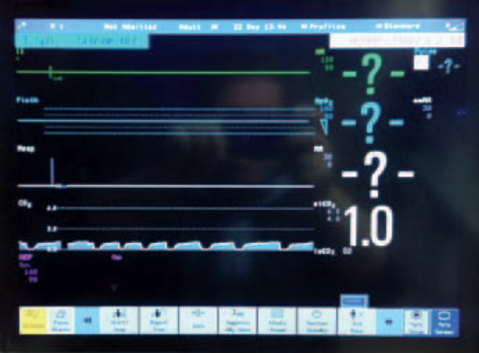

Capnography and EASY-CAP

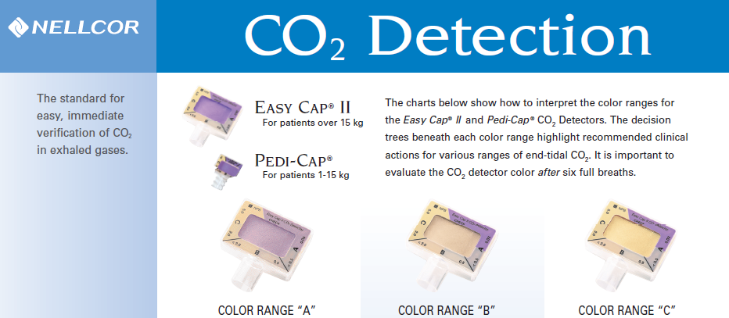
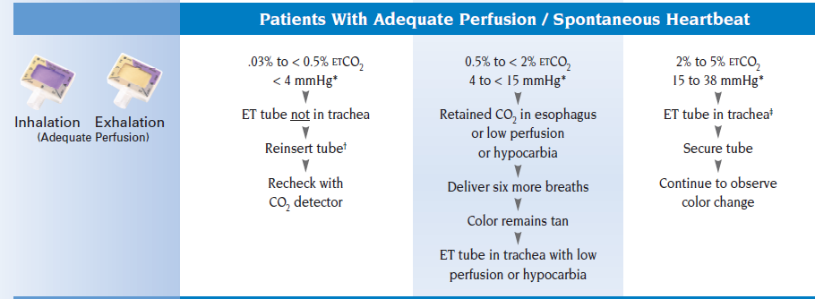
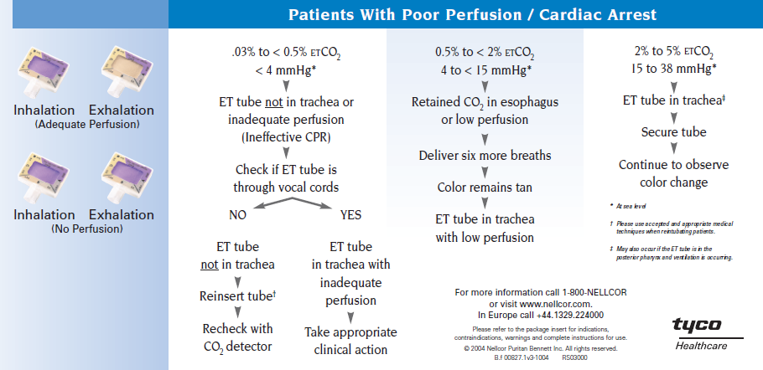

http://www.nellcor.com/prod/Product.aspx?S1=AIR&S2=CO2&id=176

Capnography for monitoring and transfer

There are guidelines:

- Recommendations for Standards of Monitoring during Anaesthesia and Recovery (2007)
- Recommendations for the Safe Transfer of Patients with Brain Injury (AAGBI, 2006)
- Inter-hospital Transfer (AAGBI, 2009)
- NAP4 (2011)

http://www.aagbi.org/sites/default/files/standardsofmonitoring07.pdf
http://www.aagbi.org/sites/default/files/braininjury.pdf
http://www.aagbi.org/sites/default/files/interhospital09.pdf
http://www.rcoa.ac.uk/document-store/nap4-executive-summary
http://www.rcoa.ac.uk/node/4211

All anaesthetic machines in theatres have CO2 monitoring, and microstream CO2 available for the blocks for transport
All anaesthetic rooms have CO2 monitoring via GM5s (Gas Monitoring module)
All areas (except NICU – expected changeover next 2 weeks)) should have microstream CO2 monitoring available.

Microstream® CO₂ Extension for capnography with the Multi-Measurement Module

Microstream CO₂ is an innovative, advanced technology for sidestream capnography. The Philips Microstream CO₂ Extension is designed to work with the Philips Multi-Measurement Module (MMS) and IntelliVue X2 and provides a real-time waveform and numeric values for CO₂ on the Philips patient monitor display. Furthermore, Integrated Pulmonary Index™ (IPI)* helps caregivers to manage four complicated monitoring parameters with a single number.

The Microstream CO₂ Extension is a lightweight, rugged, plug-and-play unit that easily attaches to the Multi-Measurement Module and travels with a patient. At the bedside, the MMS/Extension combination can be connected to IntelliVue and M3/M4 patient monitors.

During transport, the unit stores patient demographics and up to eight hours of patient trend data, as well as calibration and measurement settings.
An advance in capnography
Microstream capnography may be used with intubated or non-intubated patients. It can offer exceptional advantages over traditional sidestream capnography:

- Very low sample flow rate of 50ml/min
- Fast response time
- Crisp waveform
- Exceptional moisture handling with an integrated water separation filter in each connector and a patented multi-port airway adapter design
- No cross-sensitivity to other gases, such as anaesthetic agents
- Quick warm-up time
- No routine calibration required
- IPI* provides an uncomplicated, inclusive assessment of a patient’s ventilator status. Utilizes real time measures and interactions of four parameters – EtCO₂, Resp, SpO₂, Pulse Rate.

The Microstream CO₂ Extension has one port for CO₂, and a second port that can be used for invasive pressure or temperature is available as an option.

Wide variety of FilterLine® sampling circuits
Philips offers a variety of one piece, plug-and-play sampling circuits tailored to different clinical requirements and in different sizes for use with neonate to adult patients. Switching from intubated to non-intubated monitoring is as easy as plugging in the appropriate accessory—no recalibration required.

For non-intubated patients, nasal and combined oral-nasal cannulas accommodate mouth and nose breathers. “H” versions for ventilation with humidified air.
For intubated patients, FilterLine® sets combine the sample line and airway adapter. A neonatal airway adapter provides ultra-low dead space.

Airway emergencies and airway obstruction (in theatres, wards, etc)
- As above – Call for help early
- Escalate to consultants early (ENT, maxillofacial and/or anaesthetics)
- All cases acute airway obstruction, especially in the postoperative period, are emergencies and consultants must be informed immediately

Airway compromise flow chart

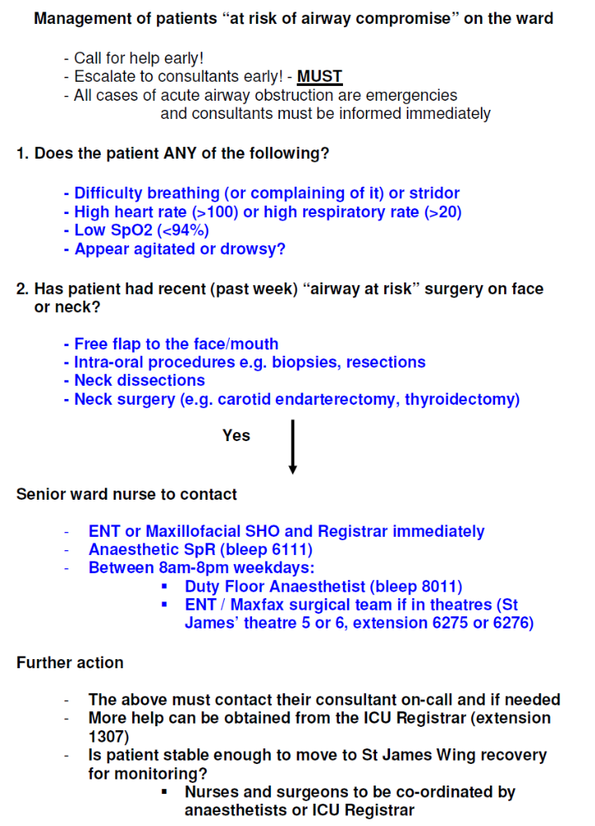

Guidelines on Difficult Airway Equipment

- All difficult airway equipment and rescue devices are standardised across our hospital with "Difficult Airway" Trolleys having the same content and layout (see table below for items 1 to 9) and similar content and layout in the Critical Care Units (items 10-12).

- An "Airway Stock" Trolley in the anaesthetic room of the cepod theatre (St James's Wing) has been created to help with:

  - the immediate replacement of items used for the difficult intubation trolley.

  - the availability of advanced airway equipment for elective cases.

- There is a duty for daily checking, maintenance and replacement of equipment after use which should be documented.

  - The daily checking is done as per table (below) and documented on the checklist on the top of the difficult airway trolley.

  - The replacement of equipment after use is done by the ODP who used the difficult airway trolley by taking equipment from the airway stock trolley so that the difficult airway trolley is available for immediate use. The items used for the airway stock trolley are ordered via the central ordering system.
- An "Airway Rescue Bag" is available in every anaesthetic room across SGH and will contain:
  - Ravussin Catheter (VBM)
  - Quicktrach (uncuffed)
  - Surgical airway set: disposable blade no 22, small artery forceps, ETT 6.0 cuffed uncut

- Advanced Airway Equipment - locations
  - Flexible scopes are available in St James's and in the three ICU's (General, Cardiac, Neuro). Disposable flexible scope (Ambu Scope) is available in Day Surgery Unit. Rigid scope (Bonfils) is available in St James's theatres.
Always ensure the traceability stickers for the scopes are put into the patients notes and the scopes are returned for decontamination with the patient's details (sticker).
  - Glidescopes are available in St James's theatres, in Neuro theatres, in A&E and in the three ICU's (General, Cardiac, Neuro).
  - Equipment can be taken from theatres to a different location for example Labour Ward, but it has to be arranged on a case to case basis.
  - Airtraq Avant is available in SJW theatres 3,5,6 and 7, as well as cardiac theatre 1 and neuro theatre 1.

The Difficult Airway Trollies will be in the following locations:
 | Location |  | Checked by
1 | St James's Theatres | between SJ2 & SJ3 | Samantha Downing  Julie Cass  John Miller
2 | Paul Calvert Theatres | outside PC3 | Sophie Varghese
3 | Cardiac Theatres | anaesthetic room CT3 | Sandra Falla
4 | Neuro Theatres | outside Neuro1 | Grace Sibanda
5 | Lanesborough 1st floor | outside LN 2 | Samantha Downing  Gemma Butterworth  Charlotte Band
6 | Lanesborough 5th floor | Anaesthetic room LN5 | Antonina Cayana  Lynn Scott  Samantha Downing
7 | Labour Ward | Obs theatre 1 | Antonina Cayana  Lynn Scott  Samantha Downing
8 | Day Surgery Unit | Store Room opposite theatre 2 | Ancy Mathew  Victoria Mount  Yun Kim
9 | A&E | near paeds bay | Sophie Varghese
10 | NICU (Neuro) | In Neuro ITU | by Neuro ITU staff
11 | CICU (Cardiac) | In Cardiac ITU | by Cardiac ITU staff
12 | GICU (General) | In General ITU | by General ITU staff

Feedback

- For any queries/feedback for DA trolleys within CICU and GICU please contact Dr Jonathan Ball, for NICU please contact Dr Anne Garner or Dr Argyro Zoumprouli, for all other locations contact Dr Jelena Devic.
- As a safety net, the team responsible for the DA in St James's theatre will also be responsible for the Airway Stock Trolley in Cepod.

Airway Stock Trolley Checklist
Please re-order when taking any item from this trolley
First drawer | no
MAD (mucosal atomiser device) for nose (white cones) | 20
MAD (mucosal atomiser device) for larynx (long thin) | 20
Airway conduits
Berman | 5
Bronchoscope (VBM) big size | 5
Bronchoscope (VBM) small size | 3
Laryngoscope blades
Mc Coy size 3 and 4 | 3 each
Second drawer
Laser Jet Catheters (subglottic catheters) | 5
Laser Jet Luer locks | 10
Capnography filters | 10
Rescue techniques
Ravussin catheters | 5
Quicktrach | 2
Scalpel size 22 (disposable) | 2
Small artery forceps | 2
Third drawer: Pro-seals
Pro-seal size 3, 4, 5 | 3 each
Fourth drawer: ILMA's & tubes
ILMA (Intubating Laryngeal Mask) sizes 3, 4, 5 | 3 each
Endotracheal tubes used with ILMA sizes 6.0, 6.5, 7.0, 7.5, 8.0 (Fastrach) | 2 each
Fifth drawer: Airtraq
Grey Aitraq (for ETT 2.5 to 3.5) | 1
Pink Airtraq (for ETT 4.0 to 5.5) | 2
Green Airtraq (for ETT 6.0 to 6.5) | 5
Blue Airtraq (for ETT 7.0 to 8.5) | 5
Sixth drawer: Glidescope
Glidescope blades size 3 and 4 | 5 each
Glidescope stylets | 5
Seventh drawer: endoscopy parts
light lead for Olympus and Karl-Storz | 1 each
light lead connectors (short metal) | min 3
light lead adaptors (long thin metal) | min 3
portable light source for Olympus | min 2
portable light source for Karl-Storz | min 2
spare batteries (CR17345, CR123A) | min 5
suction ports (grey for Karl-Storz and black for Olympus) | 3 each
ETT holder for rigid scope (Bonfils) | min 2
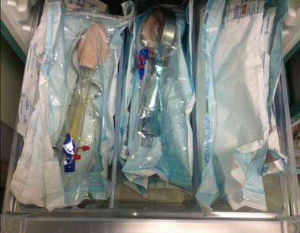
Airway Stock Trolley (in CEPOD) Updated July 2013 (photos)

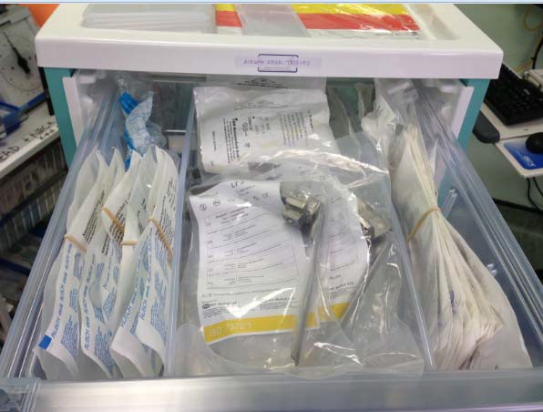
Berman Airways x 5
Bronchoscope Airways x 5 and small size x 3
Nasopharyngeal Airways (four sizes) x 2 each
MAD for nose x 20 MAD for larynx x 20
Mc Coy blades (two sizes) x 2 each
1

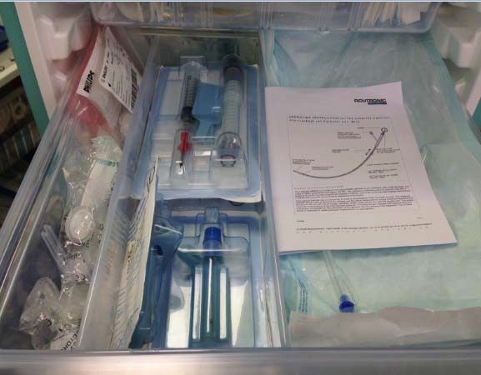
Quicktrach x 2 Ravussin x 5 Scalpel size 22 x 2
Small artery forceps x 2
Laser Jet Luer Locks x 10 Capnography filters x 10
Laser Jet Catheters x 5
2Laser & Rescue
3 Proseal


Proseal three sizes x 3 each


ILMA 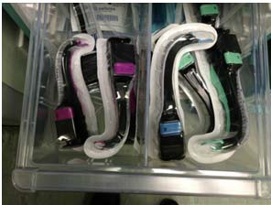
Fastrach five sizes x 2 each ILMA three sizes x 3 each

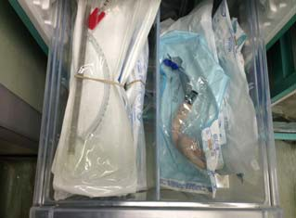
- Airtraq
Blue x 5 Green x 5 Pink x 2 Grey x 1

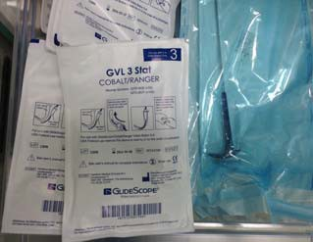

- Glidescope
Glidescope blades size three x 5 blades size four x 5
stylets x 5


- Endoscopy spare parts
spare batteries

light lead (x1 olympus, x1 Karl-Storz)

light lead connectors (metal short)

light lead connectors (metal long thin)

suction ports

portable lights (Olympus, Karl-Storz)

ETT holders for Bonfils

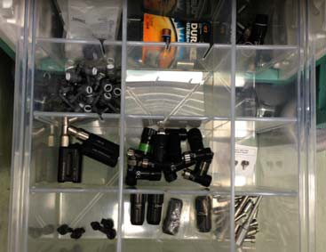

Guidelines on Awake Fibreoptic Intubation

Indications
- Anticipated or known difficult airway (difficult face mask ventilation and/or laryngoscopy) in patients with or without risk of aspiration
- Neurological assessment after intubation

Contraindications
- Patient refusal, unco-operative patient, inexperienced endoscopist
- Care with critical airway or bleeding in the airway
- Avoid nasal route if coagulopathy, pregnancy or lack of nasal vasoconstrictors (increased risk of nasal bleeding)

Supervision
- If endoscopist is a trainee, the Duty Floor Anaesthetist (normal working hours) or the on-call General Consultant (out of hours) should be informed

Consent verbal and written
- Explain technique in simple terms and consent patient (document in notes)
- Sterilization details of fibrescope (sticker) in patient’s notes for traceability

Patient positioning
- Patient sitting up 60⁰on the trolley and endoscopist facing patient (preferred) or
- Patient supine with head-up 15-30⁰ and endoscopist standing behind patient

Routine preparation
- iv access, iv induction & emergency drugs, monitoring including capnography
- Check anaesthetic machine, suction equipment (yankeur suction catheter)

Drugs for airway anaesthesia

Lidocaine : calculate max dose as 8.2 mg/kg with extra care in the elderly
or those with liver or cardiac impairment [BTS bronchoscopy guidelines]
[ie for 70Kg adult max dose of about 570mg lidocaine for airway anaesthesia]

- Nasal spray co-phenylcaine (6.5mg/spray)
- Lidocaine gel 2%(Instillagel) (20mg/ml) for nasal/oral route
- Lidocaine 10% metered spray (Xylocaine) for oral route
- Lidocaine 4%(pink) (40mg per ml) for spray as you go (SAYGO)
10ml syringes filled with 1.5-2.0ml lidocaine 4% and the rest with air
If lidocaine 4% is not available, use lidocaine 2%

Nasal vasoconstrictor for nasal route
- Co-phenylcaine: lidocaine 5% with phenylephrine 0.5% or
- Xylometazoline (Otrivine) 0.5ml

All other variants of awake FOI to be discussed with supervising Consultant and may include:
- nebulised lidocaine, cocaine 5% for nasal vasoconstriction, nasopharyngeal airways with lidocaine gel 2%, cricothyroid puncture for airway anaesthesia, and sedation with propofol infusion or remifentanil infusion
Equipment preparation

ETT and airways: choose size and design of ETT wisely, for example:
- For nasal route use soft preformed nasal ETT size 6.5mm or 7.0mm
either blue (Portex, Polar preformed) or white (Mallinckrodt, Satin RAE)
- cut proximal 1.5cm off (as they are too long for the fibrescope)
- do not warm these soft ETT’s (high risk of kinking)
- For oral route use Intubating LMA Tube or reinforced ETT 6.5mm or 7.0mm
- For oral route: protect fibrescope and use bite block or bronchoscope airway

Fibreoptic set up:
- Camera and light source
- Orientation (black notch at 12o’clock and lock into position)
- Focus and white balance
- Lubricate fibrescope and mount ETT
- Wipe the end of the fibrescope with alcohol wipe (anti-fogg action)
- 16G epidural catheter in working channel, cut last 2cm to prevent sideways spray

Patient preparation
- Supplemental oxygen via nasal sponge (2l/min) or cut top half of Hudson mask
- Drying agent: glycopyrrolate 200mcg iv upon arrival to anaesthetic room
- Conscious sedation: if not contraindicated titrate midazolam or fentanyl iv

Nasal route: vasoconstrict & anaesthetise both nostrils
- Warn patient of bitter taste
- Co-phenylcaine 2-3 sprays per nostril and repeat in 5mins
- Lidocaine 2% gel (3mls per nostril), ask patient to sniff and swallow or spit any excess
- [NB: very important to vasoconstrict inferior turbinate which is in chronic partial vasodilation]

Oral route:
- Warn patient of bitter taste
- Lidocaine metered spray 10% to the back of the mouth: 6 sprays
- Lidocaine 2% gel in the back of the mouth to gargle (5mls)
Suction check
- In 1min use external suction for excess secretions and check for weakening of gag reflex

Start endoscopy and SAYGO
- Go slowly, recognising the anatomy, following the black hole (airspace)
- Keep re-assuring the patient during the procedure
- Nasal route: choose the more patent nostril under direct view with the fibrescope (the sniff test is unreliable).
- Oral route: via bite block or bronchoscope airway (always protect fibrescope)
- To increase airspace ask patient to sniff, protrude tongue, take a deep breath or phonate
- SAYGO via epidural catheter: 2-3 syringes above and 2-3 below the vocal cords
- Ask assistant to hold fibrescope so you can free both hands to advance the ETT
- Nasal route: before railroading ETT warn patient of ‘pressure’, apply pressure perpendicularly to the face and turn the bevel towards the nasal turbinates (bevel to face laterally to decrease risk of nasal bleeding)
- To minimize risk of ‘hold up’ around the glottis, rotate the ETT so that the bevel is facing posteriorly (towards the arytenoids)
- Once ETT placed in trachea, hold it firmly (consider steri-strips)

Confirmation of tracheal intubation

- 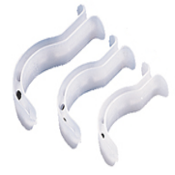With direct view with fibrescope and capnography
- iv induction only after confirmation of tracheal intubation
- Inflate cuff after loss of consciousness
- Check and document laryngoscopy grade after intubation
- Plan extubation accordingly and consider a Cook Airways Exchange Catheter

Follow up of patients with difficult airway
- If laryngoscopy grade is III or IV, fill out an Airway Alert Form copied into the medical notes, the patient and patient’s GP
Explain to the patient the importance of informing the anaesthetist before any future procedure

Airway Management During Laser

OPERATING ROOM HAZARDS
- Windows in the operating room (and on doors) should have an opaque covering. A warning sign should be placed on the operating door room.

OPERATING ROOM PERSONNEL
- All personnel in contact with the laser in the operating room must have laser training.
- ODA must be present inside the operating theatre at all times (not outside of the theatre due to the lack of laser goggles).

SURGICAL CONSIDERATIONS AND LASER USE
- Entire face and neck should be protected with saline-saturated surgical towels to prevent possibility of reflected laser burn. The patient’s eyes should be closed during surgery and covered with moist eye patches.
- Use saline-saturated cotton pledgets, which must be moistened periodically, to protect exposed tracheal tube cuffs.
- Lasers should always be in the “standby” mode except when read to fire, so that inadvertent activation is impossible. Laser in pulsed mode is safer than in continuous mode.
- Laser fibres must be single-use only and discarded after one use.
- Recommendation about the use of video-endoscopy during airway surgery – this displays the surgical field in full view of the operating room team.

ANAESTHETIC TECHNIQUE
- Avoid high FiO2 in closed breathing systems (unless a patient’s physiological reserve indicates otherwise) – ideally use FiO2 30-40%. During jet ventilation, entrainment of room air reduces the FiO2 that the patient receives.
- Do not use N2O as this supports combustion. Alternatives include air, nitrogen or helium.
- Lower limits of combustibility for volatile anaesthetic agents: halothane 4.75%, enflurane 5.75%, and isoflurane 7.0%
- Techniques to maintain airway
    - Intermittent apnoeic technique
    - Tracheal intubation
    - Jet ventilation (supra-glottic, transtracheal, subglottic catheters)
- Tracheal tubes that are specifically designed for laser use:
  - Laser-Flex tubes (Mallinckrodt, St Louis, Mo.)
    - Airtight stainless steel spiral with 2 distal PVC saline-inflatable cuffs
    - Resistant (but not absolute protection) against CO2 and KTP laser but not Nd-YAG
  - Bivona “Fome-cuf” (Bivona, Gary, Ind.)
    - Aluminium spiral tube with outer covering of silicone
    - Self-inflating foam-sponge-filled cuff
    - Only approved for CO2 lasers
- Fill tracheal tubes and LMA cuffs with saline to which a small amount of dye, such as methylene blue, has been added so that cuff perforation is readily apparent.
    - LMA cuffs with residual fluid may rupture when autoclaved (so dispose after use?)[4]
- Tracheal tubes wrapped with appropriate metallic tape have been used. Disadvantages include: it renders the tube larger in diameter and more rigid, causes kinking, traumatises the mucosal surface, and also do not prevent cuff exposure to laser (it can only be applied to the shaft of the tube). There is also limited commercial availability of such tapes.
- Supraglottic jet ventilation (rigid pharyngo/laryngoscope or bronchoscope) eliminates risk of laser airway fire due to the absence of combustible material e.g. tracheal tube.
  - Use of a high frequency jet ventilator with “pause pressure” (to minimise risk of barotrauma) is recommended e.g. Mistral ventilator (Acutronic Medical Systems AG, Hirzel, Switzerland) which is available in St James’ Wing, theatre 7.
  - Disadvantages of jet ventilation include
    - risk of barotrauma (surgical emphysema, pneumomediastinum, pneumothorax and gastric distension)
    - vocal cord motion
    - mucosal dehydration
    - lower respiratory tract soiling (blood, debris or vomitus)
    - inadequate ventilation, or hypo-/hypercarbia
    - relative contra-indications of jet ventilation (e.g. obesity, large obstructing lesions, and poor chest wall or lung compliance).
- Subglottic catheters are laser “resistant” due to Teflon coating[5] but not laser-proof
    - Case reports of damage exist e.g. catheter perforation by laser, and subsequent subcutaneous emphysema and pneumothorax following jet ventilation[6]
- The use of LMAs (and variants e.g. reinforced LMA, ProSeal LMA) for laser surgery is controversial[7-10]

IN CASE OF AIRWAY FIRE
- Stop delivery of all anaesthetic gases, including oxygen.
- Remove source of fire e.g. burning or burnt airway device
- Use saline (must always be available in a pre-filled 50 ml ‘bladder’ syringe on scrub nurse’s tray) to extinguish any fires.
- Ventilate patient with 100% O2 by bag-and mask
- Examine the airway for damage e.g. rigid or flexible bronchoscopy
- Further airway investigations and management as appropriate.

Dental Trauma

Please see links below

http://www.rcoa.ac.uk/node/6584

http://www.rcoa.ac.uk/node/6585

- Dental trauma during anaesthesia
  - Managing risks
  - Managing avulsion
  - Managing damage
- Patient referral form
- Post-operative care

Safe use of oxygen

The Trust is taking steps to improve the safety of oxygen for patients, as recommended by the NPSA and BTS guidelines. The clinical guidelines cover all aspects of the emergency use of oxygen for adult patients in the hospital setting – they do not include children under 16 years and adults on ITU or HDU facilities

There are five key recommendations - which are to be fully implemented from Monday November 1st 2010:
- Except in emergencies, Oxygen should only be given in accordance with a written prescription
- Oxygen should be prescribed by specifying a target saturation (SpO₂) range
- Prescribers should specify the starting device and flow/concentration in the clinical notes and by verbal handover
- Nurses should monitor the oxygen saturation at least every 4 hours, sign the prescription chart, and adjust oxygen delivery to keep the SpO₂ within the target range

Oxygen should not be given to patients who are not hypoxaemic (except in critical illness and carbon monoxide poisoning)

Oxygen cylinders

Please read full document June 2013
http://www.aagbi.org/sites/default/files/SALG-FIRE-SAFETY.PDF

1 Set up the cylinder  for patient use before  placing it close to the  patient. | The most likely time for an ignition to occur is either when the valve is  initially turned on or when a flow is selected.
2 Place the cylinder in  an appropriately  designed holder. | Where possible, cylinders should be placed in holders designed to  be fitted, ideally, to the bottom of the bed (or to the back of  wheelchairs). The position of the holder needs to take account of  how close the cylinder is to the patient.  The holder should ideally keep the cylinder upright so that if there  is an ignition its impact would be minimised.
3 Avoid placing the  cylinder on the bed  next to the patient if  at all possible; use  extra care when there  is no option but to  place the cylinder on  the bed. | There are times when there is no option but to place the cylinder on the  bed or stretcher. If this is the only option, setting up and turning on the  cylinder before putting the cylinder on to the bed will minimise the  potential risk of injury to the patient.

Blood Group & Save, and Cross-Matching
http://stginet/Units%20and%20Departments/Haematology/documents/REVISED%20PRE%20OP%20BLOOD%20ORDERING%20SCHEDULE.pdf

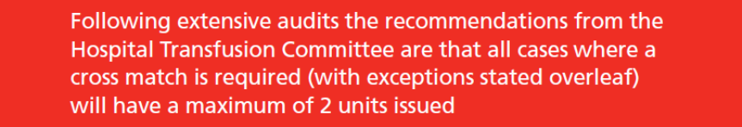
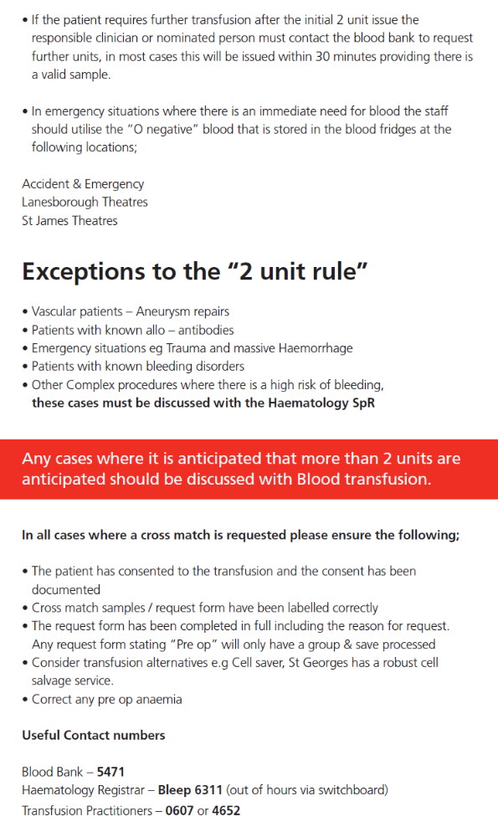

Blood transfusion issues

http://stginet/Units%20and%20Departments/Haematology/BLOOD%20TRANSFUSION.aspx?WindowsAuthenticationFailed=True

Consent for blood transfusion

Audits presented to Safety of Blood, Tissues and Organs (SaBTO) have identified that the practice of obtaining any form of valid consent for the transfusion of blood components is highly variable in the UK. The following issues were identified:
- Patients are not always given information on the risks, benefits, and alternatives to transfusion, or the right to refuse transfusion
- Patients are not always made aware that they have received a transfusion
- Patients who are unaware that they have received a transfusion may go on to donate blood when they should not
- There is inconsistent practice across the UK.

SABTO held a public meeting earlier this month and this resulted in 14 recommendations, the main recommendation being;

“Valid consent for blood transfusion should be obtained and documented in the patient's clinical record by the healthcare professional”

The above guidance will be discussed at the next Hospital Transfusion Committee meeting in December and presented to the Patient Safety committee. Further guidance will be issued following the HTC December meeting. For further information please follow the link below;

http://www.transfusionguidelines.org.uk/Index.aspx?Publication=BBT&Section=22&pageid=7691

Blood Tracking and Time Expired Blood
Staff must use their ID cards to access the fridge and scan the units in & out of the fridge - if this is not done then it looks as if the blood has been out of the fridge for a long period of time.

If blood is out of the fridge for >30minutes it must be discarded.

Please do not take more than 2 units out of the fridge at any one time unless for a dire emergency or it has been specifically requested for by the anaesthetist

Please beware that time expired blood – this has resulted in many adverse incidents and is a waste of blood and money (SDU July 2011).

Blood and Blood products are an expensive commodity. The wasting of blood and blood products can be prevented by correct storage of blood and blood products and returning unused products to the blood bank.

Current prices (Oct 2011): BLOOD - £138, PLATELETS - £240, FFP - £38

The BCSH (British Committee for Standards in Haematology) stipulate that blood and blood product bags can be disposed of immediately following transfusion. We have reflected this into the policy. Blood bags should only be retained in cases where a transfusion reaction is suspected. All blood and blood product bags should be disposed of as per the Clinical waste policy.

Mark Grumbridge (08/10/13)
Transfusion Practitioner

Management of Massive Haemorrhage

http://stginet/Units%20and%20Departments/Anaesthetics/Documents/Jo%20Norman%20uploads/Massive%20Hem%201.pdf

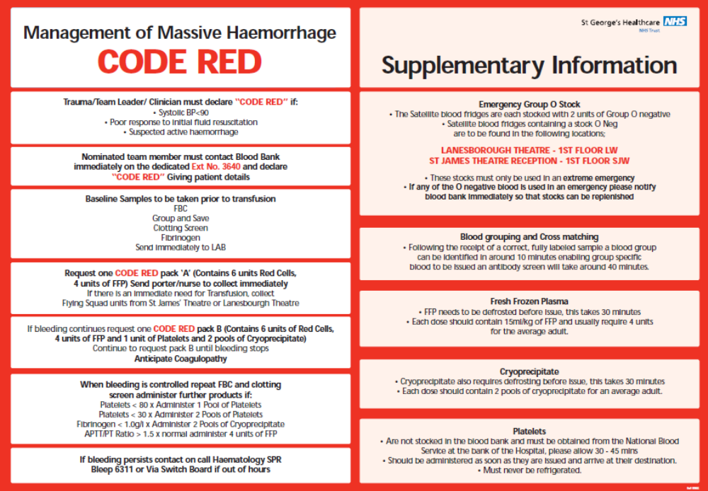

Management of Massive Haemorrhage for CODE RED for TRAUMA

http://stginet/Units%20and%20Departments/Haematology/documents/REVISED%20CODE%20REDA.pdf

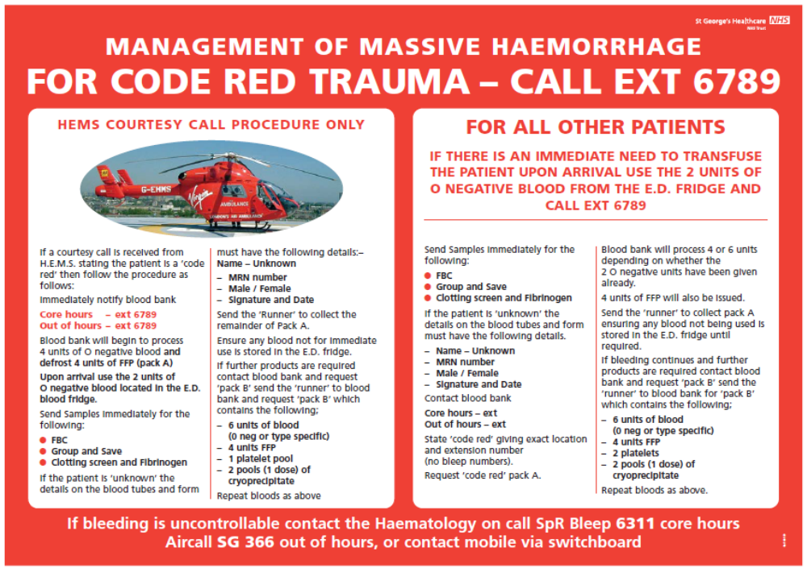

Emergency Open AAA Repair

For an emergency open AAA
- 6 units of blood, platelets and FFP should be ordered at the start with the expectation of giving them in theatre
- This will be discussed at the transfusion committee for confirmation – you should not be required to provide a platelet count for such cases (Hanif Meeran is lead for Transfusion for the anaesthetic department).

Guidelines for EMERGENCY OPEN AAA repair (Dr Hanif Meeran, Oct 2011)
These are patients with significant pre op blood loss and coagulation activation. Clotting function and factor concentrations will be very dynamic and thus the ability of laboratory tests to track these changes usefully is poor. Clotting tests must be performed, but one can expect to have to give clotting products as well as red cells in theatre in order to achieve haemostasis and so treatment must not be delayed by test results.

Notify blood bank that you require 6u RBC, 15ml/kg FFP, 2 pools platelets and cyoprecipitate. Involve haematology doctor on call and explain the situation as they can work with the lab technician to authorise or order in products, and help guide treatment.

Ask ODP to set up a cell saver.

Send urgent fbc, coag screen and fibrinogen level from theatre. Point of care coagulation testing (TEG) is much faster and is available in the cardiac theatre suite or cardiac ICU, ask the staff there to help you.

Standard transfusion triggers are:
Hb>8g/dl for RBCs
INR >1.5 (or TEG r>9min) for FFP
Plts <100 (or TEG MA <50mm) for platelets
Fibrinogen<1g/dl for cryoprecipitate

However while RBC transfusion can be guided by the Hb given on blood gas analysis, clotting products will usually be given on clinical grounds for these patients.

Give tranexamic acid 1g iv

Elective AAA and endovascular stenting is quite different with more time for planning and a patient who is in better condition to start with. These can usually be managed with two units of cross matched blood to start with and a cell saver for open cases, but a discussion should take place between anaesthetist and surgeon as to what preparations should be made in light of the planned surgery.

Intraop LidCo Monitoring
Maurizio Cecconi and Jeremy Cashman

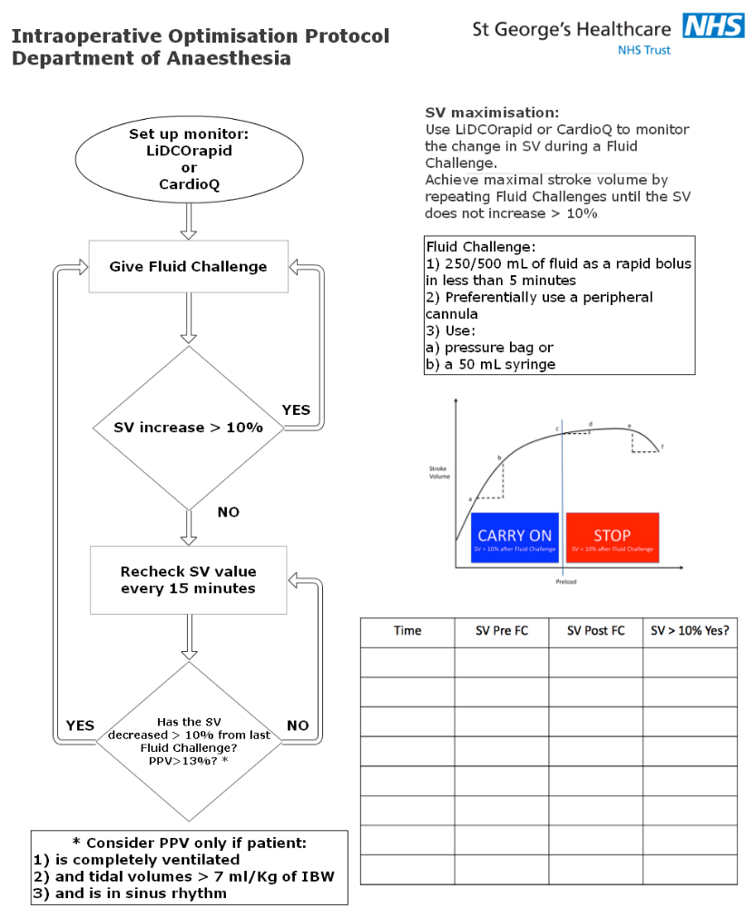

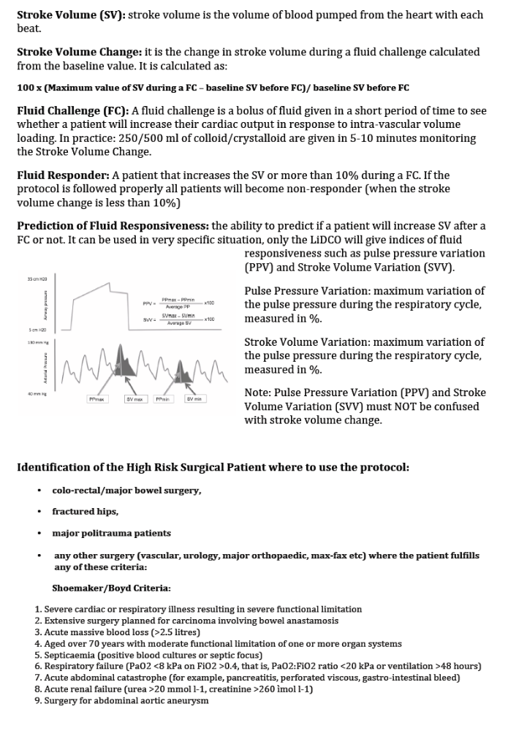

Organ Retrieval

Patients from NICU who are brain stem dead (heart beating) and for organ retrieval will be managed by cardiac/neuro trainee and/or the consultant. Patients for heart/lung harvesting are usually managed by the retrieval team who often bring their own anaesthetist.

Organ retrieval procedures for non heart beating and heart beating donors
- Will normally take place in Neuro theatres, 2nd Level, Atkinson Morley Wing
- It may on occasion be necessary to use in St James’ Wing theatres, 1st Floor St James’ Wing.
- Donors may be transferred from A&E, Neuro, Cardiac and General ICUs or Paediatric Intensive Care.

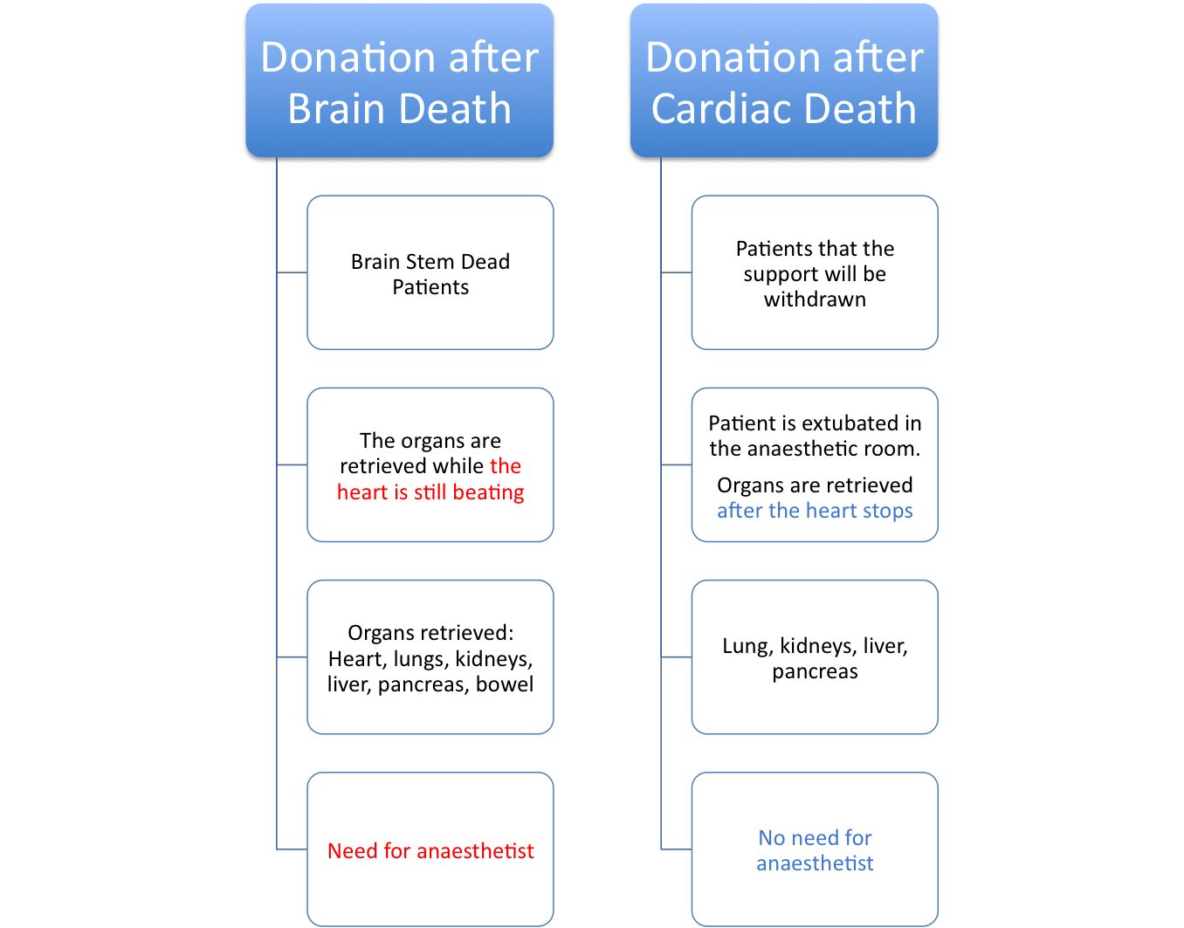

First line of call: Senior registrar
Second line: Anaesthetic Consultant of the responsible group

Donor after brain death (heart beating) – time in theatres usually 4.5 hours
- The role of the anaesthetist:
  - Maintain airway and cardio-respiratory stability
  - Give muscle relaxant if you want to suppress movement (due to spinal reflexes)
  - Administer antibiotics/ Heparin before cross-clamp
  - No need to be in theatre after cross-clamp
- Support needed: ODP/anaesthetic nurse
Anaesthetic group responsible for retrieval:
  - PICU Paediatric group
  - GITU General group
  - NITU Neuro group
  - CTITU Cardiac group
“Life or limb threatening” CEPOD cases still has priority over organ retrieval cases

Cardiac Arrests

Anaesthetists must document their management and any interventions they have carried out e.g. airway support and central venous access following a cardiac arrest

26/09/2012

Our future aim is to expand our ODP service to include non theatre areas including being members of the in house cardiac arrest teams. At the moment, it is not appropriate to do this due to several reasons:

- Based on SGH resuscitation figures for cardiac arrest calls from January to June 2012, there were 102 confirmed cardiac arrests and 160 peri-arrest calls. 53 patients were intubated i.e. approximately 20%.
- The ODP service is currently unfunded
- The ODP that covers A&E and the Heart Attack team (CQUIN) would otherwise be diverted away
- We need to consider ALS training for ODP’s

Therefore, ODP’s will not to routinely attend all cardiac arrest calls.

The anaesthetic co-ordinator (bleep 8425) will still be available to allocate resources e.g. ODP’s for elective non-theatre intubation or difficult airways.

The Management of the Unconcious Patient Following OHCA

St. George’s Hospital offers a primary percutaneous coronary intervention service where a number of patients require anaesthetic input on their arrival to the catheterisation laboratory as they often bypass the emergency dept. to facilitate prompt coronary intervention. We admit over 100 patients a year following an out-of-hospital cardiac arrest and a system was put in place to facilitate the safe management of those patients by triggering a “heart attack call”.

The underlying PDF is the entire protocol:-

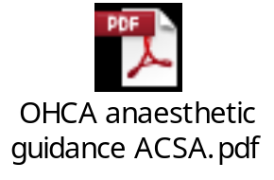

Trauma

AET theatres Acute Emergency Theatre/ PC Theatre I

Primary Role
To provide an Acute Emergency Theatre for emergency life or limb threatening injuries transferred directly from A&E within 60 min of patient arrival.

Secondary Role- Use by Plastics/2nd Cepod
As a secondary role the PC theatre I may be used for short, predictable elective or emergency cases on days where capacity is allocated to Plastics (see session allocation below) or if the orthopaedic/trauma lists are not fully utilised. Cases have to be approved by the Duty Floor Anaesthetist / On Call Orthopaedic Trauma Consultant / Clinical Theatre Manager and must fulfil the following criteria:
- Stable emergency cases with predictable theatre time of less than 1 hour
- Elective cases that are at risk of on the day cancellation with predictable theatre time of less than 1 hour
- All cases must leave theatre by 16:30

To ensure a timely start, the 6111 bleep holder should identify a suitable case with plastics or from the Cepod list during the night and ensure early sending at 8 am in the morning. Plastics should have a surgeon available for list briefing at 8 am.

Current Session Allocation

 | Monday | Tuesday | Wednesday | Thursday | Friday
AM | Plastics | Ortho | Plastics | Ortho | Ortho
PM | Ortho | Ortho | Ortho | Ortho | Ortho

Use of PC Theatre I by Orthopaedics

On sessions where PC theatre I is allocated to orthopaedics the overall control lies with the orthopaedic trauma consultant on-call, e.g. case restrictions do not apply as long as an orthopaedic theatre can be made available within an hour in case of a major trauma. The trauma consultant on-call has the ultimate responsibility for managing all PC theatres accordingly and flexibly.

When the trauma team is activated the trauma consultant on-call should identify one theatre within PC area to finish the current case and then standby until further knowledge about the trauma is gained.

Regarding the role of the anaesthetist as part of the ‘trauma team’ and when they can leave (as it often gets busy)

From A&E (Samer Elkhodair, A&E Consultant):

- All Trauma calls should be attended by the anaesthetists
- They should stay until the primary survey has been done
- If there is no airway issue with the patient then this should be documented
- If the clinical findings and the predicted course of the case does not cause any concerns about the AW then the AW expert can ask the trauma leader to “stand down” and leave the team to attend other priorities
- They can then leave once the patient is off the scoop (they are best positioned and trained to control the head/airway during this manoeuvre)
- They are to return to the A&E department immediately if things change

Out of Hours – major trauma case

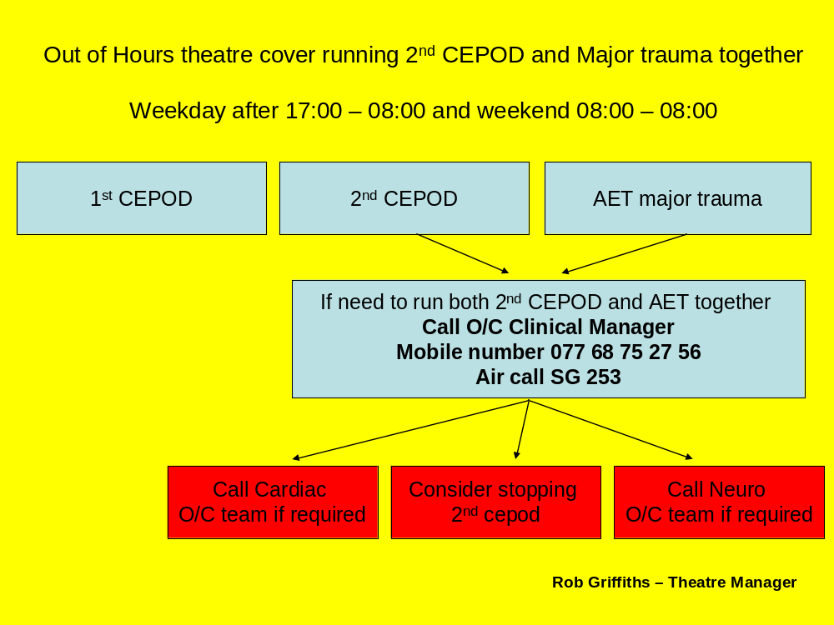

Open fractures and timing of operation

Open fractures are treated on the next available trauma or plastics list as appropriate, this allows for specialist involvement at an early stage allowing planning of future care.

Exceptions to this guideline are
- Where there is evidence of vascular compromise.
- Agricultural contamination of the wound requiring early debridement.
- Where the management of the open fracture is in the context of managing a patient with multiple injuries. i.e. if taking the patient to theatre for other pressing surgeries, if the patient is stable enough it is reasonable to also pay attention to the open injury.

Optimisation of high risk surgical patients

Entry criteria (the following has been suggested)

Patients whose operation is planned to exceed 1.5 hours and who have one or more of the following:
(1) Previous severe cardiorespiratory illness e.g. acute MI, COPD, CVA
(2) Planned extensive surgery for carcinoma, e.g. oesophagectomy
(3) Massive blood loss (>8 units)
(4) Age >70 and evidence of reduced physiological reserve in one or more organs
(5) Shock (MAP<60, CVP < 15, UO < 20 mls/hr, cold and clammy)
(6) Septicaemia (positive blood cultures, WBC >12,000, fever for >48hr)
(7) Respiratory failure (PaO₂ < 6 kPa on F_{i}0₂>0.4 or mechanical ventilation)
(8) Acute abdominal catastrophe, e.g. perforated viscus
(9) Acute renal or hepatic failure
(10) Peripheral vascular disease with aortic disease

Pre-op Evaluation of Elective Major Vascular Patients

AORTIC ANEURYSM AND OTHER MAJOR VASCULAR PROCEDURES (BASED ON ACC/AHA TASK FORCE CIRCULATION 1996)

The AHA Task Force made recommendations according to surgical risk, cardiac risk and patient’s functional capacity. Aortic aneurysm and major vascular surgery is designated high-risk surgery.

All patients will require Haemoglobin, Urea, creatinine and electrolytes, Clotting studies
ECG, ECHO, Lung Function Tests

CXR only if indicated e.g. recent chest infection, suspicion of neoplasm etc.

The patients can be categorised into:

Cardiac predictors | Pathway
Major  - Recent M.I or pulmonary oedema  - Severe dysrhythmia  - Unstable angina  - Severe valvular disease | Hospital admission with cardiology opinion or outpatient clinic as appropriate
Intermediate  - Angina  - Congestive cardiac failure  - Previous infarct | Outpatient cardiology opinion and investigation if appropriate. E.g. stress echocardiogram, thallium scan
Limited functional capacity
- Cannot manage a flight of stairs
- Cannot exercise
Minor clinical predictors  - Age over 80  - Hypertension  - Non-sinus rhythm  - Recent satisfactory review in cardiology | Waiting list
No clinical predictors | Waiting list

Anaesthetic Guidelines for Renal Transplantation

TRANSPLANT DAY – before going to theatre

- Look for work-up sheets/MDT meeting minutes in the notes: they often summarise most of the necessary information
- Review the patient before surgery; ensure no intercurrent issues
- Cardiovascular suitability: tests usually repeated at regular intervals whilst on waiting list
- Check dialysis status: pre-transplant dialysis usually arranged
- State of hydration – haematocrit, fasting times, last dialysis session. Most patients will be hypovolaemic: bear in mind for intraoperative fluid management
- Check K⁺, Ca levels, acid-base status
- Clotting status: quite a few patients are already/may be started post-op on anti-platelet- or blood thinning agents – be aware for invasive monitoring/regional blocks
- Hb levels <8.0 g/dl are usually treated with packed red blood cells, but comorbidities/older age may trigger transfusion at higher Hb levels
- Check that 2xRBC units have been cross-matched as per protocol
- Check CMV and Hepatitis B/C status
- Expect and plan around intraop haemodynamic instability – hypovolaemia, high prevalence of hypertension, diabetes mellitus, autonomic neuropathy
- Delayed gastric emptying possible – consider RSI if high risk of aspiration

PREMEDICATION

- If essential, oral temazepam– avoid IM injections

INTRA-OP MANAGEMENT

- Protect existing AV fistulae: wrap loosely in gamgee/no drips or BP cuff on AV side
- Start with small-bore IV access, then place a large-bore peripheral IV cannula after induction; if planning to use an existing haemodialysis line, remember they are all heparin-locked. Aspirate blood 3-5 mL from port before use.
- Consider CVP line if strong indication for CVP monitoring/central venous access, but consider risk of infection in an immunosuppressed host. Oesophageal Doppler/LiDCO monitoring will be suitable for most renal transplant recipients
- Bottom line on monitoring: use your clinical judgement on a case-by-case basis and monitoring tools you are comfortable with - you will be asked to give intraoperative fluids in the region of 30-40 mL/Kg for the entire procedure
- Train-of-four monitoring essential: serious incidents have occurred with vessel lacerations due to inadequate neuromuscular blockade
- Maintain normothermia (Bair Hugger, fluid warmer), monitor temperature

Induction -Propofol (or thiopentone) + fentanyl; co-induction with midazolam very effective in limiting propofol dosage for CV stability
-NMBD: usually atracurium; vecuronium only if atracurium absolutely contraindicated. Consider rocuronium for RSI in an airway that is not expected to be difficult to manage. Suxamethonium is best avoided.

Maintenance -Sevoflurane or Isoflurane +/- N₂0; no definitive clinical evidence that Sevoflurane causes renal problems in humans
-Keep FiO₂ around 0.5, especially if IHD/reduced O₂ carrying capacity etc.
-Atracurium/vecuronium as directed by nerve stimulator
-Fentanyl and IV paracetamol for analgesia

Other drugs -Antibiotics as per protocol (available on the Intranet site, adapted for penicillin-allergic patients)
-Immunosuppressants: IV Methylprednisolone 500mg + Basiliximab 20 mg. Both must have been administered by the time the kidney is reperfused
-Heparin/mannitol may be requested depending on circumstances
-Reversal acceptable with Neostigmine/Glycopyrrolate

Always check prescriptions/dosages against electronic drug chart as per usual practice: occasionally patients have come to theatre with the wrong drug/dosage. Check with nephrologists/surgeons if gross discrepancies

Fluids -0.9% sodium chloride to keep CVP 12-15 cm H₂O/FTc 350-360 msec
-Type of crystalloids: unless able to regularly monitor K⁺ levels intraop, stick to 0.9% sodium chloride

There is an ongoing debate on what fluids are appropriate for renal transplant patients. Practice is quite variable across the UK and there are no universal guidelines at present.

-Blood if indicated (as above), venous gas/Hemocue for Hb as needed

POSTOPERATIVE MANAGEMENT

Fluid Replacement Protocol – (Hourly Urine Output: H.U.O)
 | H.U.O.<250 mL | H.U.O.250-500 mL | H.U.O.>500 mL
</=50 kg dry weight | H.U.O. + 25 mL | H.U.O. | 50% of H.U.O.
>50 kg dry weight | H.U.O. + 50 mL | H.U.O. | 75% of H.U.O.

-Take into account other infusions (e.g., sliding scale) when working out fluid amounts
NB Colloids such as gelatins are not recommended due to the high incidence of allergic reactions

Pain relief protocol -Fentanyl PCA +
-Regular paracetamol +/-
-Infusion of 0.125% L-bupivacaine 1-13 mL/hour through epidural catheter inserted by the surgeon between wound layers (check with surgeon first if they will use it or not)
*All of the above if not contraindicated*

- Transfer to Buckland ward when observations in recovery are satisfactory
- Continue O₂ therapy by simple mask/nasal specs whilst pt. on PCA
- Admission to HDU/ITU: seldom required, usually for patients at high risk of perioperative cardiac events (check pt work-up sheet). If no HDU/ITU bed, a longer holding period in Recovery may be acceptable.

Updated by Dr N Fossati: May 2015. Review date: May 2018.

Anaesthesia for A-V Fistula and Graft Surgery

These guidelines are based on a combination of available evidence and established clinical practice at St George’s. They are not meant to be prescriptive, rather to help clinicians use their clinical judgement to make the appropriate decisions for each case.

PRE-OPERATIVE ASSESSMENT AND GENERAL MANAGEMENT

- Cardiovascular work up as required is usually completed before the patient is added to the operating list. All patients should have a recent 12-lead ECG;
- Patients are dialysed the day before surgery; check that K⁺ levels are adequate as this is not always the case in patients with poorly performing dialysis accesses. Low K⁺ levels taken immediately post dialysis are usually not sustained and need no replacement (check with a pre-op venous gas if unsure);
- Diabetic patients on insulin should be started on a sliding scale according to St George’s protocol;
- Patients are often on a combination of anti-platelet and anticoagulant agents: moreover, most of them will be given perioperative heparin. Operating on patients with increased INR is sometimes unavoidable; make sure surgeons are happy with higher INR levels. Intraoperative heparin may need to be omitted;
- Consider withholding ACE and ARB inhibitors 12 hrs prior to surgery to minimise intraoperative cardiovascular lability. Discuss with renal physicians as appropriate.
- Check Hb levels against the patient’s co-morbidities and the expected bleeding. Transfuse pre-op/intraop as clinically appropriate;
- Blood units should be cross-matched for complex proximal procedures and vascular access rescues/re-dos. Always check availability with the blood bank before proceeding as irregular antibodies are present in approx. 1:5 patients for this particular subgroup (source: St George’s Blood Bank);
- As a general rule, discuss your anaesthetic choice with the surgeons if you are unsure of the needs of the procedure.
.
INTRA-OPERATIVE MANAGEMENT

- GA with a low threshold for endotracheal intubation/2nd generation LMAs is usually appropriate for procedures above elbow level. Moreover, aspiration risk is significant in renal patients (higher risk of gastroparesis);
- IV access may be extremely difficult, particularly in the presence of already failed dialysis accesses: use of US guidance for peripheral cannulation may be required. Surgeons may help in case of exceedingly difficult access; in such cases, the use of existing dialysis lines is also acceptable;
- Dialysis lines are heparin-locked: some millilitres of blood, usually according to the amount indicated on the line itself, need to be drawn in order to avoid systemic heparinisation. Make sure the line is heparin-locked again when not in use;
- Most patients are cardiovascularly labile, including immediately after induction. BP needs to be maintained at a level that allows effective AVF/graft perfusion, like for every vascular case. Take pre-operative BP levels into account;
- A judicious combination of fluid administration and vasopressors is required to maintain adequate BP values. Metaraminol works much better than ephedrine in these patients, but it may affect heart rate;
- Monitoring with Oesophageal Doppler may be indicated in many above elbow procedures (e.g., poor cardiac function, expected acute inflow increase of 2L/min, such as with most proximal grafts) and may help titrate fluid management more confidently;
- 0.9% sodium chloride is still the preferred infusion fluid, despite increasing evidence that it may cause hyperchloraemic acidosis and increase K⁺ levels. There are, however, no national guidelines on this matter.

General anaesthesia

Induction Midazolam can help reduce propofol dosages at induction to minimise post-induction hypotension. Mivacurium or atracurium are adequate if muscle relaxation is required: most procedures are relatively short. Avoid suxamethonium.

Maintenance Sevoflurane or Isoflurane +/- N₂0; FiO₂ usually no less than 0.45;
Atracurium / mivacurium boluses as required;
Fentanyl or morphine boluses.

Other drugs Heparin as required;
A single dose of antibiotic is needed for AV grafts. In case of allergies, discuss with surgeons;
Antiemetics: ondansetron and cyclizine can be used.

Other Keep patients warm to prevent shivering and vasoconstriction upon emergence from anaesthetic; use a bair hugger and, where appropriate, warm up fluids and blood products.

Regional anaesthesia

- Decide on your technique early on and discuss your choice at theatre briefing: a different list order or extra help while putting blocks in may be needed to reduce delays;
- Blocks for simple/first attempt radio-cephalic or brachio-cephalic AV fistulae are usually adequate;
- Remember to consider carefully clotting status.

POSTOPERATIVE MANAGEMENT

Pain relief Carefully titrated fentanyl or morphine boluses in recovery are usually acceptable. Most patients can be prescribed regular paracetamol iv/po and tramadol 50 mg po TDS;
Fentanyl PCA is indicated for procedures involving long tunnelisations, e.g. axillo-popliteal AV grafts. ‘Necklace’ grafts do not usually require a PCA;
Some renal patients may suffer from chronic pain syndromes and be on regular opiates. Adapt your pain therapy accordingly.
Fluids Ensure fluids until able to drink+/- blood transfusions +/- sliding scale are prescribed as appropriate. For the type of crystalloid, see above. Gelatins are no longer recommended due to the increased risk of anaphylaxis.

Admission to HDU/ICU Uncommon; to be considered on a case-by-case basis.

Reviewed by the Renal Anaesthetic Team: Drs Pallavi Dasannacharya, N Fossati, C Johnston, G Sanders and A Walton, May 2015. Review date: May 2018.
Ophthalmic Anaesthesia at Moorfields in Lanesborough Wing
April 2015
Clinical Lead : Beverly Sutton

All ophthalmic services are provided by Moorfields NHS Foundation Trust, with the exception of ophthalmic anaesthesia. This gives rise to a unique situation and special considerations need to be considered as a result.
Two ophthalmic operating theatres are situated on the 5th floor of Lanesborough Wing; they are designated remote sites. However, it should be appreciated that these are fully functioning operating theatres with all the resources of any other theatre both in terms of equipment and personnel. There is a four bedded recovery room and full resuscitation facilities are available. These theatres are situated in the main hospital building and serviced by three lifts. As such access to all other areas of the hospital, including ITU is easily achieved.
Moorfields offer the full range of ophthalmic services, including paediatric. The throughput is very high with the majority of patients being treated as day cases. A large proportion of cases are performed under local anaesthetic. The ward, situated adjacent to the theatres is staffed 24 hours, seven days a week and both elective and emergency cases can be admitted. The relationship between Moorfields and St Georges is that Moorfields’ patients have full access to all St George’s facilities

Pre-assessment
All patients are seen in advance of surgery by ophthalmic nurses in the pre-assessment clinic. All patients scheduled for a general anaesthetic are clerked by the ophthalmic F1 doctor. All patients have pre-operative investigations in line with NICE guidelines.
There is a weekly consultant delivered high risk pre-assessment clinic staffed by two anaesthetic consultants with regular sessions in ophthalmic surgery. This is supported by nursing staff and the F1 doctor. Patients are referred to the clinic by multiple pathways, including: nurse led pre-assessment clinic, consultant surgeons and Moorefield’s City Road pre-assessment clinic.
Patients seen in high risk anaesthetic clinic are assessed, investigated and an anaesthetic plan constructed. This information is passed to the appropriate anaesthetist for the list involved. Patients deemed inadequately prepared for anaesthesia/surgery are referred back to their GP or on to a specialist service.

Type of anaesthetic
Approximately 3000 cases are performed each year of which 500 are general anaesthetic. The majority of local anaesthetics are performed with no sedation and no pre-operative fasting.
All cases requiring sedation are fasted, in line with hospital guidelines. Most patients receive very light sedation, but a small proportion of patients receive deep sedation for part of the procedure, often with TCI propofol or remifentanil.
All patients are monitored during their operation in line with professional guidelines .Pulse oximetry alone is generally used for patients having local anaesthetic. Additional monitoring is utilised as dictated by the patient and/or surgery. Full invasive monitoring is available.

ASA Grade
Patients with ASA I-IV are anaesthetised for both local and general anaesthetic in the ophthalmic theatres. When considering those of ASA III-IV, the aim is to minimize risk by optimising the patient pre-operatively, an appropriate well thought out anaesthetic plan and the right mix of anaesthetic experience. Additional equipment (eg Glidescope) and staff (second anaesthetic consultant) can be brought in, if necessary. Over the last few years there has been an active policy to manage these higher risk patients in the ophthalmic theatres, rather than seek space in main theatres. This policy followed a period of multiple failed attempts to gain main theatre space. The current policy has been successful and to date we have had no critical incidents and no cancellations.

Anaesthetists
All theatre sessions are covered by consultants with ophthalmic experience. No trainees are allowed to work alone in this setting. The majority of time there are two consultants present running two operating lists. On occasions there are single lists with a solo anaesthetist; if necessary the solo anaesthetist is actively encouraged to engage additional help (eg. Duty Floor Anaesthetist). No high risk patients should receive a general anaesthetic under these circumstances.

Access to other services
All Moorfields patients have access to all services within St George’s Hospital, with no exception. Laboratory services, transfusion, other medical and surgical specialties, imaging (X-ray, CT, MRI) and ITU and HDU. High risk patients (eg. Dialysis dependent chronic renal failure, sickle cell disease) are booked into HDU/ITU beds post-operatively, admitted by the same criteria as St George’s patients.
Paediatrics
All paediatric ophthalmic services are offered by Moorfields at St George’. Children requiring surgery are admitted to Jungle ward. These are all concentrated on the Wednesday morning list which has an ophthalmic paediatric surgeon and an anaesthetist experienced in paediatric practice. The children are operated on first in the morning and recovered in the recovery room. No adult patients are treated in theatre or recovery during this time. Following recovery the children return to Jungle ward and are discharged from there. If it is necessary to admit a child they are accommodated on one of the paediatric inpatient wards.
The operating rooms and recovery are fully equipped to cater for paediatric practice.

Emergency/out of hours
Most ophthalmic emergencies do not require immediate surgery. The majority can wait and be booked onto the following day’s list. Therefore out of hours emergencies are fleetingly rare. When such cases do arise they are booked onto the main theatres CEPOD list and surgery is performed in main theatres.

Evening and weekend operating
Like many other surgical disciplines, Moorfields is seeking to increase operating capacity with evening and weekend lists. These sessions are all covered by the regular anaesthetic consultants and consultant surgeons. Only elective surgery is performed and all patients need to be ASA I or II. This is an evolving practice and will need to be monitored closely.

Long term plans
In the long term it is anticipated that ophthalmic services will be relocated to a purpose build facility within the main body of St George’s. Both the move and the new location will generate new challenges. The Anaesthetic Department are actively involved in all discussions.

Venous cannulation
Please complete the yellow/white venous access forms in theatre for all new venflons etc. Patients will not be accepted from the receiving wards if the form is not completed with recovery staff having to chase anaesthetists before they can discharge.

The forms are not necessary in DSU.

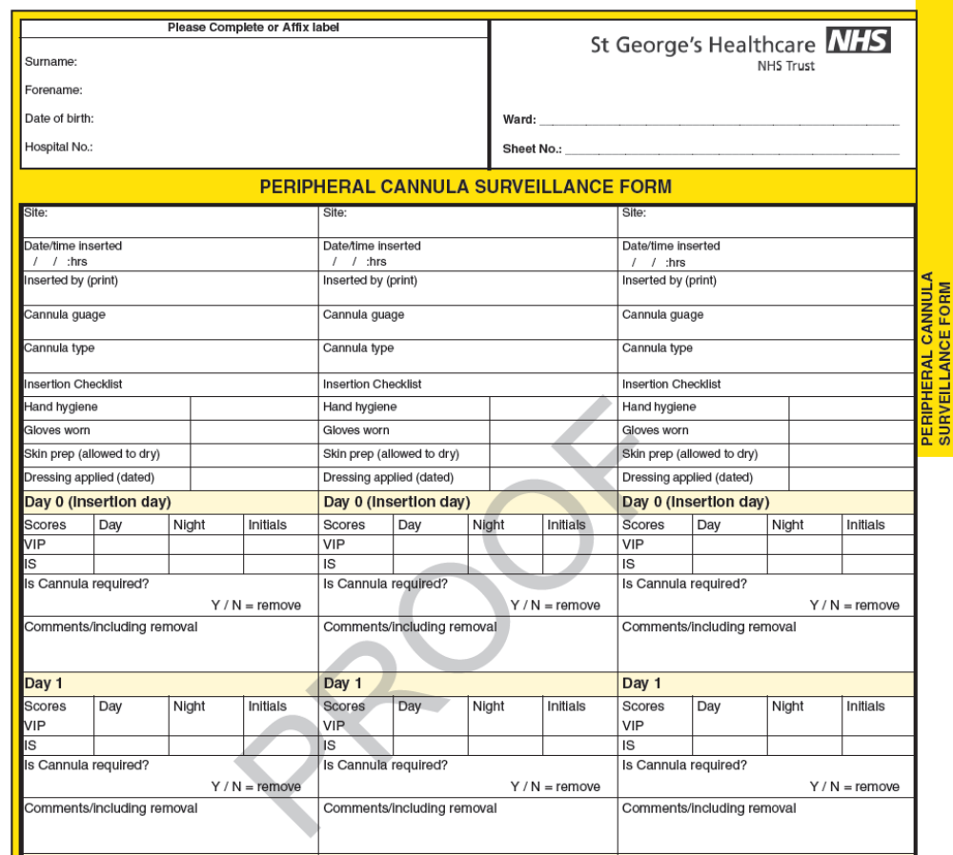

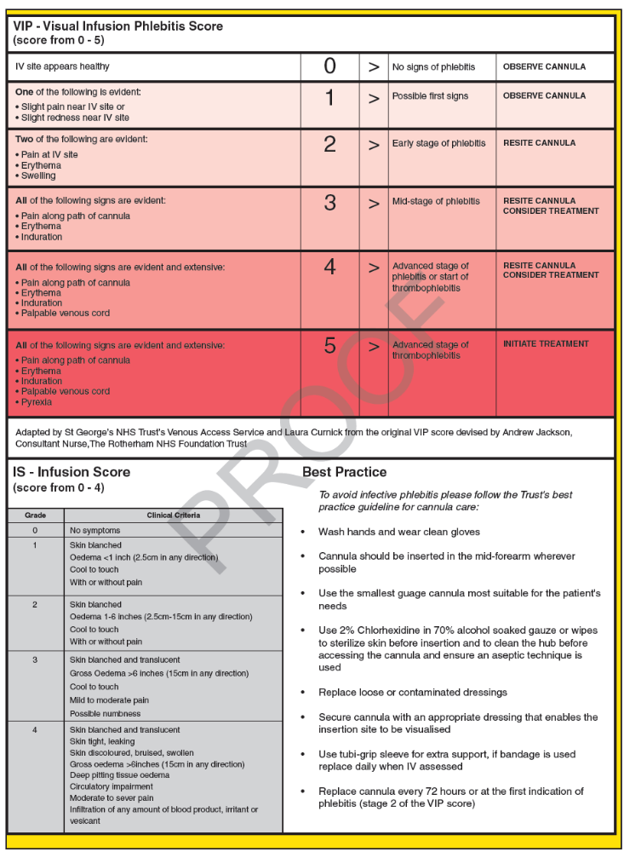

Vascular Access Team
http://stginet/Units%20and%20Departments/Central%20Venous%20Access/Homepage.aspx

The Venous Access Service is a team of dedicated professionals who run a comprehensive service specializing in the insertion and care of intravenous devices (e.g. tunnelled catheters, PICC, Vascaths and Acute catheters). The service covers a wide range of responsibilities including discussing available device options for patients to fit their needs and lifestyle while having treatment. The team is also involved in teaching in the care and management of Central Venous Catheters, closely monitoring and reducing the risk of Central Venous Catheter related infection.

Michaela Mayhew (Nurse consultant) Ext. 3153 or bleep 7119, SG608
Gema Munoz-Mozas (Independent nurse practitioner) Air call SG832

Venous Access Service Referral

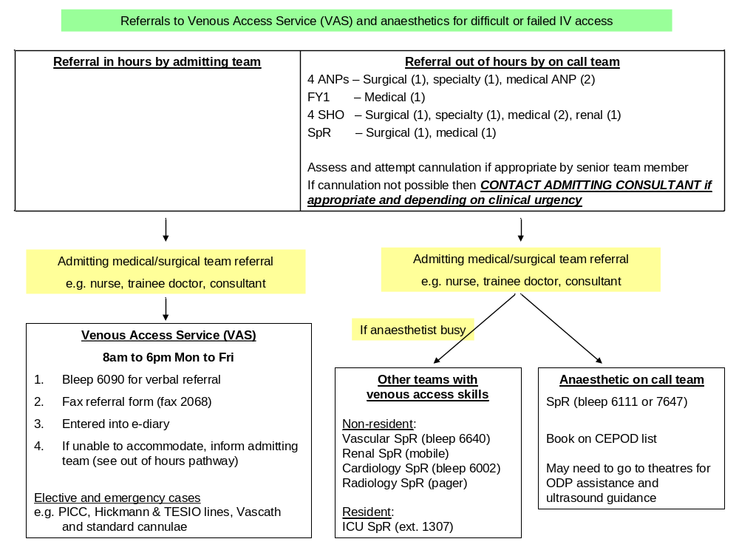

Extra-vasation Policy for Peripheral IV’s

Extra-vasation policy for extravasations of peripheral IVs:

IMMEDIATE ACTION
REASSURE patient
STOP the injection/infusion immediately
WITHDRAW as much of the drug as possible
REMOVE the peripheral cannula
REFER to plastic surgery to guide treatment

http://stginet/Procedural%20Documents/Patient%20related/Patient_Management/Clin_5_38%20%20Extravasation%20.pdf

Use of Cleaning Solutions for Neuraxial Blockade

Chlorhexidine
- There is evidence to support the fact that chlorhexidine is neurotoxic.
- The manufacturers have stated that chlorhexidine, (all concentrations), be used for external use only with no direct meningeal contact.
- 2% chlorhexidine is recommended prior to insertion of central lines
- 2% Chlorhexidine does show better antibacterial effect, however there is evidence showing that 0.5 and 0.05% produce statistical reduction in skin colonisation
- NAP 3 authors recommend that 2% should not be used for skin asepsis prior to insertion of epidurals or spinals. They recommend 0.5% chlorhexidine in 70% alcohol. They do acknowledge that this is outside the products license.

Cardiac Arrest or Cardiovascular Collapse Caused by Local Anaesthetic
http://www.aagbi.org/sites/default/files/la_toxicity_2010_0.pdf 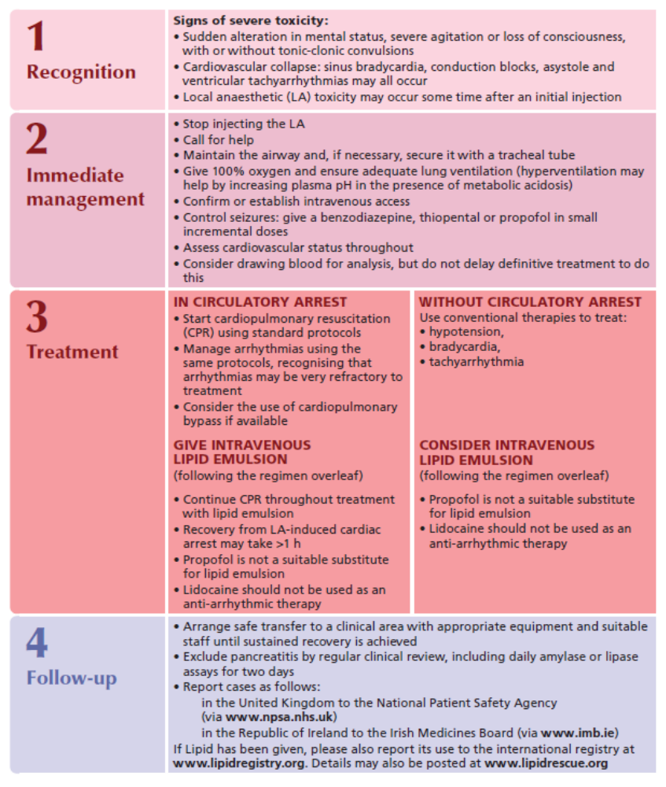
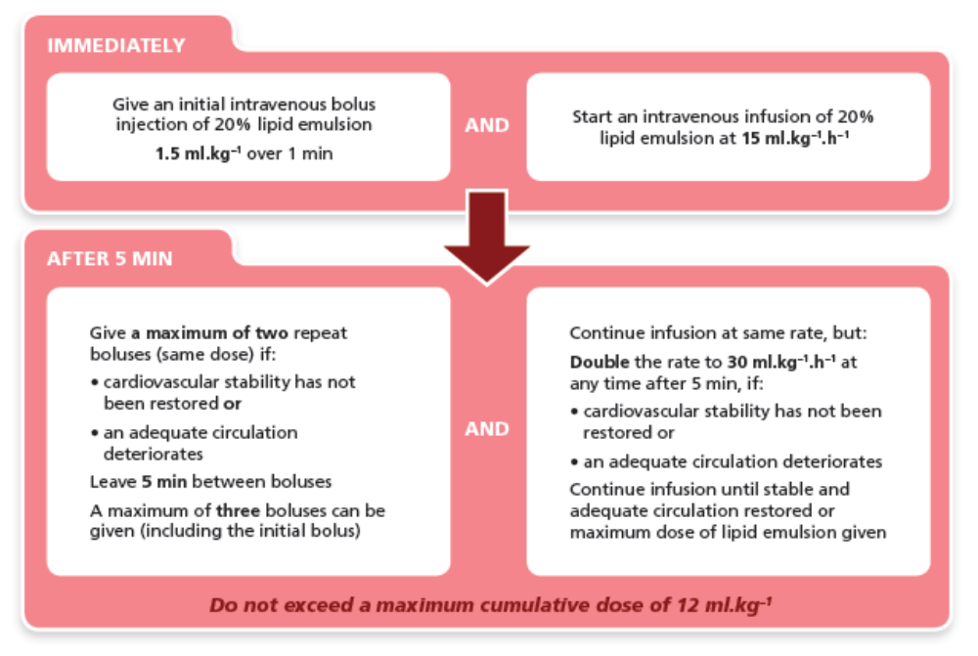

INTRALIPID is stored in
- Obstetrics theatres fridge
- St James’ Wing recovery fridge
- Lanesborough Wing recovery fridge
- DSU recovery fridge

Notes
- Restoration of spontaneous circulation after local anaesthetic-induced cardiac arrest may take more than 1 hour to achieve.
- Ensure that 500 – 1000 ml 20% lipid emulsion is available for the treatment of severe cardiovascular compromise or cardiac arrest associated with local anaesthetic toxicity in all clinical areas where high doses of local anaesthetics are used.
- Report all cases of suspected local anaesthetic intoxication to the National Patient Safety Agency (http://www.npsa.nhs.uk/).

Malignant Hyperthermia
Lead is Dr Lenny Ng

New guidelines from AAGBI in 2011/12

MH boxes
- There is one in each recovery area in each wing
- The action cards are attached to each box and every anaesthetic machine in the hospital

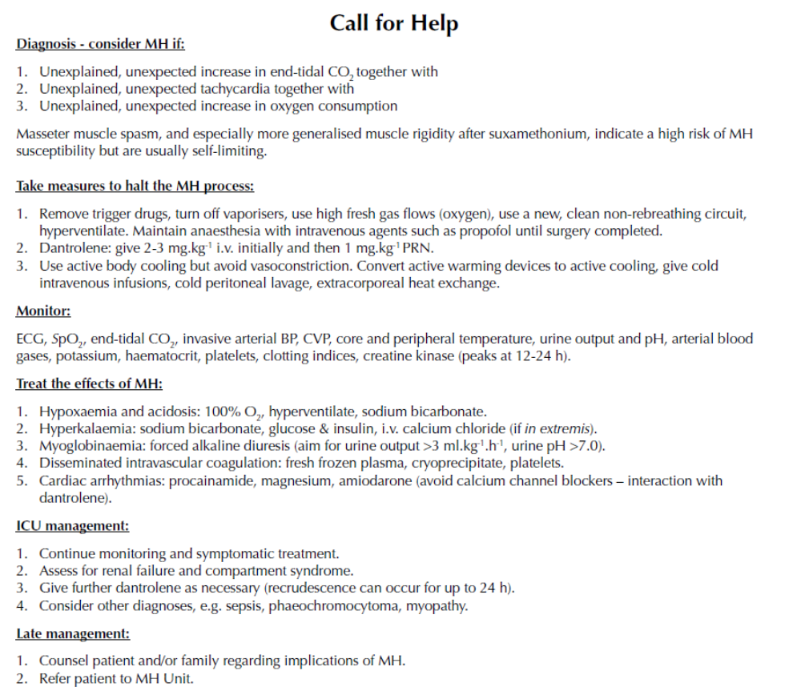

Fractured NOF Protocol

http://stginet/Units%20and%20Departments/Anaesthetics/Documents/Protocols/NOF%20Protocol.doc

General Principles.
Patients with a fractured neck of femur represent a high risk group. St. George’s has a higher than average mortality and LOS for these patients. Postoperative morbidity is likely to be a significant problem and the reason for increased LOS. Provision of service should be available throughout the week and at weekend.

Case-mix adjustment and morbidity measurement
- Age, ASA and POSSUM scoring
- Post Operative Morbidity Survey(POMS) and LOS for postoperative recovery
Preoperative Care
- Patients with fractured neck of femur require urgent surgery and should be operated on within 24 Hrs
- Diagnosis, initial resuscitation and pain relief should begin in A&E
  - Evaluation and initial management
    - Venous access (min 18G )
    - Fluids in progress
    - Oxygen applied 2 l/ min whenever supine
    - Urinary catheter -hourly urine output
  - Pain management
    - Pain assessment
    - Analgesics
    - Consider regional block ( Femoral nerve block FNB, fascia iliac compartment block FICB ) whenever possible- seek acute pain team advice
  - Minimum set of investigations to be performed
    - FBC/U&E/G&S/Cross match 2 units/Glucose/Clotting/CXR/ECG
    - Repeat FBC/U&E if operation delayed more 24 hours
  - Additional set of investigations for those with systolic murmurs and/or evidence of heart failure. (These should not delay progress to theatre if an operating slot is available, but necessitates invasive monitoring, including cardiac output monitoring and admission to HDU postoperatively).
    - Echocardiogram
Reasons for Delay
  - Acceptable
    - HB < 7.0
    - Severe Electrolyte Imbalance (Na < 120 or > 150 k < 2.8 or > 6.0 mmol/l)
    - Uncontrolled diabetes
    - Uncontrolled heart failure
    - Correctable cardiac arrhythmia
  - Unacceptable
    - Awaiting Medical assessment
    - Unnecessary investigations e.g. echocardiogram
    - Minor electrolyte abnormalities
    - No Consent
    - High INR
Give Vitamin K
FFP/Octaplas
    - Aspirin, Clopidogrel
    - Lack of facilities
- It is the responsibility of the Trauma coordinator/Nurse to inform theatres, senior theatre nurse (Paul Calvert Theatres) surgeons and anaesthetists (Dedicated Trauma Anaesthetist, Duty Floor Anaesthetist DFA bleep 8011 or O/C Anaesthetist bleep 6111 ) of the presence of such patients
- They should be scheduled 1st on the daily trauma list starting at 1.30pm.
- Patients should not be starved for longer than 8hrs and must have access to clear fluids for up to 2hrs before surgery. (Trust Policy)
Intra-operative Care
- There are Pros and Cons to both General and regional anaesthesia
  - The quality of postoperative pain relief warrants consideration of regional techniques either alone or in addition to General anaesthesia
- Antibiotic prophylaxis on induction
- Warming
  - Patients should have forced air warming applied
  - intravenous fluids should be go through a fluid warmer
- All patients should have access to cardiac output monitoring and goal directed care should be considered as a standard of care
  - Oesophageal Doppler guided fluid administration is recommended for those undergoing General and regional anaesthesia and has been shown to reduce LOS significantly
Postoperative Care
- ASA III/IV patients will be admitted to HDU/ITU for 24-48hours
- All ASA I/II patients will stay in recovery for up to 6 hours post-operatively or until fit to return to the ward as advised by the anaesthetic team.
  - Discharge from Recovery Criteria ( see patient chart)
    - Sedation score <2
    - SBP >90 or<180 mmHg, HR >45 or < 110 per minute
    - SpO2 > 95%, RR > 8 < 25 per minute
    - UO > 0,5ml/kg/h
    - Hb > 8,0g/dl
    - Temp > 35oC, Pain Score < 1, PONV <1, Dressing checked
    - Postoperative management plan written : Oxygen therapy, analgesia, fluids
- All patients should return to a dedicated ward (Gunning)on discharge from recovery or HDU
  - Dispersal of these patients throughout the hospital will result in sub standard care
- Daily expectations of milestones should be set
  - POMS will be recorded on a daily basis
- Prophylaxis for venous thromboembolism
- The presence of an anaesthetist on the postoperative ward round is preferable for the first 4 days - 70% of complications occur during this time

Dr A. Krol – Consultant Anaesthetist
Dr M. Hamilton – Consultant Anaesthetist

Activation of the Primary Percutaneous Coronary Intervention (PPCI)

In the event of a patient being referred by an Ambulance Service to St George’s Cardiac Centre for a Primary Percutaneous Coronary Intervention the following steps must be followed to ensure the patient is reviewed and treated in a 60 minute timeframe from arrival at the hospital.
CCU receives referral call from ambulance service, confirms expected time of arrival and whether patient is conscious or unconscious. The cardiac nurse arranges to meet patient and crew at the side entrance of Atkinson Morley Wing (AMW)

Conscious Patient Unconscious Patient

CCU nurse immediately activates PPCI team by air calling (#6321) call sign SG445, and contacts on call cardiology consultant.
CCU nurse immediately activates 2222 asking for ‘Heart attack team to go to main entrance cath lab’ and gives switchboard ETA of the patient to Cardiac Catheter Lab.
CCU nurse then calls PPCI team (off site out of hours) by air calling (#6321) call sign SG445, and contacts on call cardiology consultant

Cardiology SHO & Cardiac nurse go to meet patient at side entrance of AMW and escorts the patient to the Cardiac Catheter Lab.

PPCI Team goes to Cardiac Catheter Lab to prepare to receive patient.

SHO & cardiac nurse goes to meet patient at side entrance of AMW and escorts the patient to Cardiac Catheter Lab.

Cardiology SpR to go straight to the main entrance Cardiac Catheter Lab where he/she will manage the patient as the lead clinician until the arrival of the cardiology consultant.

Anaesthetist and ODP to go straight to main entrance Cardiac Catheter Lab and prepare to assess and definitively manage the patient’s airway while awaiting PPCI team. PPCI Team goes to cardiac catheter lab to prepare for procedure.

Additional useful contact numbers

Speciality | Bleep Number
Cardiology SpR | 6002
Cardiology SHO | 6003
CTICU | 6404
Anaesthetist cardiac / neuro | 7647
Matron / Senior Cardiac Nurse | 6285
Cardiology consultant (interventional or non invasive) will remain responsible for the care of all patients in the catheter lab including those who have negative angiography.
This responsibility includes referring and handing over patients to appropriate teams, and where appropriate transferring to one of the ICU’s

Recovery Guidelines for Anaesthetists

- TRANSFER FROM THEATRE

- Anaesthetist accompany patient.
2. Patient should be in a stable condition prior to transfer.
3. Patient should be on tipping trolley or bed.
4. Oxygen should be administered during transfer.
5. On arrival in recovery the following vital signs should be taken as soon as possible:
a) Pulse rate
b) Blood Pressure
c) Respiratory rate
d) SaO2

- ANAESTHETIST SHOULD REMAIN WITH THE PATIENT IF:
a) Respiratory rate <8 or >25/minute
b) Any airway difficulty
c) SaO2 <95% on supplementary oxygen
d) Systolic BP <90 or >180
e) Heart rate <45 or >110
- Patient is in severe pain

- HANDOVER FROM ANAESTHETIST TO RECOVERY NURSE

a) Nature of surgery
b) Medical or anaesthetic problems
c) Any anticipated problems
d) Special monitoring requirements
e) Analgesics and anti-emetics given pre-op: NSAIDS and anti-emetics given must be recorded on drug chart
f) Post-operative analgesic and anti-emetic regimen
g) I.V. guidelines
h) Oxygen requirements for whole post-operative period
- Where to find anaesthetist for next hour

D. ANAESTHETIST MUST RETURN TO SEE PATIENT
- If called by recovery must go immediately or delegate appropriate person
b) Consider reviewing all patients ASA III or greater (or ask review by on call team)

- LENGTH OF STAY IN RECOVERY
- All patients who have remained in recovery for 3 hours must be reviewed by a consultant or ST in both surgery and anaesthesia
- If patient has remained longer than 4 hours, consideration should be given to referral to ITU or HDU.

- PATIENT’S NOTES
All significant problems occurring in recovery must be recorded in patient’s notes

The Anaesthetist transferring a patient to the recovery room is responsible for the care of that patient until:

- The patient is fully conscious
- Effective analgesia is established
- Cardio-respiratory parameters are within normal or expected limits appropriate to that patient

The Anaesthetist may delegate aspects of the care of that patient to a trained recovery nurse or ODP if:

- The patients condition is stable and appropriate for the anaesthetic and operation performed
- The Anaesthetist has personally communicated to the recovery nurse or ODP all relevant medical history, anaesthetic and operative details, airway management and oxygen therapy, analgesic and intravenous infusion instructions
- The nurse or ODP has accepted that responsibility and is satisfied with the condition of the patient
- The Anaesthetist has indicated precisely where he/she can be contacted in case of difficulty

The anaesthetist has a duty of care that may only be delegated to another anaesthetist in exceptional circumstances once the condition of the patient is stable and the second anaesthetist has been personally informed by the responsible anaesthetist, who is readily available and has accepted that responsibility.

The anaesthetist must ensure that adequate monitoring equipment is available for the patient. Minimum monitoring comprises pulse oximetry, blood pressure and temperature together with clinical observation of colour, pulse and respiration and conscious level.

Patients with significant cardiovascular disease and those who have shown any cardio-respiratory instability during anaesthesia should also have ECG monitoring for at least the period of their stay in recovery and then be reviewed by the anaesthetist before discharge to ward care.

General discharge criteria are listed in the Operating Theatre and Recovery Record, which is completed by the theatre staff for every patient. Specific discharge criteria should be set where necessitated by the patient’s condition and wherever possible the patient should be re-assessed by the responsible anaesthetist before discharge.

Surgical Division High Dependency Unit (HDU) on Holdsworth ward

Operational policy for 3 bedded elective Surgical Division HDU on Holdsworth Ward

- The purpose of this unit is to facilitate the high dependency care to elective surgical patients
- The unit will be open from 8am Monday to 12:00pm Saturday, with patients repatriated to their specialist ward or to GICU if not ready for ward level care.
- Due to the location of the High Dependency Unit on Holdsworth Ward only suitable patients can be allocated to this area.

Staffing
- During operating hours, the unit will be run by a team of 3 nurses and a junior ICU doctor
- A critical care consultant will be available for consultation at all times.
- A consultant morning and evening ward round will be conducted
- Whilst on the unit the patient will be under the direct care of the critical care team

Admissions policy
- The booking process for an HDU bed is the same as the present process – via GICU
- The patients will be triaged by the GICU Consultant Intensivist team to go to either HDU Holdsworth or GICU
- In the future when pre assessment is more streamlined this process may change.

Inclusion criteria:
- Patients with an ASA 2-3
- Patients with clinically / functionally significant cardiovascular and / or metabolic (renal, hepatic, endocrine) co-morbidities
- Patients undergoing surgery with a probability of a blood loss of ≥500ml
- Patients undergoing extensive surgery +/- reconstruction
- Patients undergoing prolonged complicated surgery

Exclusion criteria:
- Head and neck surgery
- Patients with chronic airway and / or respiratory disease who may require post operative respiratory support including non invasive ventilation, this is due to the HDU’s location and distance from the main ICU for support.
- Patients who might or will need renal replacement therapy
- Emergency surgery
- Patients on inotrope or vasopressor support
- Intubated patients who require limited post op ventilation

When there is ICU capacity issues the Consultant in charge of GICU may override the above inclusion criteria to maintain patient safety and efficient use of available resources.

Patient delivery and clinical handover
- To facilitate handover the anaesthetist in charge of the patient should contact the HDU doctor to handover in recovery EXT 3717 or bleep 8278
- It is imperative that there is a doctor to doctor handover of care
- Whilst the patient is in recovery they remain the responsibility of the anaesthetic and surgical team
- If there are bed issues and the patient is clinically able to move to HDU the anaesthetist should hand over their care to the HDU team
- When the patient meets the criteria below and handover has occurred the recovery team may transfer the patient to Holdsworth HDU

- The anaesthetist caring for the patient at the end of the procedure must ensure the patient has a safe maintained and protected airway without any airway adjunct
- The patient must be awake and orientated
- If an epidural or PCA is prescribed this must be set up and started by the anaesthetist prior to admission to HDU
- The Anaesthetist and Surgeon must both make a written post operative pain relief plan and written instructions for the continuing care of their patient which must be in the patient’s notes before they leave the patient in the unit

Clinical deterioration
- Any patient, who’s clinical needs exceed the limited scope of this unit, due to its location and distance from the main unit, as determined by the GICU consultant, must be moved to a place where further more robust and extensive care can be implemented as soon as is practicable.
- Arrest Calls will be made via switchboard for patients within HDU, as there will be a delay with support from the main unit.

Discharge policy

- At 8 am the morning after surgery the patient must be discharged from the HDU either to the ward or GICU if requiring on going care above ward level, so as to maintain the flow of elective surgical patients, and maximise utilisation.
- Patients suitable for discharge will be identified both in the evening and first thing in the morning and discharge planning started accordingly

April 2013
Dr Phil Newman
Consultant ICM and Anaesthesia

Castastrophes in Anaesthetic Practice (We’ve all had them)

There is help available.

Escalate early to clinical lead

Write everything down. If done in retrospect be sure to make that clear in the notes.

Photocopy notes BUT keep them within hospital boundaries.

Inform your defence agency.

Probity is paramount however you feel at the time.

http://www.aagbi.org/sites/default/files/catastrophes05.pdf

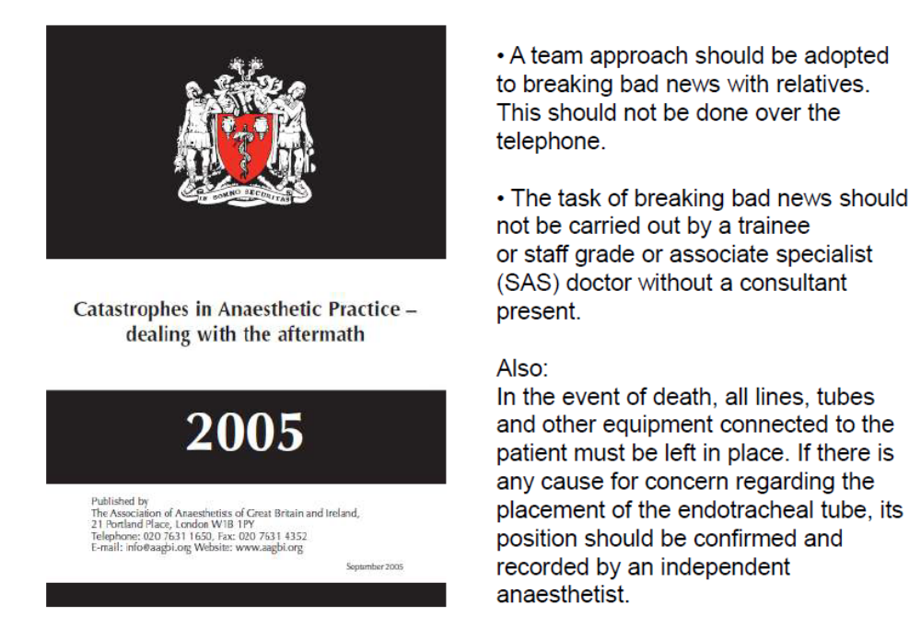

Inter & Intrahospital Patiient Transfer Guidelines

It is essential that a systematic approach is taken to the process of patient transfer; starting with the decision to transfer, through the pre-transfer stabilisation, and then the management of the transfer itself.
This will encompass all the stages including skilled evaluation, communication, documentation, monitoring and treatment, handover and return to base.

Decision to transfer

This must be made by a senior doctor, normally a consultant. Documentation of the decision should include name, grade and contact details of the doctor making the decision, and the time and date at which the decision was made.
While arranging the destination for the patient, all communication must be documented, including the name, grade and contact details of those making the arrangements both at the referring and receiving centres, the date and time of calls made and details of any advice received.

The transfer must be done by either bleep 6111 or 7647 anaesthetist for general and trauma cases, bleep 6890 PICU anaesthetist for paediatric cases and bleep 6392 obstetric anaesthetist for obstetric cases.
The duty floor consultant anaesthetist 8011 or the consultant on call must be informed prior to transfer.

Stabilisation before transfer

A transfer should not be undertaken until the patient has been resuscitated and stabilised.
It may be necessary to secure the airway with an endotracheal tube with appropriate end tidal carbon dioxide monitoring.
Intravenous access must be in place and basic monitoring instituted (non invasive blood pressure, continuous ECG and pulse oximetry).
For critically ill patients, continuous invasive blood pressure monitoring should be considered; however, treatment should not be delayed while waiting for the transfer.
Temperature monitoring should be considered, especially in paediatric patients.

Accompanying the patient

A critically ill patient should be accompanied by a minimum of two attendants. The precise requirement for accompanying personnel will depend upon the clinical circumstances in each case, a decision to be made by the named consultant of the patient.

A patient’s level of critical care needs is often used as a guide to transfer requirements:-

- Level 0: Patients, whose needs can be met through normal ward care, should not usually need to be accompanied by a doctor or nurse.
- Level 1: At risk of their condition deteriorating, or those recently relocated from higher levels of care require a nurse escort.
- Level 2: requiring more detailed observation or intervention including support for a single failing organ system or post operative care and those stepping down from higher levels of care must be escorted by a doctor and a nurse.
- Level 3: Patients requiring advanced respiratory support, or basic respiratory support with together with support of at least two organ systems. This level includes all complex patients requiring support for multi organ failure. These patients must be escorted by anaesthetists and skilled nurses.

All individuals involved in the transport of critically ill patients should be suitably competent, trained and experienced.
Emergency/Trauma ODP (operating department practitioner) can be contacted on bleep 6999.

Monitoring , drugs and equipment

Patients with level 1, 2 or 3 critical care needs will require monitoring during the transfer. Monitoring needs to be established and secure before the transfer is commenced. This may require the insertion of central venous and arterial lines.

The personnel involved in the transfer should ensure that they have adequate supplies of the necessary drugs. These may include sedatives, analgesics, muscle relaxants and inotropes. Many of these drugs are best prepared beforehand in prefilled syringes. It is also essential to ensure an adequate supply of oxygen cylinders.

As much of the equipment as possible should be mounted at or below the level of the patient. This allows easy access and improves stability of the patient trolley. All equipment should be robust, durable and lightweight. Electrical equipment must be designed to function on battery when not plugged into the mains. Additional batteries should be carried in case of power failure. Portable monitors should have a clear illuminated display and be capable of displaying ECG, arterial oxygen saturation, non invasive blood pressure, two invasive pressures, capnography and temperature. Non invasive blood pressure may rapidly deplete battery power and is unreliable when there is external movement and vibration. Alarms should be visible as well as audible in view of the loud background noise levels.

Adult transfer packs containing airway equipment (ETT/LMA/guedel/facemasks), IV equipment (cannulae, giving sets, fluids) and emergency drugs can be found in:-
- Accident and Emergency resuscitation dept
- General intensive care
- Cardiothoracic intensive care
- Neurointensive care
- Paul Calvert theatre 1.

Paediatric transfer packs containing airway equipment, IV equipment and emergency drugs can be found in:-
- Paediatric intensive care
- Accident and emergency resuscitation dept
- Paul Calvert theatre 1.

Contents of the transfer packs are checked by the individual departments (accident and emergency, general, cardiothoracic and paediatric intensive care units). The trauma ODP (BLEEP 6999) is responsible for checking the packs in Paul Calvert theatre 1.

Portable ventilators and monitors can be found in:-
- Accident and emergency resuscitation dept
- General intensive care
- Neurointensive care
- Cardiothoracic intensive care
- Paediatric intensive care
- St James theatre 3 (ventilator only)

Documentation and handover

Clear records should be maintained at all stages. This is a legal requirement, and should include details of the patient’s condition, reason for transfer, names of referring and accepting consultants, clinical status prior to transfer and details of vital signs, clinical events and therapy given during transport.
Inter/Intrahospital transfer sheets are found on the General Intensive care unit.

On arrival to the destination, there should be a formal handover between the transfer team and the receiving medical and nursing staff who will assume responsibility for the patient’s care.
Handover should include a verbal and written account of the patient’s history, vital signs, therapy and significant clinical events, as well as all relevant investigation results.

Special groups: Obstetric Patients

A Situation- Background- Assessment-Recommendation (SBAR) sticker must be used to facilitate the transfer/handover of care when antenatal/postnatal women are transferred both within and out of the hospital (SBAR stickers found on delivery suite).
- All transfers to another hospital must be done via the labour ward co-ordinator (bleep 8149). The consultant obstetrician and midwifery manager on call must also be informed. For further information please refer to: Transfer of the Obstetric patient, Chapter 13, Maternity Unit Guidelines, St George’s Hospital.

Special groups: Paediatric patients

Parents of paediatric patients may request to be present throughout the transfer, permission would be at the discretion of the paediatric anaesthetist.
There is an increased risk of hypothermia on transfer, so adequate warming must be undertaken.

References

- Interhospital Transfer, AAGBI Safety Guideline, February 2009.
- Guidelines for the Transport of the critically ill adult. 2002. London, The Intensive Care Society.
- Transfer of the Obstetric patient, Chapter 13, Maternity Unit Guidelines, St George’s Hospital
- Critical Care in the Emergency Department: Patient Transfer. Dunn, Gwinnott et al, Emerg Med J. 2007 Jan; 24(1): 40-44
- Guidelines and levels of Care for Paediatric Intensive Care Units. Crit Care Med 2004 Vol32, No. 10. Rosenburg and Moss.
- Paediatric Advanced Life Support, Resuscitation Council (UK) 2010
- Training and assessment of competency of trainees in the transfer of critically ill patients. Anaesthesia 2004; 59: 1248-9. Spencer et al.
- Outcome of critically ill patients undergoing interhospital transfer. The Medical Journal of Australia 2001; 174: 122-5
- Levels of critical care for adult patients. 2002 London, The Intensive Care Society

Dr H Bagia
Consultant Anaesthetist
May 2015
For review 2018

Eating and Drinking by Staff in the Theatre Environment
(Guidelines June 2013)

Rationale:
The evidence around harm to patients by food in the theatre environment is unclear. However, clinical areas such as anaesthetic rooms, theatres and preparation rooms should generally not be used for non-clinical items. There seems to be sufficient evidence that activities by theatre staff involving hand-to-nose, hand-to-mouth or hand-to-eye action increases the likelihood of occupational exposure to infectious material therefore eating is generally prohibited in the operating theatre. However, especially anaesthetic staff are often required to work long shifts without access to areas where eating and drinking is acceptable. The risk of these staff members not receiving adequate hydration and nutrition outweighs the potential small risk to patient. If anaesthetist were required to leave the anaesthetic room to have food and drink, the impact on operational efficiency has its own clinical risk.

Who does it apply to?
It applies to anaesthetic and other theatre staff in cases where they are unable to take regular breaks outside of theatres.

It does not apply to theatre staff members who are able to take regular breaks.

Where does it apply?
It applies in the anaesthetic rooms only.

It does not apply to operating theatres, theatre corridors, preparation rooms and any other clinical areas where eating is strictly forbidden. Only clear fluids in closed bottles are permitted in these areas.

Guidance
Non scrubbed theatre anaesthetists are permitted to eat/drink in the anaesthetic room with the following precautions:
- Food and drinks should only be consumed if there are no patients in the anaesthetic room
- Food or drink must not be consumed at the same time as IV drugs are being prepared.
- No hot or smelly food should be consumed.
- No raw or cured meats should be consumed – e.g. salamis
- Prior to returning to the theatre the worktop is cleaned using a detergent wipe.
- Hands are decontaminated before meals and before returning to the theatre.
- Food and drinks should not be visibly kept in anaesthetic rooms.
- Food and drinks should not be stored in a clinical fridge (eg drug fridge). Any food found in these fridges will be removed and disposed of and disciplinary action taken.
- Packaging and unconsumed food must be disposed of in a general waste bin outside the anaesthetic room.
- Dropped food must be cleaned up immediately using a detergent wipe.
- The anaesthetic room must be cleaned daily.

Renate Wendler: (Consultant Anaesthetist & Care Group Lead for Theatres)
Catharine Stirling (Head of Theatres)
Matthew Laundy (Consultant Microbiologist and Trust Infection Control Doctor)

SGUL guidance on involving medical students in the provision of clinical care:

October 2013
Introduction
Medical students are involved in clinical care, with the consent of patients. Normally, there is little risk of hazard to the patient due to the limited involvement and responsibility of students, but on occasion students may be involved in performing aspects of care which are potentially hazardous for patients, even under direct supervision e.g. ordering investigations or some practical procedures.
This guidance seeks to balance:
- the educational needs of medical students to be involved in clinical care to learn and develop as medical professionals;
- the rights of patients to expect high quality care and to choose whether supervised students are involved in the delivery of care.
Context for the performance of procedures and other patient care by medical students
- Medical students are not qualified doctors, and are not registered by the General Medical Council.
- Practical procedures and other involvement in clinical care by medical students takes place in clinical environments which hosts GUL undergraduates.
- The actions of, and involvement in patient care by, medical students is under the supervision of the senior clinical attachment lead, normally the responsible General Practitioner or Consultant.
- Medical students training in NHS clinical placements are indemnified through the indemnity of their senior clinical supervisors–usually NHS indemnity for NHS Consultants, and indemnity arranged by supervising NHS General Practitioners.

Expectations of patients regarding student involvement in patient care
- The involvement of medical students in patient care is contingent on meaningful patient consent to their involvement (including the consequences of student involvement), as set out in the GMC guidance on clinical placements.1

Expectations of students regarding student involvement in patient care
- The responsibilities of medical students are set out in the joint General Medical Council/Medical Schools Council guidance: Medial students: Professional values and fitness to practise.² The guidance stresses the importance of patient consent to the involvement of medical students, and in particular, that medical students should ensure patients are aware of the student’s unqualified status.
- The guidance also requires students not to exceed their capabilities, and to seek supervision when they are uncertain of their capabilities.

Supervision by clinical teams
The GMC recognises that clinical care is usually delivered by medical staff (and others) of differing seniority and experience, and makes explicit how the Consultant’s supervisory responsibility may be delegated to others in the clinical team providing appropriate training and support is provided:
‘Different grades of doctors are able to provide different levels of supervision for medical students.
- Consultants or General Practitioners should be the doctors who have overall responsibility for the supervision of medical students. They can make informed judgements as to the day-to-day supervision that the individual medical student requires based on the previous experience of that student and the types of tasks they may have to complete.
- Middle grade doctors, including specialty trainees and specialty doctors, can support students by providing educational and coaching opportunities. They are able to provide supervision to medical students where a consultant has approved for them to do so.
- F1 and F2 doctors can oversee students in carrying out simple tasks but they should not have overall responsibility for supervision of the medical student. F1 and F2 doctors should act in this limited capacity only where they are fully competent to carry out the task that they are observing themselves. Other registered healthcare professionals may observe the work of medical students in a similar way to an F1 or F2 doctor*.
- All those responsible for supervising, coaching or overseeing medical students should be trained, supported and briefed to carry out this role.’¹
Principles guiding the involvement of medical students in patient care.
Most supervised student involvement in patient care (history, examination, case discussions, and non-hazardous procedures) involves little risk to patients and can be justified to the patient and Medical School.
When involving a student in the delivery of clinical care, the supervising Consultant or General Practitioner should consider the following issues:
- Is the procedure/care to be performed by the student part of care that is necessary and indicated for this patient?
- What is the degree of potential hazard to the patient from the procedure? Is the risk of any hazard increased by performance of the procedure/care by an undergraduate medical student, even under direct supervision?
- Is learning to perform a practical procedure appropriate to the level of training of the learner? For medical students,normal reference would be to the SGUL MBBS undergraduate curriculum and the Foundation Programme Curriculum.³ For procedures/care outside the curriculum and which is normally performed by qualified doctors only, is there an educational case to be made by the supervising Clinician for student involvement?
- Has the Consultant/General Practitioner evaluated the student's level of experience or skill in deciding whether to involve him or her in this aspect of patient care?
- Is the proposed clinical supervisor (Consultant/General Practitioner, or delegated clinician see above or reference 1)competent in the procedure or care concerned and able to directly supervise the student?
- Can the Consultant/General Practitioner provide a reasoned account to the patient, employer and Medical Schoolof his or her decision to involve a student in the delivery of specific care?
For more invasive and potentially hazardous procedures, even when supervised and with patient consent (such as, but not exclusively, chest drains, central lines, organ biopsy, insertion of intrauterine device), the increased risk to the patient and the minimal educational benefit to the student in occasionally performing a procedure normally performed by qualified doctors, would not be seen to justify the performance of a procedure by a student.

Are students able to perform practical procedures on patients who are unable to consent to student involvement e.g. intensive care?
Where patients lack capacity to provide consent e.g. in settings such as intensive care, the responsibility lies with the consultant to weigh the appropriateness of a student being involved in any aspect of care and to take responsibility for the student's participation. In so doing, the consultant should consider the principles cited above, and also consider:
vii) Is this a procedure or clinical experience that can only be obtained when working with patients who lack capacity?
Which procedures are medical students normally allowed to do?
SGUL MBBS students will normally perform (if considered competent to do so by their clinical supervisors) , under supervision and with patient consent, the clinical care as required by the SGUL curriculum - including practical procedures required by the Doctor as Professional domain – see Appendix. This list of procedures has been mapped to those in the Foundation Programme Curriculum and Tomorrow’s Doctor.^{3,4}
Students may be taught other procedures/aspects of care during clinical attachments, but decisions about whether students should be taught any procedure would be subject to the principles cited above.
References
- Clinical placements for medical students. Advice supplementary to Tomorrow’s Doctors 2009. GMC 2009. [http://www.gmc-uk.org/Clinical_placements_web.pdf_38514214.pdf]
- GMC/MSC Guidance. Medical students: Professional values and fitness to practise. GMC. 2009. [http://www.gmc-uk.org/education/undergraduate/professional_behaviour.asp]
- The Foundation Programme Curriculum 2013 [http://www.foundationprogramme.nhs.uk/index.asp?page=home/keydocs#c&rg]
- GMC. Tomorrow’s Doctors. 2009 [http://www.gmc-uk.org/TomorrowsDoctors_2009.pdf_39260971.pdf]

Appendix 1
Which practical procedures for T and P Years?
These are the core practical procedures students should aim to have experience of, under supervision, by the end of T and P year (see table below).
10 in T year
10 different procedures in P year and a minimum of 15 different procedures by the end of P year

Assessment standard: ‘safe, under supervision, and procedurally correct’

Diagnostic | Therapeutic
DOPS
Venepuncture and management of blood forms and bottles | Insertion an intravenous cannula
Venepuncture for blood cultures | Observation of, or performance of, the setting up an intravenous fluid infusion and use of infusion device
Measuring peak flow reading and interpreting reading | Observation of, or performance of, the preparation and administration of an intravenous medicine
Recording ECG | Intramuscular injection
Taking an arterial blood gas sample and interpreting the results. | Subcutaneous injection
Transcutaneous pulse oximetry and interpretation of results | Insulin injection and instructing patient how to do it
Male urinary catheterization
Female urinary catheterization
Nasogastric tube insertion
Diagnosis of death | Discussion of a safe but therapeutic concentration of oxygen and  administration of that oxygen prescription

Which practical procedures for Final Year
Standard: ‘Safe, supervised, procedurally correct and successful’
For the Doctor as Professional assessment domain, students are expected to have completed:
- a minimum of 12 (excluding the compulsory CC&A DOPS) different procedures listed by the end of F Year, if the 12 procedures are not completed, students will need to defer the F Year Assessments and complete the list of procedures in the F Year elective.
These are the core practical procedures students should aim to have experience of, under supervision, by the end of the F Year.

F year Diagnostic | F year Therapeutic
Venepuncture for blood sample for cross matching | Inserting an intravenous cannula | Administering a blood transfusion or blood products
Taking an arterial blood gas sample and interpreting the results. | Preparation of an intravenous infusion and use of infusion device | Skin suturing, wound care and basic wound dressing
Clinical diagnosis of death | Preparation and administration of an intravenous medicine | Male urinary catheterisation
Venous sample for blood cultures | Sub-cutaneous injection | Female urinary catheterisation
 | Intramuscular injection | Insertion of a nasogastric tube
 | Use of local anaesthetic for suturing

Drugs

STORAGE SUMMARY

DANTROLENE | Malignant hyperthermia  Dantrolene  - Starting dose of 12 x 20mg present in MH Box  - Subsequent dose to be obtained from pharmacy  - The action cards are attached to each box and every anaesthetic machine in the hospital
  Neuro Recovery | St James’ Recovery | Lanes 1st Floor Recovery | Lanes 5th Floor Recovery | DSU Recovery
FLUMAZENIL & NALOXONE | In drug cupboards
INTRALIPID | Is located in the crash trolley every theatre suite recovery
  REMOTE SITES
  Endoscopy, Cath Labs, Neuro-radiology
  (To request location as crash trolleys)
  DSA, Lanes CT, Lanes MRI
  To be serviced by ‘Remote Site Trolley’
  Block Trolleys (Paul Calvert and DSU)
  A&E Medication Cupboard
SUGAMMADEX | - Ordered via CD book to ensure stock maintained  - Locations in the following CD Cupboards  - Also located in the 3 ICUs  - Plan to arrange supply in remote site trolley and stock for A&E to be confirmed
  Neuro Theatre 1 | St James’ Theatre 3 | Lanes Theatre 3 | DSU Theatre 1 | Moorfields Hospital Supply to Lanes Theatre 4, 5th Floor

Drug ampoules and boxes
- Do not replace unused ampoules taken out of packaging

Medical error due to packaging and ampoules looking similar (SDU 21/04/13)
Action
  - DON’T PUT AMPOULES BACK
  - EITHER DRAW THEM UP OR KEEP IN OWN PACKAGING
  - Don’t open and put differing emergency ampoules together (e.g. in white plastic trays) since they look similar

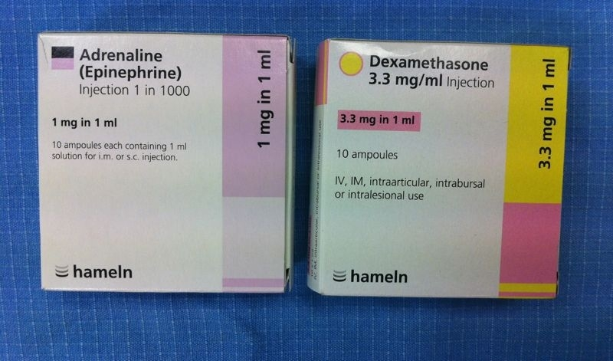

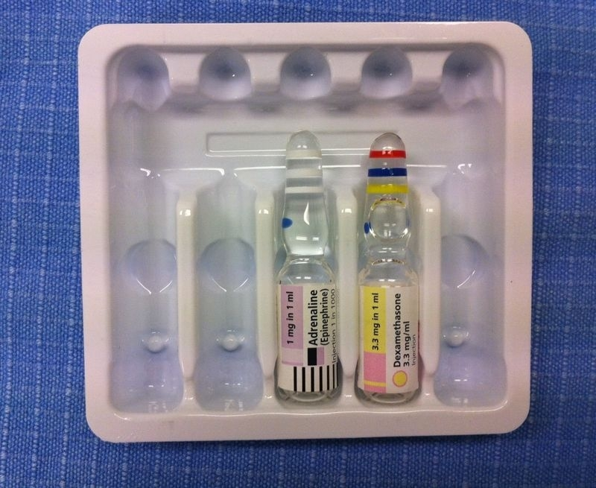

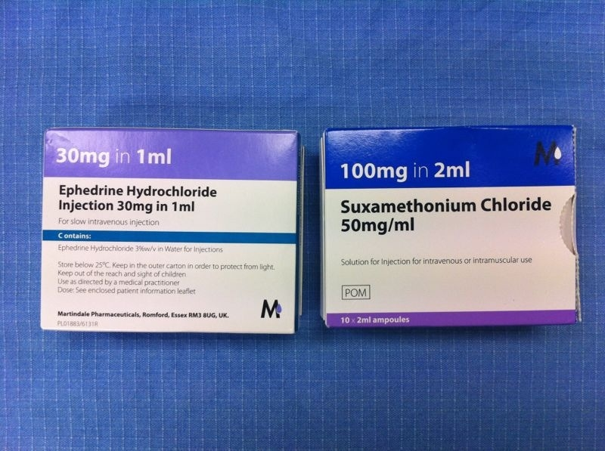

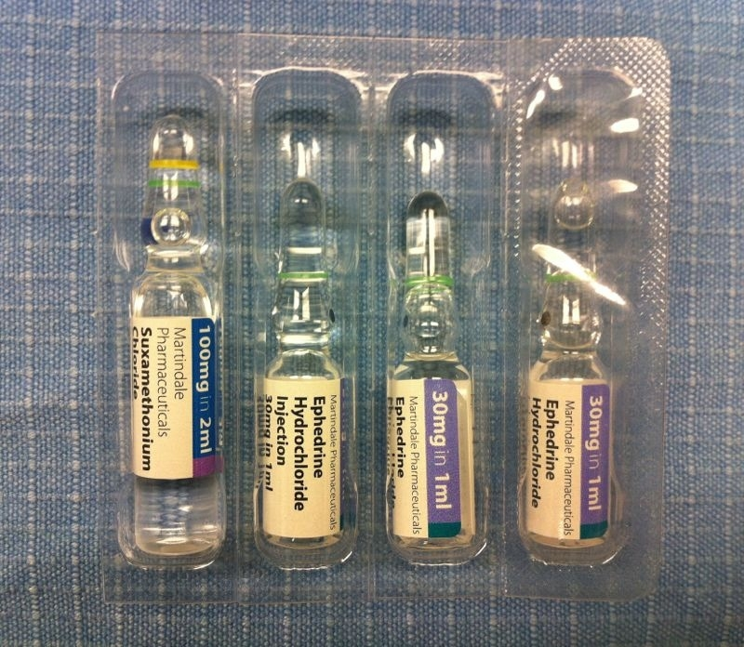

Sugammadex
June 2012
“Sugammadex is licensed for reversal of the neuromuscular blocking agents, rocuronium and vecuronium. It is a highly selective drug, designed specifically to encapsulate and inactivate the above neuromuscular blockers (NMBs) within 2 to 3 minutes of administration. It is capable of reversal of rocuronium and vecuronium only and is ineffective for reversal of all other NMBs.”

It is being kept in:
- CARDIAC THEATRE 1 CD CUPBOARD FOR AMW
- ST JAMES’S THEATRE 3 CD CUPBOARD FOR ST JAMES’S WING
- LANESBOROUGH THEATRE 1 FOR LANESBOROUGH WING

There have been concerns about the use of sugammadex in the anticipated and unanticipated difficult airway.

A recent case report highlights several decision-making issues in airway management i.e. ensuring the “right personnel, right equipment and right technique” are used. http://bja.oxfordjournals.org/content/early/2012/01/26/bja.aer494.full.pdf+html

Sugammadex should complement, rather than obviate, the need for a logical Plan A, B, C for very difficult airways including appropriate and timely consideration of elective/urgent awake techniques (fibreoptic intubation or tracheostomy) as highlighted by the NAP4 report.

BRIDION®▼100 mg/ml solution for injection
Summary of Product Characteristics

Adults
Routine reversal:
A dose of 4 mg/kg sugammadex is recommended if recovery has reached at least 1-2 post tetanic counts (PTC) following rocuronium or vecuronium induced blockade. Median time to recovery of the T4/T1 ratio to 0.9 is around 3 minutes (see section 5.1).

A dose of 2 mg/kg sugammadex is recommended, if spontaneous recovery has occurred up to at least the reappearance of T2 following rocuronium or vecuronium induced blockade. Median time to recovery of the T4/T1 ratio to 0.9 is around 2 minutes (see section 5.1).

Using the recommended doses for routine reversal will result in a slightly faster median time to recovery of the T4/T1 ratio to 0.9 of rocuronium when compared to vecuronium induced neuromuscular blockade (see section 5.1).

Immediate reversal of rocuronium-induced blockade:
If there is a clinical need for immediate reversal following administration of rocuronium a dose of 16 mg/kg sugammadex is recommended. When 16 mg/kg sugammadex is administered 3 minutes after a bolus dose of 1.2 mg/kg rocuronium bromide, a median time to recovery of the T4/T1 ratio to 0.9 of approximately 1.5 minutes can be expected (see section 5.1).

There is no data to recommend the use of sugammadex for immediate reversal following vecuronium induced blockade.

Pain relief
SDU April 2013

IMMEDIATE POSTANAESTHETIC RECOVERY (AAGBI September 2002)
“Pain and emesis should be controlled and suitable analgesic and anti-emetic regimens prescribed”
- Write post op analgesia for all patients

Diclofenac
July 2010

The only proven compatable diluents are 0.9% sodium chloride or 5% glucose. For this reason, do not dilute in Hartmann's as compatability is not guaranteed. It is necessary to buffer diclofenac injection (with 8.4% sodium bicarbonate) irrespective of which diluent is used as the solution for injection formed is acidic in nature and may be irritant to the patient if unbuffered.

The dilution factor recommended is 100ml to 500mls to dilute 75mg (of either sodium chloride or glucose).

St Georges Healthcare NHS Trust Memorandum
Date: 17th July 2013

The European Medicines Agency’s Pharmacovigilance Risk Assessment Committee has recently recommended updates to the treatment advice for diclofenac in light of the findings of a Europe-wide review of the cardiovascular safety of Non Steroidal Anti-Inflammatory Drugs (NSAIDs).

Advice for all healthcare professionals:
• Diclofenac is now contraindicated in patients with established:
o ischaemic heart disease
o peripheral arterial disease
o cerebrovascular disease
o congestive heart failure (New York Heart Association [NYHA] classification II–IV)

Patients with these conditions should be switched to an alternative treatment at their next routine appointment

• If an NSAID is required, naproxen or low-dose ibuprofen are considered to have the most favourable thrombotic cardiovascular safety profiles of all non-selective NSAIDs
• The decision to prescribe any NSAID should be based on an assessment of a patient’s individual risk factors including any history of cardiovascular and /or gastrointestinal illness
• If Diclofenac treatment is required this should only be initiated after careful consideration for patients with significant risk factors for cardiovascular events (e.g. hypertension, hyperlipidaemia, diabetes mellitus, smoking)

Codeine
(July 2013)

http://www.mhra.gov.uk/Safetyinformation/DrugSafetyUpdate/CON296400
Advice for healthcare professionals:
- Codeine should only be used to relieve acute moderate pain in children older than 12 years and only if it cannot be relieved by other painkillers such as paracetamol or ibuprofen
- Codeine is contraindicated in all children (ie, younger than 18 years) who undergo tonsillectomy or adenoidectomy (or both) for obstructive sleep apnoea
- Codeine is not recommended for use in children whose breathing might be compromised, including those with: neuromuscular disorders; severe cardiac or respiratory conditions; upper respiratory or lung infections; multiple trauma; or extensive surgical procedures. The symptoms of morphine toxicity may be increased in these settings
- In children age 12–18 years, the maximum daily dose should not exceed 240 mg. This may be taken in divided doses, up to four times a day at intervals of no less than 6 hours. It should be used at the lowest effective dose for the shortest period. Duration of treatment should be limited to 3 days and if no effective pain relief is achieved, treatment should be reviewed by a physician
- Information should be given to parents and caregivers on how to recognise the signs of morphine toxicity, and advice should be given to stop giving the child codeine and to seek medical attention immediately if their child is showing these signs or symptoms
- Symptoms of codeine toxicity include: reduced levels of consciousness; lack of appetite; somnolence; constipation; respiratory depression; ‘pin-point’ pupils; or nausea and vomiting
- Codeine is contraindicated in all patients of any age known to be CYP2D6 ultra-rapid metabolisers
- Codeine should not be used by breastfeeding mothers because it can pass to the baby through breast milk and potentially cause harm
SGH obstetrics handbook
Codeine and breastfeeding is common knowledge in the obstetric anaesthesia community, and our practice was changed after the FDA alert (2007) and has been in line with current recommendations for years.

Please refer to page 73 of the obstetric anaesthesia handbook with its recommended regimen for post CS analgesia.

For ALL obstetric anaesthesia related issues trainees should refer to the obs handbook and should have good reason before deviating from it.

Midazolam

To avoid further incidents with different preparations of Midazolam, we have agreed the following:
- Midazolam 2mg/2ml will be kept in all CD cupboards in the anaesthetic rooms
- Midazolam 10 mg/2ml (for oral/nasal premedication etc) will be stored in theatre recoveries only

Please be aware of two different preparations of Midazolam if you work in these theatres. Any other preparations of Midazolam should be returned to pharmacy.

Ondansetron

Ondansetron for intravenous use: dose-dependent QT interval prolongation—new posology

Article date: July 2013

Summary
There is new guidance for intravenous use of ondansetron in relation to: repeat dosing for all adults; dosing for prevention of chemotherapy-induced nausea and vomiting in patients age 75 years or older; and dilution and administration for patients age 65 years or older

Ondansetron (brand leader Zofran) is indicated for the prevention and treatment of nausea and vomiting induced by cytotoxic chemotherapy and radiotherapy, and for the prevention and treatment of postoperative nausea and vomiting.

Prolongation of QTc interval and cardiac arrhythmia, including Torsade de Pointes, are known risks with ondansetron. In the August 2012 issue of Drug Safety Update, we informed you about the results of a study that showed ondansetron causes a dose-dependent prolongation of QTc, and about new recommendations for the maximum single intravenous dose in adults.

Further analyses of the results of this study, together with other data sources, have enabled greater understanding of the relation between dose and risk of QT prolongation. As a result, further specific guidance is available for intravenous ondansetron in relation to: repeat dosing in all adults; dosing for prevention of chemotherapy-induced nausea and vomiting (CINV) in patients age 75 years or older; and dilution and administration for patients age 65 years or older.

Advice for healthcare professionals:
New advice
Patients age 75 years or older:
- A single dose of intravenous ondansetron for the prevention of CINV must not exceed 8 mg (infused over at least 15 minutes)
Adult patients younger than 75 years:
- A single dose of intravenous ondansetron prevention of CINV must not exceed 16 mg (infused over at least 15 minutes)
Dilution and administration in patients age 65 years or older:
- All intravenous doses should be diluted in 50–100 mL saline or other compatible fluid and infused over at least 15 minutes
Repeat dosing in all adults (including elderly patients):
- Repeat intravenous doses of ondansetron should be given no less than 4 hours apart
Reminder of previous advice (from August 2012)
- Ondansetron should be avoided in patients with congenital long QT syndrome
- Caution must be used if administering ondansetron to patients with risk factors for QT interval prolongation or cardiac arrhythmias. These include: electrolyte abnormalities; use of other medicines that prolong QT interval (including cytotoxic drugs) or that may lead to electrolyte abnormalities; congestive heart failure; bradyarrhythmias; or use of medicines that lower heart rate
- Hypokalaemia and hypomagnesaemia should be corrected before ondansetron administration
Further information
There are no changes to the recommended dosing for ondansetron use in the following settings:
- oral or rectal administration for CINV in any adult (including elderly patients)
- intravenous or oral use for prevention and treatment of postoperative nausea and vomiting in any adult (including elderly patients)—maximum recommended oral dose in this setting is a single dose of 4 mg
- intravenous or oral use for either indication in children (age >6 months and adolescents)
The Summaries of Product Characteristics should be consulted for further information. Information is also available in BNF section 4.6 (drugs used in nausea and vertigo).
Remember that you can report suspected side effects to ondansetron on a Yellow Card (www.mhra.gov.uk/yellowcard).
Article citation: Drug Safety Update vol 6 issue 12, July 2013: A3.

VTE Prophylaxis
The Department of Health has stated that reduction of VTE related to hospital admission is a top clinical priority for 2010/2011. A CQUIN target has been set of 90% VTE risk assessment for all in patients this year.

As part of the National VTE Prevention Programme, all Trusts must provide evidence that they have performed the following:
- Carry out VTE risk assessment on ALL hospitalised patients, including day cases, using a version of the NHS tool. We must document that VTE risk assessment has been carried out on admission, again after 24 hours and again when clinical conditions change. Our target is 90% by the end of this year, rising to 100% subsequently. The baseline data must be submitted monthly from the end of this month and must show improvement during each quarter.
- To administer appropriate prophylaxis based on the risk assessment, weighing up the VTE risk versus the risk of bleeding for each patient.
- To ensure patients are given information about VTE risk on admission and discharge.
- To demonstrate patients have been encouraged to mobilise
- To carry out root cause analysis on every DVT or PE occurring within 90 days of a hospital admission.





Diabetic Control
Variable rate IV insulin protocol for procedure/NBM/Surgery
- Aim to maintain blood glucose between 6 - 10mmol/l in order to maintain adequate metabolic control and reduce the risk of hypoglycaemia, particularly under anaesthesia
- IV INSULIN REGIMEN requires a DEDICATED CANNULA. Both IV Insulin and glucose should be delivered via an infusion device/ pump through a non-return device (eg Codan R-LOCK Check Valve)
IV INSULIN INFUSION via syringe driver  50 units of Actrapid ® made up to 50 ml with Sodium Chloride 0.9% to give a 1 unit/ml solution.  *Use scale 2 in type 2 diabetes unless BMI over 35kg/m² or severe illness when scale 3 is advised. | TOGETHER WITH | GLUCOSE / POTASSIUM INFUSION via infusion pump  - 500ml of Glucose 10% with 10mmol (0.15%) Potassium Chloride.  - Start and continue infusion at 85 ml/hr (500ml in 6 hours).  NB: Glucose must continue whilst insulin infusion continues.
  Capillary blood glucose (CBG) (mmol/L) | Scale 1 Start if usual insulin <30units/ day | *Scale 2  Start if usual insulin  30-60units/day.  Also use if patient is not usually on insulin | Scale 3  Start if usual insulin >60units/ day
  Capillary blood glucose (CBG) (mmol/L) | Insulin infusion rate (Units/hr)
  ≤3.9 | 0.5 and treat hypoglycaemia
  4-6.9 | 0.5 | 1 | 2
  7-9.9 | 1 | 2 | 3
  10-14.9 | 2 | 3 | 4
  15-19.9 | 3 | 4 | 5
  ≥20 | 4 | 5 | 6
 | TOGETHER WITH | GLUCOSE and POTASSIUM MONITORING  - Monitor capillary blood glucose (CBG) hourly whilst on VRIII  - When insulin infusion and CBG stable for 2 hours and patient conscious and no clinical changes, then monitor CBG 2 hourly whilst on VRIII  - Check venous blood potassium every 2-4hours.

FLUID REPLACEMENT / MAINTENANCE
Fluid (and sodium) replacement should be considered separately and prescribed separately according to the patient’s clinical need. Insert a second cannula for this purpose.

Adjusting insulin infusion and treating hypoglycaemia
NB: Insulin requirements may increase with inter-current illness.
- If CBG remains ≥12mmol/L for 3 consecutive readings AND is not dropping by ≥3mmol/L/hr, increase insulin dose to next scale or by 1 unit/hr. (Check insulin infusion pump is working and connected before adjusting)
- If CBG is ≤3.9mmol/L then reduce insulin infusion to 0.5 units/hr, continue with the 10% glucose & potassium infusion and treat the hypoglycaemia with 100ml Glucose 20% STAT and repeat CBG after 10-15 minutes. If after 10-15 minutes, CBG remains ≤3.9mmol/l, repeat glucose bolus and contact Diabetes team or the Anaesthetist if out of hours.

Stopping the Intravenous Insulin and Glucose/Potassium infusion
- Only do this when the patient is eating and drinking normally and nausea / vomiting are controlled
- If previously NOT using insulin: Stop infusion at any time and restart usual therapy if appropriate at the usual times
- If previously using insulin:
- The dose(s) of subcutaneous insulin should be given as indicated in the table below
- Stop the IV Insulin and Glucose/Potassium infusion one hour after the 1st dose of subcutaneous insulin
- Institute capillary blood glucose (CBG) monitoring pre meal and pre bed

http://stginet/Units%20and%20Departments/Anaesthetics/Documents/AM%20DM%20Fasting.pdf

http://stginet/Units%20and%20Departments/Anaesthetics/Documents/AM%20DM%20Fasting.pdf
Restarting usual subcutaneous insulin therapy
Usual Subcutaneous Insulin Regimen | If planning to restart subcutaneous insulin at:
Usual Subcutaneous Insulin Regimen | Breakfast | Lunch | Supper
BD Biphasic e.g. Novomix30 | Give usual AM dose then usual regimen thereafter | Give ½ of usual AM dose STAT then usual regimen thereafter | Give usual supper dose then usual regimen thereafter
BD Long or Intermediate acting e.g. Insulatard or Levemir | Give usual AM dose then usual regimen thereafter | Give ½ of usual AM dose STAT then usual regimen thereafter | Give usual supper dose then usual regimen thereafter
Morning Once Daily Long e.g. Lantus or Intermediate acting insulin | Give usual AM dose then usual regimen thereafter | Give 3/4 of usual AM dose STAT then usual regimen thereafter | Give ½ usual AM dose STAT then usual
Nocte Once Daily Long or Intermediate acting Insulin. | Give ½ of usual nocte dose STAT then usual regimen thereafter | Give 1/3 of usual nocte dose STAT then usual regimen thereafter | Give usual nocte dose at supper instead of at bedtime, then usual regimen thereafter
Basal bolus regimen e.g. Lantus + Novorapid. | Long acting (basal) insulin should be administered first as indicated above, followed by the usual dose of rapid acting insulin with meals.

IV INSULIN CHART Name: Hospital No: DOB Ward:
INTRAVENOUS INFUSION via infusion pump
PRESCRIPTION |  |  |  |  |  | ADMINISTRATION
Date | Fluid | Volume | Additives* | Duration | Signature | Batch | Start | Signature | Finish | Signature
  - *If potassium is <4mmol/L then change Glucose infusion from 0.15% Potassium Chloride in 10% Glucose (10mmol K⁺ in 500ml) to 0.3% Potassium Chloride in 10% Glucose (20mmol K⁺ in 500ml) and recheck potassium after 2hrs
  - If potassium is <3mmol/L then discuss with the anaesthetists
  - If potassium is >5.5mmol/L then use 10% Glucose (500mls) and recheck potassium after 2hrs

INTRAVENOUS INSULIN PRESCRIPTION  (via syringe driver) | Date &Time | PrescriberSignature & Bleep | Batch No | Start Time | Nurse  Signature | Finish Time | Nurse  Signature
50 units Actrapid® made up to 50ml with sodium chloride 0.9%
50 units Actrapid® made up to 50ml with sodium chloride 0.9%
50 units Actrapid® made up to 50ml with sodium chloride 0.9%

VARIABLE RATE INTRAVENOUS INSULIN INFUSION PRESCRIPTION
Delete scales not required. Use new column (delete previous prescription) each time insulin scale is changed.
Capillary Blood Glucose (mmol/L) | Scale1 | Scale 2 | Scale 3 |  | Insulin  Units/hr | Insulin  Units/hr | Insulin  Units/hr | Insulin  Units/hr | Insulin  Units/hr
Capillary Blood Glucose (mmol/L) | Insulin (Units/hr)
≤3.9 + call Dr | 0.5 and treat hypoglycaemia
4-6.9 | 0.5 | 1 |  | 2
7-9.9 | 1 | 2 |  | 3
10-14.9 | 2 | 3 |  | 4
15-19.9 | 3 | 4 |  | 5
≥20 + call Dr | 4 | 5 |  | 6
Prescriber Signature
Bleep No
Date &
Time

IV INSULIN CHART Name: Hospital No: DOB Ward:
SYRINGE DRIVER CONTROLLED INSULIN INFUSION  Monitor and record CBG hourly |  |  |  |  |  |  | RESULTS  Monitor electrolytes regularly
Date &  Time | Capillary  Blood Glucose | Insulin Rate units/hr | Volume left in syringe (ml) | Volume infused in one hour (ml) | Total Volume Infused  (ml) | Signature | Sodium  Range  135-145 mmol/ | Potassium  Range  4 -5.5 mmol/L
Recheck electrolytes and review fluid status

A&E Guidelines on Drugs

New A&E guidelines:

[24/09/2012]
- All ED [Emergency Department] staff to document the dose and type of local anaesthetic used for ALL nerve blocks performed in the ED on the once only page of the drug chart.
- Nurses to ensure handover to ward teams to this information also.
- Anaesthetists – please review the copy of the drug chart especially in those going to theatre as an emergency as ED doctors may have administered opiates, benzodiazepines, ketamine or other drugs commonly used in the ED.

[17/05/2012]
- Drug charts to be photocopied (even if blank, to avoid actual or potential confusion) and to accompany all patients’ notes.

Machine Check Competency

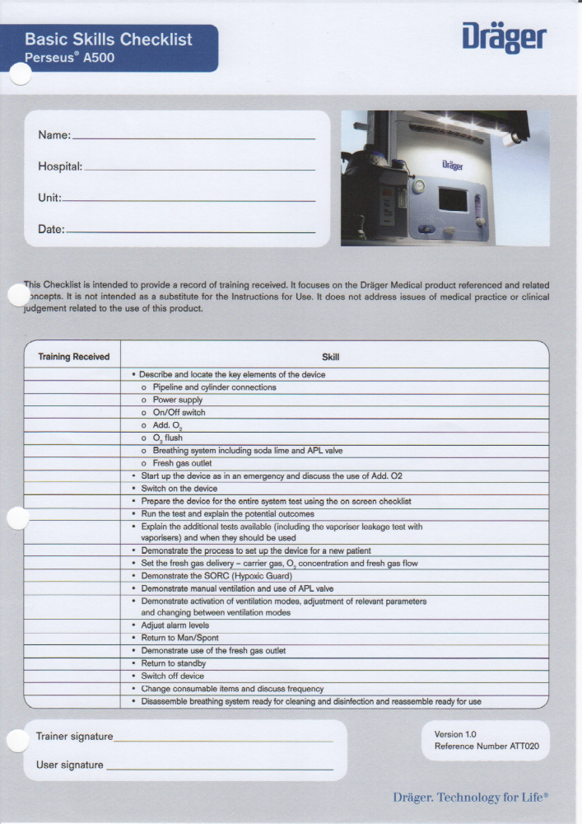
Adverse Incident Reporting

Please log all adverse incidents
- Trust incidents
- Go to Intranet Homepage
- Click on “Applications” (left hand margin)
- Scroll down to “Non Clinical Applications”
- Click “Datix – Electronic Incident Reporting”
- http://stg1datix01/datix/live/index.php

- Anaesthetic related
- Go to Intranet Homepage
- Click on “Units and Departments” (left hand margin)
- Click on “Anaesthesia”
- Scroll down to “Referrals/Forms”
- Click on “Link for adverse incident reporting: eforms.npsa”
- https://www.eforms.npsa.nhs.uk/staffreport/

St. George’s grading matrix of Adverse Incidents
- Taken from the National Patient Safety Agency (NPSA) and the National Reporting and Learning System - NRLS

Grade of patient safety incidents | Definition
No harm | Incident prevented – any patient safety incident that had the potential to cause harm but was prevented, and no harm was caused to patients receiving NHS-funded care.  Incident not prevented – any patient safety incident that occurred but no harm was caused to patients receiving NHS-funded care.
Low harm | Any patient safety incident that required extra observation or minor treatment⁽¹⁾ and caused minimal harm to one or more patients receiving NHS-funded care
Moderate harm | Any patient safety incident that resulted in a moderate increase in treatment⁽²⁾ and that caused significant but not permanent harm to one or more patients receiving NHS-funded care
High harm | Any patient safety incident that appears to have resulted in permanent harm⁽³⁾ to one or more patients receiving NHS-funded care.
Extreme harm | Any patient safety incident that directly resulted in the death⁽⁴⁾ of one or more patients receiving NHS-funded care

(1) Minor treatment is defined as first aid, additional therapy, or additional medication. It does not include any extra stay in hospital or any extra time as an outpatient, or continued treatment over and above the treatment already planned; nor does it include a return to surgery or readmission.

(2) Moderate increase in treatment is defined as a return to surgery, an unplanned readmission, a prolonged episode of care, extra time in hospital or as an outpatient, cancelling of treatment, or transfer to another area such as intensive care as a result of the incident.

(3) Permanent harm directly related to the incident and not related to the natural course of the patient’s illness or underlying condition is defined as permanent lessening of bodily functions, sensory, motor, physiological or intellectual, including removal of the wrong limb or organ, or brain damage.

(4)The death must be related to the incident rather than to the natural course of the patient’s illness or underlying condition.

Guideline for Anaesthesia in MRI
(This guideline needs to be used in conjunction with anaesthesia or sedation in remote locations)

Version No: | 2
Authorisation: | Neuro Anaesthetic Care Group
Date Of Authorisation: | March 2015
Date Of Issue: | March 2015
Review Date: | March 2017
Pages: | 4
Produced By: | Roopa S Devanahalli (Cons Anaes)

Introduction:

Anaesthesia in the MRI suite can be potentially hazardous, if undertaken without prior thought and planning. However, as demand for this service increases (including intra-operative MRI for neurosurgery), anaesthetists should become familiar with the requirements in the MRI suite, so that, the high anaesthetic standards expected in the operating theatre can also be achieved in this challenging environment, providing patient comfort, safety and high quality images.

Anaesthetic issues:

1: Remote Location: Scanner will be situated outside the operating theatres so all issues of anaesthesia in remote location apply.

2: Specific patient characteristics: Patients requiring MRI scan tend to fall into categories as mentioned below.

2.1 Paediatric patients between the ages of 3 months and six years will generally need a GA.
Children under the age of 3 months can commonly be scanned following “feed and
Wrap’ without sedation.

2.2 Patients with intellectual impairment or other neurological disorders with involuntary movements or patients with rheumatoid arthritis that prevents them lying still for the requisite time, confused patients due to acute illness, claustrophobic patients and critically ill intensive care patients who are sedated while on ventilators require GA or sedation.

2.3 Intensive care patients: This group presents a high-risk population, especially those on vasoactive infusions.
Patients transferred from the intensive care unit to MRI require full monitoring by an anaesthetist during transfers as well as during the imaging investigation. Patients for these procedures should not be moved to MR until they are stable unless the cause of that instability requires immediate diagnosis to enable treatment to be undertaken. Movement around the hospital of recently admitted trauma, or seriously ill patients for investigation should be rigorously planned.

Scanning intensive care patients with MRI also requires plenty of time. The main problems are caused by the number of lines and infusion pumps attached to the patient. These should be disconnected unless absolutely essential. Those infusions that must be continued need extensions of adequate length to keep pumps outside the 3 gauss line as pumps will malfunction above this field strength, this means passing the lines through the waveguides with the pumps remaining in the control room.

2.4 All patients referred for MR procedures with cardiovascular catheters and accessories that have internally or externally positioned conductive wires or similar components should not undergo MRI unless the catheter is removed, because of the risk of excessive heating in the wires.

3: Responsibility for these cases should be undertaken by a Consultant Anaesthetist or intensivist who has had appropriate training and experience of the anaesthetic equipment used in Neuroradiology and also of the working environment.
3.1 A senior Trainee must be responsible to, and subject to clinical supervision by a designated consultant at all times, even if deemed competent to make decisions without immediate reference to a more senior clinician.
3.2 Direct or Indirect Supervision must be provided by a designated consultant, who should be available to the trainee should difficulties arise. Out of hours they should be available on site within 30minutes of being contacted.

4: The radiographer in charge of MRI has the ultimate responsibility for the patients’ and accompanying staffs’ safety, if they are not happy with the situation then the patient should be sent back to the ward, to be scanned only after relevant discussions have taken place.

Ferromagnetism:

5: Ferromagnetic objects will be drawn to the magnet, and can become dangerous missiles for staff and patients by getting attracted to the magnet. Iron is the most common example of ferromagnetism, hence the name, but other ferromagnetic elements include nickel, cobalt and some of the rare earth metals (e.g. gadolinium). Ferromagnetic items must be kept outside the 30-50 Gauss lines or ideally, excluded from the MRI suite.

Anaesthetic technique:

6: MR scanning is relatively pain free and the need to use sedation for adult patients is infrequent. There is, however, a group of patients who find the narrow bore of the magnet a claustrophobic environment and require mild sedation to tolerate the procedure.
Patients who are to receive intravenous sedation must undergo a period of fasting the same as if they were having a general anaesthetic, i.e. 6 hours for solid food and milk, 2 hours for clear fluids e.g. water, black coffee, black tea.

7: If the patient’s anaesthetic requirements exceed conscious sedation, a formal general anaesthetic with an LMA or ETT is preferable to deep sedation in view of remote and potentially hazardous location, with poor access to the patient.

8: If the patient requires intubation, this should be done outside the scanning room. If an LMA is to be used and the patient is allowed to breathe spontaneously, care should be taken that there is not excessive head movement with ventilation, as this will degrade the images.

9: In the event of an adverse incident patient should be evacuated from the MR suite to deal with the emergency resuscitation.

9: It is safer to transport the patient to the theatre recovery room after GA.

MRI and Monitoring:

10: The AAGBI standards of monitoring guidelines must be followed whenever a patient is anaesthetised or sedated. “The anaesthetist must be present and care for the patient throughout the conduct of an anaesthetic”.

11: MRI compatible monitors are ideal which include a master monitor and a slave monitor which sits in the control room and receive information wirelessly from the master which stays in the MRI suite.

12: Continuous Capnography is mandatory in all anaesthetised and /or sedated patients. Long sampling tube has a long lag time and may also mix with dead space gas as a result may not give accurate end tidal results but adequate for apnoea monitoring and trends.

13: ECG dots must be MRI compatible to avoid burns. ECG is useful to only to assess the rhythm as artefactual ST and T wave changes are common. ECG cables can generate heat in the scanner and can burn especially if allowed to loop. It is preferable to use carbon fibre leads and all the leads should be kept as close as possible to the centre of the the magnet bore and should run in a straight line from praecordium towards the patient’s feet.

14: Standard pulse oximeter can malfunction in MRI suite and can cause burns due to overheating. MRI compatible pulse oximeter use fibre optic cable and are expensive and fragile hence care must be taken with their use.

15: Non invasive blood pressure tube and connector should be plastic and they function well and safe.
Invasive pressure transducers are not ferromagnetic and are safe to use but the cables should be kept out of magnet bore to avoid image distortion.

16: Common syringe pumps are not compatible with MRI and they should be kept outside 100 Gauss line but safer if kept in the control room with long minimum volume tubing running through a wall port.

17: MRI compatible anaesthetic machine can be placed inside the MRI suite but the standard machine should be kept in the control room.

18: Circle, Bain and T-piece circuits can be used if they are all plastic.
Standard endotracheal tube and LMA can be used with pilot balloon kept away from the area being scanned as it causes artefact. Reinforced tubes cause significant atrefacts.

MRI and Safety:

19: Contrast: The most common agent used is gadalonium and which is relatively safe and has low incidence of anaphylaxis (1:1000 000). The radiologists should be familiar with the guidelines for management of anaphylaxis.

20: Anaesthetists should be aware of safety aspects related to main static magnetic fields, gradient magnetic fields, RF fields and electrical safety of equipment. Anaesthetists should understand the consequences of Quenches, which is due to sudden evaporation of the liquid helium due to a rise in temperature, can lead to a dangerously hypoxic environment in the MRI suite. Helium can escape to the atmosphere via quench pipes but damaging to the scanner case can allow helium into the room. As helium is colourless and lighter than air it will rise hence oxygen analyser should be placed high in the room.

21: Noise: Noise levels in the magnet core can rise up to 80dB hence ear plugs must be considered during the scan.

22: All staff and patients should have an MR safety and exclusion questionnaire completed before entering and the ultimate responsibility for safety remains with the supervising radiographer and the MR radiologist.

References:

- Provision of anaesthesia services in magnetic resonance units and MRI update – safety in magnetic resonance units. AAGBI, London 2010.
- Safety guidelines for magnetic imaging equipment in clinical use. MHRA, London 2007.
- Anaesthetic services in remote sites. RCoA, London 2014.

Guidelines for Provision of Anaesthetic Assistance

Author: Dr J-P van Besouw, FRCA, FRCP (Ed), Hon FRCS
Consultant Anaesthetist
Date of last Review: 11th March 2015
Date of Next Review: 11th March 2018

- These recommendations apply wherever general anaesthesia, regional
anaesthesia, local anaesthesia and/or sedation are administered by an
anaesthetist.
- Anaesthetic assistance is defined as the availability of a suitably trained individual, who is dedicated to assisting the anaesthetist from induction through to immediate recovery of the patient.
- The term "dedicated" is taken to mean a named assistant who is present for the entire theatre list, and whose priority at all times is to provide assistance to the anaesthetist.
- Anaesthetic assistants are members of the perioperative team, which provides, in addition to anaesthetic assistance, assistance for the surgeon (scrubbing and circulating), and supervision of patients in the immediate recovery period.
- Practitioners, who provide anaesthetic assistance, may contribute to the provision of these other duties on a rotational basis.
- While this work is predominantly performed in operating departments, trained assistance is required wherever anaesthesia is administered. This involves areas such as diagnostic imaging, endoscopy suites, Emergency Medicine Departments, Dental surgeries, Maternity Units and Psychiatric Units. These areas are frequently isolated from the main theatre complex, and consequently the requirement for appropriately trained assistance is paramount.

Duties
SUMMARY OF FUNCTIONS FOR STAFF PROVIDING ANAESTHETIC ASSISTANCE
(Adapted from National Occupational Standards for Operating Department Practice)
Provision of a Safe Environment:
Compliance with requirements of WHO checklist
Preparing equipment, medicines and fluids
Checking monitors and anaesthetic related equipment
Ensuring adequate stock
Ensuring a clean environment and equipment
Administrative Functions:
Arranging to send for the patient from the ward / clinic
Ensuring correct patient for correct procedure – sign in
Recording patient details in departmental records / database
Ensuring appropriate information accompanies the patient (case notes, results, forms, etc)
Communication:
Providing the patient with an explanation and reassurance
Relay information from the patient to the theatre medical and nursing staff.
Provide a link to ensure colleagues are appropriately informed

Practical Functions:
Assisting with induction of anaesthesia and airway management
Assisting with local anaesthetic blocks
Assisting with the positioning of the patient.
Duty of Care.
Ensuring that safe systems of work are being employed at all times.
Ensure compliance with Trust standard operating procedures.
Raise concerns where appropriate.
Report adverse events impacting on patient and staff safety.

Ref:
http://www.gov.scot/Publications/2003/05/17153/21988
http://www.nes.scot.nhs.uk/media/4239/anaesthetic_core_competencies_2011.pdf
http://www.aagbi.org/sites/default/files/anaesthesia_team_2010_0.pdf
http://www.anzca.edu.au/resources/professional-documents/pdfs/ps08-2012-recommendations-on-the-assistant-for-the-anaesthetist.pdf

Guideline for Intraoperative Handover
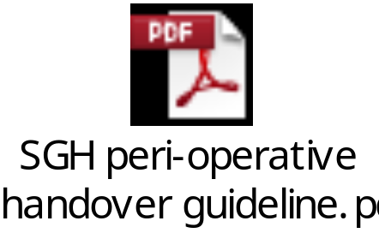

Clinical Product Management Policy

http://stginet/Procedural%20Documents/Corporate%20-%20IT/Finance/Fin_6_Clin%20Product%20Policy.pdf

Executive Summary
St Georges Healthcare NHS Trust Clinical Product Management (CPM) endeavours to provide leadership to the procurement process through practical application and critical thinking derived from an extensive background of clinical experience. Utilisation of CPM processes encourages a balance of optimal clinical outcomes and supply governance while striving to deliver objective evidenced based clinical analysis through research, multidisciplinary collaboration and data which includes function, cost, utilisation, impact on infection control, and patient outcomes.

CPM will be achieved through the appropriate distribution of governance roles which will ensure the oversight of clinical product choice, product evaluation and quality control. This will include the management of Trust relationships with suppliers to ensure the most favourable strategic alliances with vendors and the oversight of the introduction of new products.

The structure of St Georges NHS Trusts CPM organisation will include a Clinical Product Management Committee that is accountable to the Trusts Patient Safety Committee. The CPMC will oversee three product review teams to include: a) Medicine, cardiac & Cardio-thoracic; b) Surgery, Theatres and, c) Anaesthetics; Children & Women, Clinical Imaging, Therapies and Diagnostics. These product review teams will include multidisciplinary staff and consultant end-users to evaluate and make recommendations on products. Business cases presented to the CPMC for authorisation will include a review of clinical evidence based research, patient safety cost/ benefit analysis and product evaluation and trials as appropriate. The CPMC will have an integrated relationship with the Medical Devices Management Committee and Procurement Sourcing and Contracting.
Policy Statement

To achieve its vision, the Trusts Clinical Product Management organisation will:

- Serve as gatekeepers of new products for each facility and system-wide in collaboration with Procurement leadership as needed.
- Drive contract compliance by identifying non-contract products and determining clinically equivalent contract supplies.
- Review product substitutions and conversions to determine clinical equivalency and the ability to meet clinical needs.
- Develop cross department review groups to standardise like products across services when products have applications throughout the organisation.
- Determine product quality concerns/issues are valid clinical concerns or product defects.
- Provide Senior Leadership with Procurement focused clinical support required to optimize and reduce the cost of providing optimal patient care.
- Provide clinical expertise regarding product safety, efficacy, and use.
- Evaluate product related safety concerns and collaborate actively with clinical teams, Risk department and Consultant Leadership to identify supply related issues.
- Provide a point of contact for suppliers wishing to build business between themselves and St Georges Healthcare NHS Trust.

Company Representive Policy
July 2010
http://stginet/MeetingsandMinutes/PRG/Aug%202010/65.doc

- Introduction
Companies wishing to do business with the Trust have traditionally been unrestricted in accessing employees on Trust premises which has led to inefficient use of employees time and contributed towards the de-standardisation of products purchased by the Trust. Such practice may lead staff to enter into negotiations and sales which are not in line with Trust Policy and Financial Standing Instructions, due to a lack of knowledge and expertise in the procurement process and thus render the Trust at risk of unsafe financial commitments or breach of the governing legislation and guidelines. Some companies who have been unsuccessful in a tendering process have been identified as attempting ‘back door selling’ techniques. This is considered poor practice and has detrimental effects on competition and the viability of NHS contracting.

The policy excludes pharmaceutical industry representatives who are covered by a separate policy, ‘Medicines Management Policy’. Please contact the Pharmacy department with regards to this policy.

http://stginet/Procedural%20Documents/Patient%20related/Medicines/Clin_3_00Meds%20management.pdf

- Aims
To provide a clear, structured and safe pathway for company representatives to engage with Trust staff.

- Objectives
- To define the procedure to be followed by Company Representatives who wish to engage with Trust staff.
- To decrease the amount of management and clinical time lost to unsolicited contact by company representatives approaching clinicians direct.
- To provide guidance to staff on how to deal with unsolicited approaches from company representatives.
- To prevent trust employees from entering into an agreement to procure products outside of those listed as standard or contracted without consultation with relevant General Manager and the Trust Procurement Department.

4.0 General Information
- In addition to providing information to health practitioners, it is recognised that the prime function of commercial representatives is to promote and sell their products and services. This function should not contravene Trust, NHS or government policies and should be carried out in a proper and ethical manner.
- When on site all representatives must comply with any instructions given to them by an authorized member of staff in the event of any emergency situation e.g. a fire or major incident.
- When on site all supplier representatives would be expected to comply with the no smoking policy, car parking policy and any other such policies or guidance that might be relevant at the time.
- Representatives may not visit clinical areas or the Procurement department without an appointment. To make an appointment to see a member of staff, please see Appendix A [of policy].
- All representatives working at St Georges should be familiar with the contents of this policy and are expected to comply with it. The policy is available from the Procurement Department.
- Representatives will wear a company identification badge at all times whilst on Trust premises. This should include a photograph and will clearly state his/her name, company and position. Where appropriate the representative should also have the authorisation letter.

Reporting to the Coroner
Deaths that occur in office hours are the responsibility of the teams involved in the care of the patient. Bereavement Services are responsible for reporting out-of-hours deaths only. Failure to report delays the process and unnecessarily distresses the relative.
(Teresa Allison, Bereavement Services Manager)

Police Statements
A&E deals with all police requests for notes, medical evidence, coroners, etc. with the necessary consents being held in the department. The police must go via A&E and not via individual hospital personnel (trainees and consultants).

The Trust discourages the police from contacting personnel by e mail for a several reasons, confidentiality being the main one.

Tess Barnes, one of the A&E secretaries, looks after the police work (admin assistant is Nichola Miles)

Major Incident Plan
Updated March 2013

In emergencies during daytime and out of hours, you can use the 0051 phone to make outside phone calls.

Full plan available:

http://stginet/Procedural%20Documents/Major%20Incident/MajorIncidentPlan.pdf

Job title Trauma Consultant Anaesthetist on-call – available via AET theatre or oncall pager

Incident Role Trauma Network – Clinical Support Action Card No. 31

MAJOR INCIDENT DECLARED
1. In the event of a Major Incident declared, you will be contacted via the AET theatre or your on-call pager from the hospital switchboard.
2. Go to the A&E Reception and collect Action Card and identification armband.
3. Establish contact and liaise with the Consultant in Charge and the Nurse in Charge of the Accident & Emergency Department at the Majors Desk to establish what assistance they need.
4. Establish and maintain contact with
_ In normal working hours: the Trauma Network Co-ordinator on bleep 8091
_ Out of hours: take on the role of the Trauma Network Co-ordinator as well as the role
of the Trauma Network – Clinical Support and then delegate if necessary to an
appropriate individual.
5. Be available and provide to the Trauma Units within the network real-time decision-making and clinical advice about patients they may have who require transfer to St. George’s Hospital as the major trauma centre.
6. In conjunction with the Consultant in charge of ED, the Lead Trauma Consultant and the Trauma Co-ordinator manage the P1 capacity of St. George’s Hospital.
MAJOR INCIDENT STAND DOWN AND DEBRIEF
7. When you receive the Message MAJOR INCIDENT STANDDOWN, ensure all that can attend the hot debrief processes after the incident.
8. Continue to work with the Trauma Network Clinical Support, Trauma Co-ordinator and NIC of Trauma Ward to understand the current needs of the Trauma Network in relation to patient flow and the capacity constraints of the hospital as the network’s Major Trauma Centre and to facilitate repatriation of patient s as appropriate.
Job title Lead Nurse for Trauma Bleep 8091 or Trauma Consultant Anaesthetist on-call – available via AET theatre or oncall pager

Incident Role Trauma Network Co-ordinator Action Card No. 32

MAJOR INCIDENT DECLARED
1. In the event of a Major Incident declared, you will be contacted by bleep 8091 via the AET theatre or your on-call pager from the hospital switchboard
2. Go to the A&E Reception and collect Action Card and identification armband.
3. Establish contact and liaise with the Trauma Network – Clinical Support. If the major incident has occurred outside normal working hours the role of the Trauma Network Coordinator will initially be taken by the Trauma Network – Clinical Support and may then be delegated back out.
4. Establish contact and liaise with the Ambulance Liaison Officer (ALO) assigned to St. George’s Hospital. They will be based in the Relatives room in A&E Resus.
5. Establish contact, liaise and act as a single point of contact for the Trauma Units and ambulance services within the South West London and Surrey Trauma Network and for other Major Trauma Centres in London.
6. Work with other South West London and Surrey Trauma Unit Network co-ordinators to facilitate any patient flow in and patient flow out of St. George’s as the Major Trauma Centre within the network.
7. Work with other Major Trauma Centres so that you have an overview of the capacity in other networks.
8. Work with the Trauma Network – Clinical Support, Clinical Site Management team on bleep 6007, NIC of Trauma Wards and Trauma Unit Network co-ordinators to prioritise the transfer of patients into St. George’s Hospital, and transfer out of less seriously injured patients back to Trauma Units
9. Follow up patients with Trauma Unit Network co-ordinators as the incident develops
MAJOR INCIDENT STAND DOWN AND DEBRIEF
10. When you receive the Message MAJOR INCIDENT STANDDOWN, ensure that you can attend the hot debrief processes after the incident.
11. Continue to work with the Trauma Network Clinical Support, Trauma Co-ordinator and NIC of Trauma Ward to understand the current needs of the Trauma Network in relation to patient flow and the capacity constraints of the hospital as the network’s Major Trauma Centre and to facilitate repatriation of patient s as appropriate.
Job title Consultant Anaesthetist on-call for St. James’ Wing or Bleep 8011- via oncall pager and bleep

Incident Role Theatre Co-ordinator Action Card No. 35

MAJOR INCIDENT DECLARED
1. In the event of a Major Incident declared, you will be contacted - via oncall pager or bleep 8011 from the hospital switchboard.
2. Go to the A&E Reception and collect Action Card and identification armband.
3. Establish and maintain contact and liaise with the Consultant in Charge of the Accident & Emergency Department and the Lead Trauma Consultant.
4. Establish contact and liaise with the Theatres On-call Manager on SG423 or Bleep 7475.
5. In conjunction with the Consultant in Charge of the Accident & Emergency Department, the Lead Trauma Consultant and the Theatres On-call Manager
_ Decide whether any and which operating list in progress should be suspended.
_ In conjunction with cardiac / obstetric / paediatric consultant anaesthetic colleagues ensure sufficient anaesthetists are available. If required by the Consultant in charge of the Accident & Emergency Department send anaesthetists to the Accident & Emergency Department to assist with resuscitation and then be allocated to patients coming to theatres.
6. In conjunction with the Theatres on-call manager and relevant consultant surgeons who have reported in, organise Major Incident theatre list(s)
7. If necessary assemble a team in the St James Wing theatres recovery room for reassessment and stabilisation of patients preoperatively.
8. If requested, allocate anaesthetists to one or more Mobile Medical Teams.
9. Liaise with the Medical Co-ordinator in the Hospital Control Room regarding capacity of the hospital to receive further patients from the Major Incident.
MAJOR INCIDENT STAND DOWN AND DEBRIEF
10. When you receive the Message MAJOR INCIDENT STANDDOWN, ensure all that can attend the hot debrief processes after the incident.
11. Work with the on-going Command and Control in the hospital to reschedule any cancelled operations in a clinically appropriate manner.
Job title On-call Theatres Manager /Theatres Floor co-ordinator– SG253/Bleep 7475

Incident Role On-call Theatres Manager Action Card No. 36

MAJOR INCIDENT DECLARED
1. In the event of a Major Incident declared, you will be contacted via SG253 from the hospital switchboard.
2. Go to the A&E Reception to collect Action Card and identification armband.
3. Return to St James Wing theatres reception area and with the Theatre Coordinator (Consultant Anaesthetist on-call )
_ Ensure that the Head of Nursing [SG423], all Clinical Theatre Managers, scrub and anaesthetic floor co-coordinators in all operating theatre suites (inc. PC, Lanes, AMW, SJW and DSU) are informed that a Major incident has been declared.
_ Ensure that all surgeons in all operating theatres (inc. PC, Lanes, AMW, SJW and DSU) that a Major incident has been declared
_ Decide on the need to stop or cancel operating lists, and if so nominate a theatre practitioner to put this into effect and communicate this to the Hospital Control Team
4. Nominate another member of staff to call in additional theatre staff if appropriate.
1. Liaise with Sterile Services Manager on Bleep 6759 during working hours and from 22.00 – 07.30 hours On–call manager tel no 07887 511469 to ensure continued clean supply of instruments
5. Establish and maintain a close link with the Consultant in charge of the Emergency Department to manage theatre capacity.
6. Together with the Theatre Coordinator (Consultant Anaesthetist) receive from the Emergency Department a prioritised list of patients for operation. Decide on number of lists and theatres to be opened, and staff accordingly.
7. Assess the need for additional staff, drugs, supplies and gases and liaise with Bank, Pharmacy and Procurement colleagues as appropriate.
8. Depending on the needs of theatres, identify anaesthetic and recovery nursing staff to work in the Emergency Department or ITU if requested by the Nursing Coordinator.
9. Ensure that forensic evidence is kept, labelled for individual patients. Material should be bagged as follows:
_ All clothing and linen in clear plastic bags
_ All dressings and clinical waste in yellow plastic bags
_ Any foreign bodies in universal containers
_ Consider staff fatigue, including your own, and ensure that staff who have taken roles are relieved at reasonable. All valuables in brown envelopes
10. Consider staff fatigue, including your own, and ensure that staff who have taken roles are relieved at reasonable intervals.

MAJOR INCIDENT STAND DOWN AND DEBRIEF
11. Attend the hot debrief processes for all staff immediately after the incident.
12. Work with the on-going Command and Control in the hospital to reschedule any cancelled operations in a clinically appropriate manner
Job title Anaesethetics On-call Team – Consultant and SpR - via oncall pager and bleep

Incident Role Anaesethetics On-call Team – Consultant and SpR Action Card No. 42

MAJOR INCIDENT DECLARED
1. In the event of a Major Incident declared, you will be contacted via - via oncall pager and bleep from the hospital switchboard.
2. Go to the Accident & Emergency Department Reception to collect Action Card and identification armband and wait there.
3. Assist the Theatre Co-ordinator/ Consultant in Charge of Accident & Emergency Department when requested in helping ensure sufficient anaesthetists are available to assist with and then be allocated to patients coming to theatres.
4. Coordinate the Anaesethetic Department’s response to the Major Incident:
_ ensure medical input to support theatres in safely discharging patients pre- and postoperation.
_ call in additional specialist colleagues as appropriate.
_ Careful planning should ensure that not all available extra staff are utilised within the first few hours or days of an incident, but staggered and rolling increases are considered to follow the peak demands that may appear throughout the incident
6. Do not leave the Accident & Emergency Department without consulting the Consultant in Charge of Accident & Emergency Department.

MAJOR INCIDENT STAND DOWN AND DEBRIEF
7. When you receive the Message MAJOR INCIDENT STANDDOWN, ensure all that can attend the hot debrief processes after the incident. Notify the staff on the ward.
8. Work with the on-going Command and Control in the hospital to reschedule any cancelled operations which require post operative critical care in a clinically appropriate manner.
Job title Nominated Accident & Emergency Department Consultants and Surgeons

Incident Role Mobile Emergency Response Incident Team (MERIT) Action Card No. 85

MAJOR INCIDENT DECLARED
1. In the event of a Major Incident declared, either the Ambulance Service or Medical Incident Officer (MIO) may require one or more Mobile Medical / Surgical Team(s) from the hospital, and indicate the number of people required.
2. A Mobile Medical Team consists of:
_ an anaesthetist (team leader),
_ an A & E doctor
_ up to four nurses (of whom at least one should be from the Accident & Emergency Department).
Members of the team will be designated by the Medical Coordinator in conjunction with the duty consultant anaesthetist (or deputy) and Nursing Coordinator.
3. A Mobile Surgical Team likely to comprise
_ a surgeon,
_ an anaesthetist
_ one or more theatre nurse / ODP.
The Medical Coordinator will arrange for members of staff to be designated as the Mobile Surgical Team in conjunction with the duty consultant general surgeon and anaesthetist (or deputy). If designated as a member of the Mobile Medical / Surgical Team:
4. Report to the Nurse in Charge of the Accident & Emergency Department. You will be supplied with appropriate protective clothing and equipment for the Mobile Medical Team (which is stored in the Major Incident storeroom on the corridor between the Minors and Majors areas of the Accident & Emergency Department).
5. You will be transported to the scene by LAS.
6. On arrival at the scene, report to the LAS Emergency Control Vehicle. Members of the team must be checked in and out of the scene by the MIO or deputy.
7. You will be tasked by the MIO on scene. The role of the Mobile Medical Team is to undertake life saving procedures with the objective of
_ maintaining the patient’s airway with cervical spine control
_ support of ventilation and oxygenation
_ stopping bleeding by simple measures such as external pressure, and establishing intravenous infusion(s)
_ splinting fractures/spine as appropriate
_ relief of pain.
8. After completion of designated tasks, report back to the MIO.

MAJOR INCIDENT STAND DOWN AND DEBRIEF
9. When you receive the Message MAJOR INCIDENT STANDDOWN, ensure that you attend the hot debrief processes after the incident.

Admission to Cardiothoracic Intensive Care

St Georges Cardiothoracic Intensive Care (CTICU) is an 18 bed critical care unit on the 1st floor of Atkinson Morley wing near cardiothoracic theatres.

Telephone 1504, 1505

Bleep 6659

CTICU admits patients following cardiothoracic surgery, critically ill cardiology patients and vascular surgery patients. All admissions are discussed with the consultant on call for CTICU.

During working hours, one of the CTICU medical team may be able to come and help the on call anaesthetist with a patient destined for the CTICU. However, out of hours, due to numbers and skill mix, the CTICU doctors are not expected to leave the unit.

Cardiac surgery patients are all allocated CTICU beds unless planned for ‘fast track’ recovery. Vascular patients that require postoperative critical care will be allocated CTICU beds as needed. The vascular surgeon and anaesthetist must communicate the need for a bed to CTICU as soon as they can. Usually this happens the evening before or first thing on the morning of surgery.

Cardiology patients are usually admitted as an emergency either from a cardiology ward or from the cardiology catheter laboratory. The patients from catheter lab are usually patients having primary angioplasty and have often had an out of hospital cardiac arrest. The on call anaesthetist will be called as a member of the heart attack team or to provide emergency airway intervention. Usually CTICU will have been made aware of the patient already, but its best to check to avoid delays. One of the cath lab staff or the ODP can make the call if you are busy.

Admission to CTICU from other areas is less frequent but sometimes patients are admitted from a cardiothoracic ward or A+E. If the on call anaesthetist is involved and needs to arrange a CTICU bed, the easiest thing to do is telephone CTICU. One of the CTICU doctors can then speak to the consultant on call. The surgical or medical consultant must also be called as they will need to speak to the CTICU consultant.

On admission to CTICU, care must be handed over to the CTICU nurse and doctor on duty. A written record of the key points must be made in the notes. This must include the admission diagnosis, background and current treatment plan. Common points to note include the plan for anticoagulants, antibiotics, haemodynamic targets and key nursing observations.

Any anaesthetist is welcome to speak the consultant for CTICU directly, either by coming to the unit or on the telephone.

Hanif Meeran, Paul Quinton, Alexander Dewhurst, Frank Schroeder, Agnieszka Crerar-Gilbert, Nick Fletcher, Dominic Spray, Mark Edsell, Nawaf Al-Subaie, Prof Brendan Madden

March 2015

Admission to NITU

The NITU consists of 14 level 2 and 3 critical care beds providing tertiary service to regional stoke, neurology, neurosurgery and interventional neuro-radiology.

Admission criteria:

- Acceptance by one of the above mentioned specialities, who will liaise with NITU directly about availability of beds
- Acceptance because of bed pressures within St George’s critical care network (patients not under the care of neuroscience). This should be discussed directly with GITU and the GITU team will then liaise directly with the NITU team, or ask for this to happen on their behalf (e.g. A&E / anaesthetics)

Elective post neurosurgical / interventional neuro-radiology admissions are arranged via nurse in charge of NITU and neuroscience bed manager.

Emergency neuroscience admissions are to discussed with the admitting team who will either liaise directly with the NITU nurse in charge and the NITU registrar / consultant, or ask for this to happen on their behalf (e.g. A&E / anaesthetics)

Useful numbers

NITU ext 4195 / 4196 (externally 020 8725 4195/6)
NITU registrar on call bleep 7203
Neurosurgical registrar on call bleep 7242
Neurology registrar on call bleep 7277

Criteria to Admission to and Discharge from PICU

Background
There is comprehensive provision of on-site Paediatric critical care at St George’s Hospital. Paediatric Intensive Care is part of the Paediatric Medicine Care Group within the Child Health Directorate. It is part of the South Thames Paediatric Critical Care Network and participates in the PICANET.

PICU is located in two areas in Lanesborough Wing – a 10 bedded area with intensive care facilities for all beds in the 1st Floor and a 4 bedded Paediatric Step Down Unit (PSDU) in the fifth floor allowing High Dependency Care.

The unit is staffed by a blend of paediatricians and anaesthetists, but at all times there is an anaesthetic trainee on site and cover from a trained Paediatric Intensivist.

Patients are admitted from wards, operating theatres and the emergency department, as well as from other hospitals, transported usually by paediatric specialist transport service (CATS & STRS).

Admission to PICU and discharge from PICU is a decision of the PICU consultant on duty and the nurse in charge. Any transfers in or out MUST be agreed by the attending PICU Consultant and the medical and nursing staff in both the referring and receiving areas.
The PICU registrar can be contacted on bleep 6890 to discuss possible admissions.
For acute emergencies phone 2222 and state your location and specify paediatric.

The responsible consultant in the receiving area must be informed of the move, before the patient has arrived (unless there are exceptional circumstances). Typically this is the responsibility of the receiving team to make their consultant aware of the new patient.

The PICU consultant decides whether the patient is admitted to PICU at 1st floor of the Lanesborough Wing or PSDU in the 5th Floor of Lanesborough wing.

PICU Admission Criteria
Demographics
By default, from discharge after birth to the 18th birthday patients will be admitted to PICU rather than GICU or NICU. (Children should be weighing more than 1.8 Kg and more than 34 weeks of gestation)

Those past their 18th birthday with ongoing care needs under the paediatricians may be more suitable for PICU than GICU

Those 16-18 with some conditions may be better looked after elsewhere. Examples – complication of pregnancy; gunshot wounds from gang fighting.

If in doubt discuss with the PICU consultant.
Physiological criteria
Airway - Any patient with an unstable airway or the need for an artificial airway.

Breathing - All patients who have acute respiratory distress and are likely to require mechanical
breathing support with either invasive or non-invasive ventilation.
- Patients who have apnoea that is not self-correcting.
- Patients who have arterial desaturation due to respiratory disease despite a high
ambient oxygen therapy (> 50%).

Circulation - All patients with an unstable or potentially unstable circulation despite adequate fluid resuscitation. This will usually be >40 mls/kg, although some dehydrated patients will have more fluid than this and not need to be monitored in PICU.
- Patients who require acute pharmacologic or mechanical support of the circulation.
- Potentially life-threatening dysrhythmias

Neurological - Patients with an acutely diminished level of consciousness or a decreasing level of consciousness.
- Patients with status epilepticus requiring continuous infusion of anticonvulsant medication.
- patients requiring intracranial pressure monitoring

Renal & Fluid - Patients requiring acute renal support (CVVH) or having a complication of renal failure resulting in any of the above.
- Electrolyte disturbance requiring close monitoring and treatment.
- Some patients who are currently stable but have the potential to rapidly decompensate (eg ingestions, major electrolyte disturbances, severe DKA with arterial pH <7.0) may warrant monitoring in PICU. These patients need to be discussed consultant to consultant.

HaemOnc - severe anaemia requiring haemodynamic and respiratory compromise
- severe coagulopathy
- severe complications of sickle cell disease – neurologic changes, acute chest syndrome
- Initiation of chemotherapy in patients with high risk of tumor lysis syndrome
- Tumors or masses compressing or threatening to compress vital vessels, organs or airway

Gastro-intestinal and Hepatic
- Severe acute gastro-intestinal bleeding leading to haemodynamic compromise
- Patients with fulminant hepatic failure requiring intensive support.
Post-operative Admissions
All elective admissions should be booked with PICU preoperatively with a PICU booking form AND discussion with the PICU consultant.
- Cases that routinely come to PICU include: Spinal instrumentation, major intracranial surgery, Tracheostomy and other major ENT procedures, major surgeries.
- Some surgical patients may benefit from preoperative admission to PICU. This is on an individual patient basis following discussion with the PICU consultant.

Major Trauma Patients
The above admission criteria apply to major trauma. In addition there are injury criteria that predict further complicaitons and therefore need for PIC. These are:-

2 or more major injuries (Abbreviated Injury scale 3) or one severe injury (abbreviated injury scale 4 or more)
Suspected or proven, unstable, bony spinal injuries with or without spinal cord injury
>20mls/kg RBC transfusion during resuscitation
>2 hours in theatre
- Any persistent or worsening acute organ or metabolic dysfunction
- High risk of deterioration or complications based on known injuries (eg splenic trauma, pelvic fracture).

PICU Discharge Criteria
Patients in the PICU are considered for discharge when the need for complex intervention exceeding general patient care unit capabilities and the patient is physiologically stable or improving:

1. Stable respiratory status (patient extubated with stable arterial blood gases) and airway patency; minimal oxygen requirements – face mask or nasal cannulae.
2. Stable hemodynamic parameters; intravenous inotropic support, vasodilators, and antiarrhythmic drugs are no longer required.
3. Neurologic stability with control of seizures; intracranial pressure monitoring equipment has been removed
4. The health care team in PICU and in the ward, determine that there is no benefit in keeping the child in the PICU.
5. Ward team have been notified and aware of discharge. Discharge documentation completed.

Dr S Manna
Issued March 2015
Review March 2016

ACSA STANDARDS 2.4.2 Hotel Services

The following standards apply to “on call staff”.
The anaesthetic trainees follow a full shift pattern whilst the consultants follow a non-resident on call pattern

2.4.2.1 Priority 1 - CQC KLOEs: safe

Appropriate facilities for rest are available for on call staff
A quiet area with comfortable seating must be seen.

1) Anaesthetic Department

- There is a large communal coffee room with comfortable seating

- At night, the room can be partitioned to provide a darker, quieter environment to facilitate rest breaks. These are essential for the reduction of fatigue and to improve safety

- Inflatable beds are provided for comfort

2) Labour Ward

- An anaesthetic office with a reclining chair is available

3) Doctors Mess

- Comfortable sofas are available to rest on

4) Post on-call rest area

- The PICU registrar room is available during the morning to rest after a busy night shift/on call to any member of anaesthetic staff before travelling home.

2.4.2.2 Priority 2 – CQC KLOes

Appropriate facilities for refreshments are available for on call staff
Staff should report that they are satisfied.

CQC KLOEs: Safe, well led

On call staff have a large choice of places to obtain a variety of hot and cold refreshments out – of - hours

1) Anaesthetic Department 24/7

- The department has a fully stocked kitchen with essentials e.g. tea, coffee, bread, jams, cheese, spreads etc.

- The kitchen has 2 microwaves to facilitate the provision of hot food 24/7

- There are 2 large cupboards in the secretary’s office with snacks and luxury items e.g. biscuits, crisps, nuts, dark chocolate, crackers etc.

- These cupboards also contain items that can be heated via microwave e.g. soups, pastas and ready – meals.

- Both the trainee and coffee rooms provide information on food delivery from local restaurants

- Doctors Mess 24/7

- Fully stocked kitchen with a microwave, toaster and kettle for hot food

- Hospital Canteen

7:30 – 11 am Breakfast

12:00 – 14:30 Lunch

17:00 – 19:45 Dinner

Costa Bar opens all day from 7am to 18:30

- Marks and Spencer’s Food

7am - 9 pm weekdays, 8am to 9pm weekends

- The Whistle-stop Newsagent

7am to 9pm every night

- Peabody’s Coffee Shop

7am to 6pm weekdays

NB The AMW Branch is open at the weekends

Consultants air call numbers

Dr G Abuella
Dr Lee Adams (locum general)
Dr A Addei | SG 729
Dr N Al-Subaie
Dr D Barnes
Dr Jens Bolten
Dr J Blackburn
Dr N Burgess (Neuro ICU Lead) | SG 341
Dr A Blythe (Kingston Hospital)
Dr J N Cashman | SG 217
Dr M Cecconi
Dr J T Clarke | SG 473
Dr A Crerar-Gilbert | SG 769
Dr P Dassancharya
Dr C Davison | SG 670
Dr A Dewhurst (Cardiac Lead) | SG 133
Dr H DeZoysa
Dr J Dinsmore | SG 589
Dr M Edsell (Deputy Care Group Lead for Anaesthetics)
Dr E Evans (Obstetrics Lead) | SG 495
Dr M Farrar (College Tutor – Junior Trainees) | SG 477
Dr N Fletcher (CICU Lead) | SG 419
Dr N Fossati (Renal Lead) | SG 252
Dr D Garewal | SG 767
Dr A Garner | SG 533
Dr C Gass (Director of Medical Education) | SG 697
Prof M Grounds (GICU)
Dr M Hamilton | SG 694
Dr S Hammond (Clinical Governance Lead for anaesthetics)
Dr D Hampson-Evans (Paediatric Lead) | SG 590
Dr R Hartopp
Dr S Hutchinson (Clinical Director) | SG 408
Dr R Iqbal | SG 180
Dr S Jha (locum trauma)
Dr R Johnson
Dr C Johnston
Dr K Jones | SG 728
Dr R Kennedy
Dr E Kourtelli (Lead for Airway Anaethesia) | SG 368
Dr M Kraayenbrink
Dr A Krol (Regional Anaesthesia Lead) | SG 381
Dr A Kayal
Dr J B Liban (Lead for Appraisal for Anaesthetics) | SG 479
Dr K Light (Lead for Recovery) | SG 695
Dr C Luong (Audit Lead)
Dr B Masuku (locum general)
Dr G McAnulty
Dr H Meeran (CICU Lead) | SG 770
Dr Fauzia Mir
Dr E Monahan | SG 130
Dr S Mongia (Day Surgery Lead) | SG 672
Dr L Murdoch (PICU Lead) | SG 244
Dr P Newman | SG 502
Dr L Ng | SG 699
Dr G Nicholson (General group Lead) | SG 555
Dr A Nicolaou (Chronic Pain RA) | SG 653
Dr J Norman (Training Programme Director) | SG 768
Dr J O’Riordan | SG 499
Dr K Patil
Dr B Phillips | SG 587
Dr C Pollitt (locum general)
Dr P Quinton (Regional Advisor) | SG 166
Dr P Razis
Dr A Rhodes (ICU Clinical Director) | SG 586
Dr H Robertshaw | SG 654
Dr R Ruggier (Neuroanaesthesia Lead) | SG 646
Dr A Sherrington
Dr F Schroeder | SG 147
Dr V Sharma
Dr M Shaw | SG681
Dr A Sherrington
Dr A Shonfeld (locum general)
Dr D Spray (Lead for Enhanced Recovery Programme)
Dr K Subhas
Dr R Suite (College Tutor – senior trainees) | SG 744
Dr R Sunderland
Dr B A Sutton | SG 354
Dr K Syeed (Lead for Transfusion)
Dr A Tredray | SG 413
Dr J P Van Besouw (Royal College of Anaesthetists) | SG 487
Dr P Waikar (Trauma Lead) | SG 352
Dr L Walker
Dr A Walton (Lead for Anaphylaxis)
Dr R Wendler (Care Group Lead, Theatres) | SG 221
Dr E Williams (Quality Improvement Lead for Anaesthesia) | SG 451
Dr F Wrightson
Dr P Wong (Care Group Lead, Anaesthetics)
Dr C Wood
Dr A Zoumprouli | SG 416
Dr R Zumpe

Appendix

Protocol for the management of the emergency surgery theatre
- Application
  - This protocol applies to all members of the multi-disciplinary team involved in the admission and management of patients admitted to the trust for emergency surgery, excluding cardiothoracic, neurosurgical and major trauma cases.

- Anaesthetists involved in the provision of emergency surgery
  - CEPOD anaesthetist: The anaesthetist rostered for the emergency theatre between 0800–2100 on weekdays. At all other times this role is covered by the resident anaesthetist on-call.
  - On call consultant anaesthetist: A consultant anaesthetist between 1800–0800 on weekdays and 0800–0800 on weekends, contactable through switchboard.
  - Resident anaesthetist on call: A registrar-grade anaesthetist contactable 24/7 via pager 6111.
  - Duty floor anaesthetist (DFA): A consultant anaesthetist between 0800–1730 during weekdays, is contactable via pager 8011.

- Definition of the emergency surgical patient
  - Emergency surgical cases are classified according to the NCEPOD classification (see appendix).
    - IMMEDIATE – Immediate life, limb or organ-saving intervention – resuscitation simultaneous with intervention. Normally within minutes of decision to operate.
    - URGENT – Intervention for acute onset or clinical deterioration of potentially life-threatening conditions, for those conditions that may threaten the survival of limb or organ, for fixation of many fractures and for relief of pain or other distressing symptoms. Normally within hours of decision to operate.
    - EXPEDITED – Patient requiring early treatment where the condition is not an immediate threat to life, limb or organ survival. Normally within days of decision to operate.
    - ELECTIVE – Intervention planned or booked in advance of routine admission to hospital. Timing to suit patient, hospital and staff.
  - Emergency cases requiring a great deal of logistical co-ordination should be discussed with the theatre floor manager and the duty floor anaesthetist who in turn will liaise with the CEPOD anaesthetist when necessary.

- Emergency theatre provision
  - A 24-hour emergency operating theatre is provided.
    - Between 1700–2100 on weekdays and 1000–2100 on weekends a second emergency operating theatre is provided, staffed with a nursing team and a dedicated consultant anaesthetist.
  - Cases classified as ‘IMMEDIATE’ will be operated on at anytime.
  - ‘IMMEDIATE’ cases will take precedence over all other cases.
  - The appropriateness of operating on cases classified as ‘URGENT’ between 2100–0830 will have to be determined on an individual case basis, in discussion with surgeons, theatre staff and anaesthetists.
  - Cases classified as ‘EXPEDITED’ will be operated on between 0830–2100.
  - Cancelled cases from elective lists must not be transferred onto the emergency list.

- Booking cases on the emergency theatre list
  - All cases are undertaken in the order that they have been booked, unless medical re-prioritisation occurs. Exempt from this rule are cases classified as ‘IMMEDIATE’.
  - A case cannot be booked onto the emergency list unless the following criteria are fulfilled:
    - The consent form is completed.
    - The patient has an in-patient bed or is being transferred directly from A+E.
    - All appropriate diagnostic investigations have been performed and results are available (this includes blood tests, X-rays, ultrasound and CT scans, etc.).
    - A surgeon competent to perform the operation will be available at the time of sending for the patient.
  - The surgeon booking the case will confirm fulfilment of these criteria at the time of booking in the CEPOD book.
  - Relevant clinical information about the patient must be clearly communicated to theatre staff and the anaesthetist when the surgical team makes the booking.
  - The surgeon booking a patient on the emergency list must contact the resident anaesthetist on-call (p6111) about the case. The resident anaesthetist on call (p6111) will then inform the duty floor anaesthetist and CEPOD anaesthetist.
  - A surgeon competent to perform the operation must be available at all times from the time the patient is ready for surgery, i.e. has been booked on the CEPOD lists and is starved.
  - If the operating surgeon is not available at the time of sending for the patient or the patient is not otherwise ready for surgery the case will be removed from the list.
    - It is then the responsibility of the surgical team to re-book the case.
    - At the time of re-booking the patient again joins the back of the waiting list.
  - Special requirements, e.g. for equipment or X-ray, need to be stated when the booking is made. A radiographer must be booked by the surgical team.

- Pre-operative assessment of the patient by the surgical and anaesthetic teams
  - Appropriate preoperative assessment and consent of the patient by the surgical and anaesthetic team must be undertaken in all cases.
  - A surgeon competent to perform the operation must have seen the patient prior to induction of anaesthesia.

- Cancellation of emergency cases and deferment to the following day
  - Urgent cases booked must not be postponed or cancelled without discussion with the surgeon responsible, the consultant anaesthetist, and the theatre floor manager.
  - Cases on the previous evening’s emergency list which were not completed due to time constraints are automatically rolled over to the following morning.
  - It is the responsibility of the 6111 bleep holder to liaise with the surgical teams and the night theatre staff to identify and preoperatively assess the first patient to ensure a timely start of the CEPOD list at 8:30 am. The first patient should be send for by latest 8:15 after discussion with the CEPOD anaesthetist and/or DFA.
  - As each surgical and anaesthetic ‘on call’ team completes their shift there must be a comprehensive hand over of relevant clinical information about each patient on the emergency list to reduce the risk of inconsistent preoperative clinical management of the patient.

- Scheduling of cases and changes to the order of the emergency list
  - As emergency cases are operated on following the order in which they have been booked request for specific scheduling times for cases should be kept to a minimum and are only possible for clinical reasons.
  - Changes to the order of emergency bookings can only be made due to medical re-prioritisation and following discussion with the surgeons and anaesthetists involved as well as the theatre floor manager.
    - Paediatric patients can be medically prioritized on the grounds of their age.
  - Once a change in the order of the emergency list has been agreed upon it is the responsibility of the surgical team taking priority to inform other surgical teams that are to be delayed.
    - Cases classified as ‘IMMEDIATE’ can be prioritized without the need for the surgical team taking priority to inform other surgical teams that are to be delayed.
8.4. The resident anaesthetist on-call will make very effort to ensure a timely list start in the morning in identifying suitable cases and liaising with the surgical specialities and the theatre staff.

- Allocation of emergency cases to the second emergency theatre list and other elective lists
  - Spare capacity on elective theatre lists can and should be used to accommodate emergency cases. The duty floor anaesthetist will coordinate these efforts in agreement with the relevant surgical teams and the theatre floor manager.
  - If a case is cancelled from the emergency list consideration must be given to placing the patient on the next available elective list of that clinical specialty/ consultant firm.
  - During times when a second emergency theatre list is provided the theatre floor manager/ and duty floor anaesthetist/ on-call consultant anaesthetist in agreement with the surgical teams involved decide upon the allocation of patients to the two lists applying the principles outlined in 5 and 8.

- Audit and data recording
  - The theatre floor manager ensures that information on completed cases is appropriate for audit purposes.
  - During handover times (0800 and 2000) the CEPOD anaesthetist and the resident anaesthetist on call (p6111) ensure that completed cases have been recorded by matching booking slips and records in the CEPOD book.

- Timeframe for implementation and review of the protocol
  - This protocol will be implemented from 18/04/2011.

Dr Patrick Wong, Care Group Lead Anaesthetics
Mr Andrew Fleming, Clinical Director (Surgery)
Ms Cathie Stirling, Head of Nursing (Theatres)
Dr Renate Wendler, Care Group Lead Theatres
Ms Jenni Karley, General Manager (Theatres and Anaesthetics)

Adult stabilization and transfer pack

Airway and ventilation

O2 mask with re-breathing bag  O2 mask with nebuliser  Guedel airways 2,3,4  Naso-pharyngeal airways 24, 26, 28  Bougie  Stylet  ET tubes (6.0, 7.0, 8.0, 9.0)  LMA 3,4,5.  20ml Syringe  KY jelly  Tube tie | Mac 3 & 4 blades with handles  McCoy 4 blade  Magill’s  NG tubes 14,16,18  Quicktrach  Micropore and Elastoplast  Facemask 3,4,5  Filter with catheter mount  Ambu-bag  Waters circuit

IV access and fluids

Alcohol swabs/Sterets X 10  Prep spray  Intra-Osseous Needle  Venflons (22, 20, 18, 16, 14G) X 2  Abbocath 20 and 22G X 5  IV dressings X 5  Tegaderm X 5  IV injection ports  IV caps/bungs  Syringes (2, 5, 10, 20ml) X 5  Needles (19, 23, 25 and filter) X 5 | Blood giving set X 2  Wide-bore IV extension X 2  3-way taps X 3  3-way taps with 10cm extension X 3  Blood gas syringes x 5  Pressure bag (1000ml)  Double line (art/cvp) set  CVP sterile pack  1000ml bag 0.9% Saline  500ml bag Voluplex  500ml bag Hartmann’s

Drugs

Propofol 1% 50mls X 2  Thiopentone X 2  Etomidate X 2  Saline 10ml amps X 10  Water 20ml amps X 5  Vecuronium X 3  Adrenaline 1:10 000 mini-jets X 3  Atropine mini-jets 1mg/10mls X 2  Glucose 50% mini-jet X 1 | Adrenaline 1:1000 X 4  Noradrenaline 1:1000 X 2  Ephedrine X 2  Metaraminol X 2  Glycopyrrolate X 2  Salbutamol nebuliser X 2  Labetalol X 1  Ondansetron X 2  Amiodarone 30mg/ml mini-jet

