Instructions for redirecting Network Printing

Click on the following link
L:\Connect SMART_PRINT 02.lnk
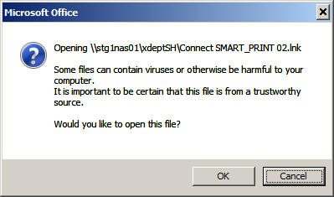 Click ‘OK’
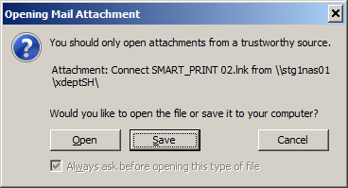 Click ‘Open’
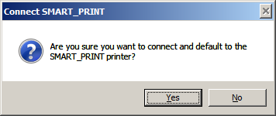 Click ‘Yes’
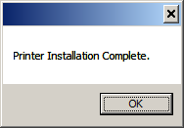 Click ‘OK’
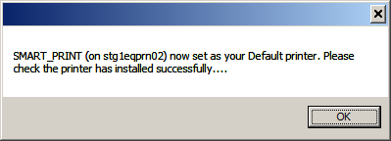 Click ‘OK’

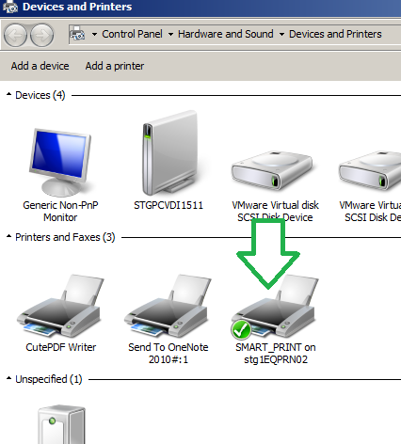
You should now see something like the above

Click on the X in the top right to close the window.
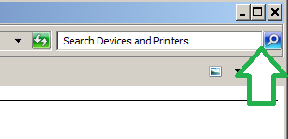
Following the instruction should redirect your printing to the right network printer. Should you require any assistance please contact the IT Help Desk on 3456

